

THE UNIVERSITY
OF TEXAS
AT ARLINGTON

School of Social Work
Box 19129
211 S. Cooper Street
Arlington, Texas
76019-0129

T 817-272-3181
F 817-272-2046

http://www.uta.edu/ssw

Smith-Osborne, A. (2012). Military social work curriculum modules: Applications for
field instruction, coursework, and graduate/post-graduate certificate programs.
Professional Development: The International Journal of Continuing Social Work
Education, 15, 14-26.

Alexa Smith-Osborne, Ph.D.
Assistant Professor, School of Social Work
University of Texas at Arlington
817-272-0452 (voice)
817-272-2028 (fax)
alexaso@uta.edu

Military Social Work Curriculum Modules: Applications for Field Instruction, Coursework, and Graduate/Post-Graduate Certificate Programs
Alexa Smith-Osborne
University of Texas at Arlington

Military Social Work Curriculum Modules: Applications for Field Instruction, Coursework, and Graduate/Post-Graduate Certificate Programs

Abstract
In 2008, the Council on Social Work Education Joint Task Force on Veterans ’ Affairs presented a preliminary report recommending that social work education introduce new content to provide students with an understanding of military culture and veterans’ services, and to enhance their practice preparedness to work with these populations. These recommendations were subsequently formulated into advanced social work competencies in military social work. This mixed methods pilot study investigates the development of social curriculum modules utilizing distance education technology, face to face, and hybrid instruction in support of a social work curriculum initiative to address these recommendations. Modules were developed on the basis of participatory action research, two cross-sectional studies, and a systematic review of the neuroscience literature. They were pilot-tested over a three year period with social work students and licensed community practitioners and were revised each semester to reflect rapidly growing knowledge in these areas, particularly pertaining to Iraq/Afghanistan (OIF/OEF) active duty and veteran populations, as well as in response to feedback from clients, students, field instructors, and course instructors. Findings suggested that practitioners improved knowledge and skills in best practices for diagnosis and treatment of stress disorders and brain injuries, neuroscience evidence on signature injuries of current conflicts, and theory application to military/veteran cases, while undergraduate and advanced graduate students in non-Veterans Administration (VA) field placements utilized the widest variety and quantity of online material.
Keywords: military social work, military, veterans, social work education, continuing education, online education

Military Social Work Curriculum Modules: Applications for Field Instruction, Coursework, and Graduate/Post-Graduate Certificate Programs
Current trends affecting America’s military suggest the need for rapid mobilization of updated social work staff development in all areas pertaining to services for military, veterans, and their families. These trends include increasing suicide rates, high divorce rates, and risk-taking reintegration behaviors (e.g., substance misuse, risky driving, legal issues) among current active duty personnel (Booth, Segal, & Place, 2009; Seal et al., 2008), increased casualty severity among combat personnel due to a 98% survival rate from combat injuries (Vasterling, Proctor, Amoroso, Kane, Heeren, & White, 2006), the Global War on Terror’s (GWOT) signature injuries of hearing loss, peripheral nerve damage, and co-morbid posttraumatic stress disorder and traumatic brain injury (Cooper, 2008; Dole et al., 2007; Gaylord, Cooper, Mercado, Kennedy, Yoder, & Holcomb, 2008; Hoge, Auchterlonie, & Milliken, 2006; Hoge, McGurk, Thomas, Cox, Engel, & Castro, 2008; Vasterling, Proctor, Amoroso, Kane, Heeren, & White, 2006; Tanelian & Jaycox, 2008), higher unemployment rates among Gulf War and GWOT veterans than the national average (Knowles, 2011; Prigerson, Maciejewski, & Rosenheck, 2001), and increasing numbers of aging veterans from the Vietnam and Gulf War eras requiring housing, personal care, and long-term care (Benotsch, Brailey, Vasterling, Uddo, Constans, & Sutker, 2000; Doebbeling et al., 2000; Rosenheck, Bassuk, & Salomon, 1999; Author removed & Selby, 2009). Further, while reports of overall rates of spousal and child abuse among military compared to civilians are conflicting, high severity spousal abuse may be higher in the military and increased rates of both spousal and child abuse varying with deployment cycles have been observed (Bradley, 2007; Heyman & Neidig, 1999; McCarroll et al., 2010; Rentz, Martin, Gibbs, Clinton-Sherrod, Hardison, & Marshall, 2006; Wadsworth, 2010). Both the existing social work role in military and VA service systems and social work expertise in interagency coordination and managing complex service systems make it clear that social workers in those systems as well as in the community will play a pivotal role in implementing such coordination. Community-based social work agencies with a high level of preparedness can work most effectively with social workers in the military and VA systems to provide crucial information and referral, case management, intervention, and psychosocial rehabilitation services to soldiers who are separating from service as they make the transition back to civilian life. Practice with military/veterans can be enhanced by continuing education on the emerging literature examining specific operation of risk and protective mechanisms for this population (Brailey, Vasterling, Proctor, Constans, Friedman, 2007; Larsen, Highfill, McRoy, Booth-Kewley, 2008; Prigerson, Maciejewski, & Rosenheck, 2002); Smith et al., 2008; Author removed, 2009a, 2009b; Author removed, in press; Vogt & Tanner, 2007).
Implications of the literature on the needs of Iraq (OIF) and Afghanistan (OEF) active duty and veterans of all combat eras and their families must also be considered by undergraduate and graduate social work programs. Addressing relevant educational needs for the current cohorts of social work students could have a significant “pay-off” in national preparedness to meet these needs. At the 2008 Council on Social Work Education (CSWE) Annual Program Meeting, the CSWE Joint Task Force on Veterans ’Affairs (CSWE, 2008) presented a preliminary report recommending that social work education introduce new content to provide students with an understanding of military culture and veterans’ services, and to enhance their practice preparedness to work with these populations. Knowledge and practice behaviors for advanced practice in military social work have been developed and published by CSWE (CSWE, 2010). The 2010 Annual Program Meeting highlighted several Schools of Social Work that are developing such content in the form of undergraduate and graduate coursework, graduate concentrations or certificate programs, post-graduate continuing education certificate programs, and combined graduate and post-graduate certificate programs (CSWE, 2010).
Research Aims
This article reports on one of those efforts, a study which investigates the development and pilot-testing of social work curriculum modules utilizing distance education technology, face to face instruction, and hybrid instruction to address these recommendations with community practitioners and social work students. It was hypothesized that military field instruction students would make greater use of online modules and associated resources than military social work tutorial students, and that non-VA field students working with veterans/military in a civilian host setting would make greater use of online modules and associated resources than VA field students. Based on literature suggesting the relative effectiveness of hybrid over fully online instruction (Ayala, 2009; Hisle-Gorman & Zuravin, 2006; U.S. Department of Education, 2010; Yorke, 2008), it was hypothesized that students in a standard course with hybrid instruction would make greater use of online modules and associated resources than field instruction students, even though more of the module content would be delivered in a face to face format.
Method
Participants
A convenience sample of 22 social work field instruction and tutorial students, 26 advanced graduate standard class students, and 36 licensed practitioners participated in the pilot test of the social work curriculum modules, presented in an online, hybrid, or face to face format to students and a face to face format to practitioners. The students were 94% female and 69% Caucasian. The practitioners were 86% female and 89% Caucasian.
Procedure
Several preliminary studies were completed: a meta-analysis of literature on protective factors for persons with psychiatric disorders (Author removed, 2005), three cross-sectional studies of veterans’ protective factors (Author removed, 2009b, 2009c, in press), a systematic review of the neuroscience literature for social work practice from 2000-2009 (Author removed & Wilder, 2010), and a literature review relevant to military and veterans’ health status, health and social service needs, and evidence-based social work practice with these populations (Author removed, 2009a, 2009d). Using the community-based participatory action research (CBPAR) approach, critique of research outcomes and applications to the proposed curriculum was obtained from stakeholders, including military personnel, military family members, and veterans. Based on the findings of this research, curriculum modules with supportive classroom materials were developed within a web-based distance education technology and an equivalent face to face course format for field instruction, coursework, independent study, and continuing education (textbooks which were required for students and recommended for practitioners are listed in the appendix). Thus, all curriculum modules are designed to be deliverable in face to face, hybrid, or fully online formats. Findings pertinent to military social work education needs were summarized in the following areas, and the online course platform and face to face curriculum were designed accordingly:
- Military- and veteran-specific health risks and protective factors
- Military/veteran high incidence health conditions over time
- Military/veteran families’ high incidence health conditions and social service needs over time
- Neuroscience fundamentals and human biology relevant to these factors
- Military culture
- Evidence-based practice methods, including manualized treatment protocols, for effective treatment of these conditions
- Evidence-based methods, including manualized protocols, that target protective mechanisms at the micro, mezzo, and macro levels
- DoD and VA benefits and delivery systems: strengths and weaknesses
- Needs for policy analysis and change to address changing needs of current military and veteran populations and their families
An online course platform (WebCT) was used to design and launch social curriculum modules of content in these areas for students. It was pilot-tested with two categories of social work students: 1) those who were engaged in micro, macro, and foundation generalist (graduate and undergraduate) field placements with Veterans’ Administration facilities and non-VA agencies serving active duty military and veterans and 2) those who were engaged in an elective independent tutorial on micro or macro practice with military and veteran populations. Undergraduate field students were added to the field instruction pilot test in the third year. The neuroscience modules were expanded and developed into a hybrid (i.e., with a second website) advanced elective graduate course in the second year. These modules were pilot-tested over two semesters with students from all concentrations. A subgroup of 3 students in the initial semester’s sample was concurrently enrolled in another graduate course on stress, trauma, and coping in which the neuroscience course instructor guest-lectured on military content; this second course did not have access to the online content. Three asynchronous online class sessions out of 15 were included in the initial semester pilot test, and five in the second; the website content was also used as the basis for assigned papers, class exercises, and tests. Electronic response technology (“clickers”) was used in all face to face classes to take attendance, review readings, take tests, and perform class polling to initiate discussion and experiential exercises.
The websites were revised each semester to reflect rapidly growing knowledge in these areas, particularly pertaining to OIF/OEF active duty and veteran populations, as well as in response to feedback from clients, students, field instructors, and field seminar and tutorial course instructors. These pilot-tested elements serve as the foundation for development of an MSSW certificate program.
Concomitantly, the modules and materials were incorporated into face to face continuing education courses which were pilot-tested with licensed community practitioners. Modules were pilot-tested over a two year period with community practitioners in three continuing education workshops on military/veteran social work as the foundation for development of a post-graduate certificate program
Based on pilot-test findings, reported here, and requests from community stakeholders, a graduate MSSW and post-graduate military certificate program were developed utilizing the curriculum modules. The graduate certificate is under review and the post-graduate certificate program has been approved and will launch in 2011.
Data Analysis
Quantitative data consisted of website utilization counts analyzed by descriptive and correlation statistics using SPSS 17. Qualitative data consisted of course evaluation comments and follow-up requests to the continuing education program, which were analyzed by content analysis and thematic synthesis (Miles & Huberman, 1994).
Results
Description of Structure and Content of the Curriculum Modules and Online Sites
The evidence-based design of the curriculum modules is summarized in Table 1. The initial website was structured into 4 modules. Module 1 was designated for introductory material, including summaries of the foundational research, information on high-need local resources and military culture, and introduction to evidence-based practice for high prevalence health conditions (e.g., sections on posttraumatic stress disorder, traumatic brain injury, military sexual trauma, sleep disorders, neurological underpinnings of stress, coping, and resilience). Module 2 contained manualized assessment and treatment protocols. Module 3 contained military population data, grant-writing procedures, and community organizing/outreach materials and protocols (e.g., for dissemination of innovations, “social marketing” to health disparities groups, CBPAR). Module 4 consisted of a description and example of the procedures for searching and synthesizing the evidence-base for practice, standardized clinical assessment instruments, single system design approaches to monitor progress and outcomes of cases, case recording procedures, combat-injured military family practice guidelines, and brief casework models (e.g., motivational interviewing and solution-focused strategies). Supportive materials such as progress note forms and handouts on sleep hygiene were also posted for download and printing from the website. A sample of an online module may be seen in Table 2.
[insert Table 1 here]
[insert Table 2 here]
The expanded neuroscience website was structured into six modules: human development, genetics, mental health (DSM conditions, resilience, and positive mental wellness) and substance abuse, cognition, stress and trauma, violence and aggression. The online course platform was designed around the identified practice domains which included the results of the systematic review research findings, central nervous system anatomy and physiology, targeted instruction in how to interpret neuroscience study findings in the range of study types and to evaluate their quality as evidence for practice. Study types included those utilizing brain imaging technologies (e.g., diffusion tensor imaging, diffusion weighted imaging, spectroscopy, functional magnetic resonance imaging), genomic mapping technology, and standardized neurological procedures/paradigms (e.g. think-no think, go-no go, fearful faces, the Wisconsin Card Sorting Test, the Stroop test, the Trailmaking Test). A sample of an online module may be seen in Table 3.
[insert Table 3 here]
Description of Structure and Content of the Associated Certificate Programs
The graduate military certificate program which is under review incorporates the CSWE Advanced Competencies in Military Social Work is designed for both Community and Administrative Practice concentrators and concentrators in Direct Practice with a specialization in Mental Health. The military social work curriculum modules described above are proposed to be delivered via the online platform for field instruction in military/veteran settings and in online and hybrid instruction in advanced year standard courses in military social work (replacing the military social work tutorial from the pilot-test phase) and neuroscience. Certificate students will also take courses in social work in health care settings and in aging which are infused with military-specific content (e.g., military Polytrauma Centers, the VA health delivery system, VA medical foster care, VA domiciliary care, impact of military service in later life stages, traumatic brain injury and early-onset dementia, delayed onset PTSD, formal and informal caregiving for veterans across the life course).
The post-graduate military certificate program for licensed practitioners is a 60-hour program consisting of 4 required and 6 elective seminars. The same textbooks are required (see Appendix). The military social work curriculum modules described above are delivered online, face to face, or in hybrid formats in the required seminars, which include a pass/fail mastery test:
- Neuroscience Underpinnings of Risk and Resilience in Trauma-Exposed Populations
- Diagnostic Assessment of Stress and Trauma Disorders and Related Co-Morbid Conditions
- Prolonged Exposure Therapy Skills and Evidence-Based Practice Practicum I
- Prolonged Exposure and Cognitive Restructuring Therapy Skills Practicum II
Elective seminars are online and face to face and will be updated each semester based on the emerging knowledge base. They may include: Complementary/Adjunct Interventions for Trauma-Exposed Populations; Assessing Suicide Risk and Suicide Prevention in Military Populations; Practice with Aging Trauma-Exposed Populations, including military retirees and veterans; Practice with Trauma-Exposed Infants and Young Children; In Your Own Practice: Identifying, Appraising, and Evaluating Outcomes indicated by New Evidence on Military Populations; Marital/Partner Relationship Issues and Intervention Approaches for Military/Veteran Populations; The Military Family and Dependent and Nondependent Caregivers.
Quantitative Results
To date, 22 students, under the direction of five field instructors and course instructors, have utilized the original online site and associated materials; three students did not review materials long enough to register on the site (see Table 4). A subgroup of 7 students in this sample also utilized a second client website specific to one of the field placement sites. Students averaged 85 separate utilization points of the site per semester, ranging from 54-212 for full semesters, and 20-82 for the current semester at the midterm point. Students averaged review of 37.8% of total content pages of the course website and 29.5% of the client website.
As hypothesized, a significant negative correlation was found between course type and the number and percent (both r = -.61; p < .05) of content pages used, indicating that undergraduate and advanced graduate field students had higher utilization of the website and materials. Independent study students tended to focus on materials directly related to their project, such as single system design materials. As more material was included over time, there was wider variation in the types of materials accessed. As hypothesized, significant positive correlations were found between non-VA field placement site and number of accesses (hits), percent of total content, and percent of different content pages utilized (r =.80, r = .75, r = .84, all at p<.01).
[insert Table 4 here]
As hypothesized, standard course students in the hybrid course utilized more of the online content than field instruction students. Standard course students averaged 417.5 separate utilization points of the neuroscience site for the semester, ranging from 34-799. Students averaged review of 72% (144/201) of total content pages (i.e., posted items) of the course website. The most utilized online elements were the course PowerPoint presentations on the Fundamentals of Neuroscience, Brain Imaging Studies of Trauma and Anxiety Disorders, and Genetics, the overview article on neuroscience and social work, and articles on neuroimaging studies of the DSM disorders, neurocognitive performance in traumatic brain injury and PTSD, hippocampal volume in unipolar depression, meta-cognition in schizophrenia, and the psychobiology of child neglect.
Qualitative Results
Content analysis of course evaluations and papers for the advanced graduate course yielded the following highest frequency type of comment and concepts:
- I acquired knowledge and skills that will be useful in my future.
- Like the use of clickers to review materials and to take tests. Like the WebCT online courses [sic] we did.
- I found most helpful everything (notes, articles, etc.) posted on WebCT at the beginning of the semester.
- The class itself was extremely interesting, yet somewhat complicated. I think [the instructor] did an excellent job explaining the complexities of the subject.
- Treatment of PTSD
- Veterans’ courts and PTSD
- Homelessness and mental illness
- Pain management
Content analysis of course evaluations for courses for licensed practitioners and their follow-up contacts yielded the following highest frequency type of comment:
- Focused and on target with relevant examples and contemporary research results.
- Focused a lot on PTSD treatment that was true for military and civilians. Though discussed issues in TX [treatment] for military. # Great information.
- Need a certificate course in this subject!
- I hope this is offered again in the fall or spring. I will be telling co-workers about this seminar.
- Would like your recommendation for specific diagnostic tool(s) for TBI/post concussive symptom.
- Presenters’ full scope knowledge base; especially considerations toward brain chemical/neuro behavioral involvement when considering a [sic] primarily behavior based conditions.
- I wish we could have ongoing access to the WebCT site demonstrated in the workshop!
- Cutting edge literature reference; use of multi-theoretical approaches with focus on prolonged exposure, very specific information to take away to practice.
Themes emerged relating to the curriculum modules’ effectiveness in meeting perceived need for more practice skills and useful theory training pertaining to military populations and a related need for more or ongoing exposure to neuroscience fundamentals (from practitioners), more training in the biological changes underpinning treatments (from practitioners), and neuroscience and evidence-based findings synthesized for application to social work practice with military personnel and families (from students and practitioners). For example, participants gained knowledge on implications of life stage theory for active duty military children and teens.
A sub-theme connecting to those major themes related to increased understanding of vulnerabilities and risk factors of combat personnel and their families, and how they related to specific protective mechanisms for varying outcomes across the life course. For example, several participants commented on the importance of their post-training increased understanding of the psychobiology of child neglect and early trauma in fully appreciating increased risk for effects of adult trauma exposure (both head injury and psychological), and implications for the potential protective effect of an appropriate military occupational specialty during active duty. Other participants observed implications of the content for intervening more effectively with combat personnel with PTSD who engage in interpersonal violence, as contrasted with effective interventions for an aggressor who does not have PTSD. Yet others noted an increased understanding of the protective effects of military culture for military members in terms of enhanced social capital, structure, and improved skills in activities of daily living (e.g., time management, orderliness, intergroup relationships).
Discussion
This pilot test of military social work curriculum models suggests that there is a perceived need for such content for professional development by social work students and practitioners, and that such content can be designed and delivered effectively in distance education (online) and hybrid formats, as well as face to face. Social work education literature has previously suggested that, if properly designed (Coe, Regan, & Freddolino, 2009; MacFadden, Moore, Herie, & Schoech, 2005; Reeves & Reeves, 2008), hybrid (Schoech & Helton, 2002) and online (Allen & Seaman, 2005; Quinn, Regan, & Schoech, 2008) coursework can be efficiently and effectively delivered. This pilot test addressed preliminary effectiveness both instructionally, in terms of course content design and utilization, and in terms of cost-effectiveness of distance content delivery across remote field instruction sites.
Efficiency and cost-effectiveness are particularly salient when considering the current issues impinging on length of stay in military treatment facilities (Priest & Hull, 2007; Zwerdling, 2007) and the growing need for culturally competent and evidence-informed practice with Reservists, National Guardsmen, and aging, as well as young adult, veterans in rural and exurban settings far from VA and military treatment centers (Langbein, 2008; Merrow, 2008; Milliken, Auchterlonie, & Hoge, 2007; Wolfe, Erickson, Sharkansky, King, & King, 1999). Further, data suggest that current All Volunteer Force veterans often have access to non-VA health care and may be more likely to use it than earlier draft-era veterans (Congressional Budget Office, 2007; Prigerson, Maciejewski, & Rosenheck, 2001; Author removed, in press). These factors indicate that social workers in civilian settings, not just those in military and veteran facilities, will encounter military and veterans and their families and must be prepared with up to date knowledge and skills to serve them. This study demonstrated that up to date military social work content, including cutting edge neuroscience knowledge, could be delivered across VA and non-VA field instruction sites, as well as in standard social work education coursework and continuing education venues. Further replication of these pilot findings is warranted, with future investigation including content knowledge assessment and observational skills ratings. Future research should also do head to head comparisons of the three delivery formats with community practitioners, as these comparisons in social work education have primarily been done with social work students rather than for professional development in continuing education venues.

References
Allen, I. E., & Seaman, J. (2005). Growing by degress: Online education in the United States, 2005. Alfred P. Sloan Foundation.
Ayala, J. S. (2009). Blended learning as a new approach to Social Work education. Journal of Social Work Education, 45, 277-288.
Benotsch, E. G., Brailey, K., Vasterling, J. J., Uddo, M., Constans, J. I., & Sutker, P. B. (2000). War zone stress, personal and environmental resources, and PTSD symptoms in Gulf War veterans: a longitudinal perspective. Journal of Abnormal Psychology, 109, 205-213.
Booth, B., Segal, M. W., & Place, N. (2009). National Leaders Summit on Military Families: Final Report. Retrieved from http://cs.mhf.dod.mil/content/dav/mhf/QOL-Library/Project%20Documents/MilitaryHOMEFRONT/Reports/Final%20Report%20with%20Appendices.pdf
Bradley, C. (2007). Veteran status and marital aggression: Does military service make a difference? Journal of Family Violence, 22, 197-209. doi: 10.1007/s10896-007-9072-4
Brailey, K., Vasterling, J.J., Proctor, S.P., Constans, J.I., Friedman, M.J. (2007). PTSD symptoms, life events, and unit cohesion in U.S. soldiers: Baseline findings from the Neurocognition Deployment Health Study. Journal of Traumatic Stress, 20, 495-503.
Coe, J., Regan, R., & Freddolino, P. P. (Eds.) (2009). Integrating technology into the social work curriculum. Alexandria, VA: CSWE Press.
Committee on Veterans’ Compensation for Posttraumatic Stress Disorder. Institute of Medicine and National Research Council of the National Academies of Science (2007). PTSD compensation and military service. Retrieved from http://www.nap.edu
Congressional Budget Office (2007, July). The all-volunteer military: Issues and performance (Pub.No. 2960). Retrieved from http://www.cbo.gov/ftpdocs/83xx/doc8313/07-19-MilitaryVol.pdf
Cooper, D.B. (2008, February 20). Understanding the continuum of care for service members who sustain TBI during the wars in Iraq (OIF) and Afghanistan (OEF). David L. Strauss Memorial Lecture, Brain Injury Association of America and the American Academy for the Certification of Brain Injury Specialists.
Council on Social Work Education Joint Task Force on Veterans’Affairs (2008, October). Committee reports and recommendations from the CSWE Veterans Task Force Working Group. Reports presented at the Council on Social Work Education Annual Program Meeting, Philadelphia, PA.
Council on Social Work Education (2010). Advanced Social Work Practice in Military Social Work. Retrieved from http://www.cswe.org/File.aspx?id=42466
Council on Social Work Education (2010, October). APM Final Program Hot Topics: Social Work Education Initiatives for Practice with Military Personnel and their Families. Retrieved from http://www.cswe.org/File.aspx?id=44223
Doebbeling, B.N., Clarke, W.R., Watson, D., Torner, J.C., Woolson, R.F., Voelker, M.D., et al. (2000). Is there a Persian Gulf War syndrome? Evidence from a large population-based survey of veterans and nondeployed controls. American Journal of Medicine, 108, 695-704.
Dole, R., Shalala, D., Eckenhoff, E.A., Edwards, T., Fisher, K., Giammatteo, M. et al. (2007 July). Serve, support, simplify: Report of the President’s Commission on Care for America’s Returning Wounded Warriors. Retrieved from http://www.pccww.gov/docs/Kit/Main_Book_CC%5BJULY26%5D.pdf
Gaylord, K.M., Cooper, D.B., Mercado, J.M., Kennedy, J.E., Yoder, L.H., & Holcomb, J.B. (2008). Incidence of posttraumatic stress disorder and mild traumatic brain injury in burned service members: Preliminary Report. Journal of Trauma-Injury Infection & Critical Care, 64, S200-S206. doi: 10.1097/TA.0b013e318160ba42
Heyman, R. E. & Neidig, P. H. (1999). A comparison of spousal aggression prevalence rates in U.S. Army and civilian representative samples. Journal of Consulting and Clinical Psychology, 67, 239-242.
Hisle-Gorman, E. & Zuravin, S. (2006). Teaching social work research: A comparison of web-based and in-class lecture methods. Journal of Technology in Human Services, 24, 77-93.
Hoge, C.W., Auchterlonie, J.L., & Milliken, C.S. (2006). Mental health problems, use of mental health services, and attrition from military service after returning from deployment to Iraq or Afghanistan. Journal of the American Medical Association, 295, 1023-1032.
Hoge, C.W., McGurk, D., Thomas, J.L., Cox, A.L., Engel, C.C., & Castro, C.A. (2008). Mild traumatic brain injury in U.S. soldiers returning from Iraq. New England Journal of Medicine, 358, 453-463.
Knowles, F. (2011, May 30). Unemployment rate higher for veterans than for non-veterans. Retrieved from the Chicago Sun-Times website at http://www.suntimes.com/5594894-417/unemployment-rate-higher-for-veterans-than-for-non-veterans.html
Langbein, J. (2008, February 1). Veterans with TBI: The veterans health system [Webcast]. Retrieved in transcript form from the Maternal and Child Health Bureau website at: http://128.248.232.90/archives/mchb/tbi_webcasts/TBI020108/mchbtbifebruary2008transcript.pdf
Larsen, G.E., Highfill, McRoy, R.M., Booth-Kewley, S. (2008). Psychiatric diagnoses in historic and contemporary military cohorts: Combat deployment and the healthy warrior effect. American Journal of Epidemiology, 167, 1269-1276.
McCarroll, J. E., Ursano, R. J., Liu, X., Thayer, L. E., Newby, J. H., Norwood, A. E., & Fullerton, C. S. (2010). Deployment and the probability of spousal aggression by U.S. Army soldiers. Military Medicine, 175, 352-356.
MacFadden, R., Moore, B. Herie, M., & Schoech, D. (Eds.) (2005). Web-based education in the human services: Models, methods, and best practices. New York: Haworth.
Merrow, J. (2008, February 12). Online news hour: War vets still struggle with education costs, despite G.I. Bill benefit [Online broadcast]. New York and Washington, D.C.: Public Broadcasting Service. Retrieved from the Public Broadcasting Service website at: http://www.pbs.org/newshour/bb/military/jan-june08/gibill_02-12.html
Miles, M. B. & Huberman, A. M. (1994). Qualitative data analysis (2nd Ed.). Thousand Oaks, CA: Sage.
Milliken C S, Auchterlonie J L, & Hoge C W. (2007). Longitudinal assessment of mental health problems among active and reserve component soldiers returning from Iraq. Journal of the American Medical Association, 298, 2141-8.
Priest, D. & Hull, A. (2007, February 18). The other Walter Reed. The Washington Post. Retrieved from http://www.washingtonpost.com/wp-dyn/content/article/2007/02/17/AR2007021701172.html
Prigerson, H. G., Maciejewski, P. K., & Rosenheck, R. A. (2001). Combat trauma: Trauma with highest risk of delayed onset and unresolved posttraumatic stress disorder symptoms, unemployment, and abuse among men. Journal of Nervous and Mental Disorders, 189, 99-108.
Prigerson, H. G., Maciejewski, P. K., & Rosenheck, R. A. (2002). Population attributable fractions of psychiatric disorders and behavioral outcomes associated with combat exposure among U.S. men. American Journal of Public Health, 92, 59-63.
Quinn, A., Regan, J., & Schoech, D. (2008). Online synchronous audio and video and human service delivery: A review. Journal of Technology in Human Services, 26, 89-104.
Reeves, P. M., & Reeves, T. C. (2008). Design consideration for online learning in health and social work education. Learning in Health and Social Care, 7(1), 46-58.
Rentz, E. D., Martin, S. L., Gibbs, D. A., Clinton-Sherrod, M., Hardison, J., & Marshall, S. W. (2006). Family violence in the military: A review of the literature. Trauma, Violence, & Abuse, 7, 93-108. doi: 10.1177/1524838005285916
Rosenheck, R. A., Bassuk, E., & Salomon, A. (1999). Chapter 2: Special Populations of Homeless Americans. Retrieved from http://aspe.hhs.gov/homeless/symposium/toc.htm
Schoech, D., & Helton, D. (2002). Qualitative and quantitative analysis of a course taught via classroom and internet chatroom. Qualitative Social Work, 1, 111-124.
Seal, K. H., Metzler, T. J., Gima, K. S., Bertenthal, D., Maguen, S., & Marmar, C. R. (2009). Trends and risk factors for mental health diagnoses among Iraq and Afghanistan veterans using Department of Veterans Affairs Health Care, 2002-2008. American Journal of Public Health, 99, 1651-1658.
Smith T C, Wingard D L, Ryan M A, Kritz-Silverstein D , Slymen D J, Sallis J F, & The Millennium Cohort Study Team (2008b). Prior Assault and Posttraumatic Stress Disorder after Combat Deployment. Epidemiology, 19, 505-512.
Author removed. (in press). Do VA health care policies support resuming an expected life trajectory after military service? Social Work in Public Health..
Author removed. (2005). Antecedents to post-secondary educational attainment for individuals with psychiatric disorders: A meta-analysis. Best Practices in Mental Health: An International Journal, 1, 15-30.
Author removed (2009a). Veterans return to civilian life: Factors associated with a resilient outcome and what social workers can do to help. Professional Development: The International Journal of Continuing Social Work Education, 12, 61-71.
Author removed (2009b). Mental health risk and social ecological variables associated with educational attainment among Gulf War veterans: Implications for current veterans in returning to civilian life in the community. American Journal of Community Psychology, 44, 327-337.
Author removed. (2009c). Does the GI Bill support educational attainment for veterans with disabilities? Implications for current veterans in resuming civilian life. Journal of Sociology & Social Welfare, 36, 111-125.
Author removed (2009d). Ethical issues and best practices in military social work. Continuing education workshop presented through the University of Texas at Arlington School of Social Work Professional Development Program.
Author removed & Selby, A. (2009). Reflections on a therapeutic horseback riding experience for a group of aging veterans. Reflections: Narratives of Professional Helping, 15, 15-19.
Author removed & Wilder, A. (2010, October). Fundamentals of neuroscience for social workers: Practice applications of a systematic review of the neuroscience literature. Paper presented at the National Association of Social Workers-Texas Chapter Annual Conference, Houston, TX.
Tanelian, T. & Jaycox, L. H. (2008). Invisible wounds of war: Psychological and cognitive injuries their consequences, and services to assist recovery. Santa Monica, CA: The RAND Corporation.
U.S. Department of Education, Office of Planning, Evaluation, and Policy Development (2010). Evaluation of evidence-based practices in online learning: A meta-analysis and review of online learning studies. Washington, D.C.: Author. Retrieved from www.ed.gov/about/offices/list/opepd/ppss/reports.html.
Vasterling, J.J., Proctor, S.P., Amoroso, P., Kane, R., Heeren, T., & White, R.F. (2006). Neuropsychological outcomes of Army personnel following deployment to the Iraq war. Journal of the American Medical Association, 296, 519-529.
Vogt, D.S. & Tanner, L.R. (2007). Risk and resilience factors for posttraumatic stress symptomatology in Gulf War I veterans. Journal of Traumatic Stress, 20, 27-38.
Wadsworth, S. M. (2010). Family risk and resilience in the context of war and terrorism. Journal of Marriage and Family, 72, 537-556. doi: 10.1111/j.1741-3737.2010.00717.x
Wolfe, J., Erickson, D. J., Sharkansky, E. J., King, D. W., & King, L. A. (1999). Course and predictors of posttraumatic stress disorder among Gulf War veterans: a prospective analysis. Journal of Consulting and Clinical Psychology, 67, 520-528.
York, R. O. (2008). Comparing three modes of instruction in a graduate social work
program. Journal of Social Work Education, 44, 157-172.
Zwerdling, D. (2007, March 6). All things considered: Military mental health care under scrutiny [Radio broadcast]. Transcript retrieved from the National Public Radio website at: http://www.npr.org/templates/story/story.php?storyId=7749714

Appendix*
Ainspan, N. D. & Penk, W. E. (Eds.). (2008). Returning Wars’ Wounded, Injured, and Ill:
A Reference Handbook. Westport, CT.: Praeger Security International.
Bremner, J.D. (2005). Brain Imaging Handbook. New York: W.W. Norton.
Chrestman, K. R., Gilboa-Schechtman, E., & Foa, E. B. (2008). Prolonged Exposure Therapy for PTSD Teen Workbook. New York: Oxford University Press.
Coll, J. E., Weiss, E. L., & Exum, H. A. (2010). A Civilian Counselor's Primer for
Counseling Veterans (2nd Ed.). Deer Park, NY: Linus Publications.
Farkas, M. & Anthony, W. A. (2006). Editorial: System transformation through
best practices. Psychiatric Rehabilitation Journal, 44, 87-88.
Fetterman, D.M. & Wandersman, A. (Eds.). (2004). Empowerment
evaluation principles in practice. New York, NY: The Guilford Press.
Foa, E. B., Keane, T. M., Friedman, M. J., & Cohen, J. A. (Eds.). (2009). Effective
Treatments for PTSD (2nd Ed.). New York: The Guilford Press.
Johnson, H. C. (2004). Psyche, synapse, and substance: The role of neurobiology in emotions, behavior, thinking, and addiction for non-scientists (2nd Ed.). Greenfield, MA: Deerfield Valley Publishing.
Minkler, M. (2004). Community organizing and community building for health (2nd Ed.). New Brunswick, NJ: Rutgers University Press.
Mowbray, C.T., Brown, K.S., Furlong-Norman, K., Soydan, A.S. (Eds.). (2002).
Supported Education & Psychiatric Rehabilitation: Models and Methods.
Linthicum, MD.: International Association of Psychosocial Rehabilitation Services.
Resnick, S. G. & Rosenheck, R. (2007). Dissemination of supported employment in
Department of Veterans Affairs. Journal of Rehabilitation Research & Development, 44, 867-878.
Rogers, E.M. (2003). Diffusion of innovations (5th Ed.). New York: The Free Press.
Rothbaum, B.O., Foa, E.B., Hembree, E.A. (2007). Reclaiming Your Life from a
Traumatic Experience: A Prolonged Exposure Treatment Program Workbook. New York: Oxford University Press.
Schauer, M., Neuner, F., & Elbert, T. (2005). Narrative Exposure Therapy. Gottingen,
Germany: Hogrefe & Huber Publishers.
On Evidence-Based Practice:
Guyatt, G. & Rennie, D. (Eds.). (2002). Users’ guide to the medical literature: Essentials of evidence-based clinical practice. Chicago: AMA Press.
Moore, R. A.& McQuay, H.(2006). Bandolier's little book of making sense of the
evidence. Oxford, U.K.: Oxford University Press.
Gambrill, E. (2006) Social work practice: A critical thinker’s guide (2nd Ed.). New York: Oxford.
*When more than one source appears on a similar topic, students/practitioners select the one that is most relevant to their practice from among them. Students in different concentrations select from among sources designated for their concentrations.

Author Note
Alexa Smith-Osborne, Ph.D. is assistant professor of social work, University of Texas at Arlington. Correspondence concerning this article may be addressed to Dr. Smith-Osborne, School of Social Work, University of Texas at Arlington, 211 S. Cooper Street, Box 19129, Arlington, Texas, 76019-0129; email: alexaso@uta.edu. Portions of this paper were presented at the Annual Program Meeting of the Council for Social Work Education, October, 2010, Portland, Oregon. Dr. Smith-Osborne has over 30 years experience in clinical practice, community practice, college teaching, and research with military families, veterans, and children, adolescents, and young adults with conditions which affect health, mental health, and cognition.

Table 1
Evidence Base for Curriculum Module Design
Factors from the Evidence | Related Social Work Education Area | Application
Increased risk for conditions which affect brain and cognitive functioning | Neuroscience fundamentals and human biology | Course in neuroscience/human biology for military high prevalence conditions
Need for evidence based interventions for effective prevention, treatment, and health care access for these conditions | Evidence-based practice (EBP) methods, including manualized protocols | Design military core course/ tutorial/field site, and infuse micro/macro practice courses with enhanced EBP approaches, including search techniques and practice toolkits; offer field placements which utilize manualized interventions and protocols
Need for use of specific protective factors | Evidence-based methods, including manualized protocols, that target these mechanisms at the micro, mezzo, and macro levels | Micro/macro military core course/ tutorial on known protective mechanisms and related EBP methods, including program development

Table 2
Sample Online Module for Field Instruction and Tutorial
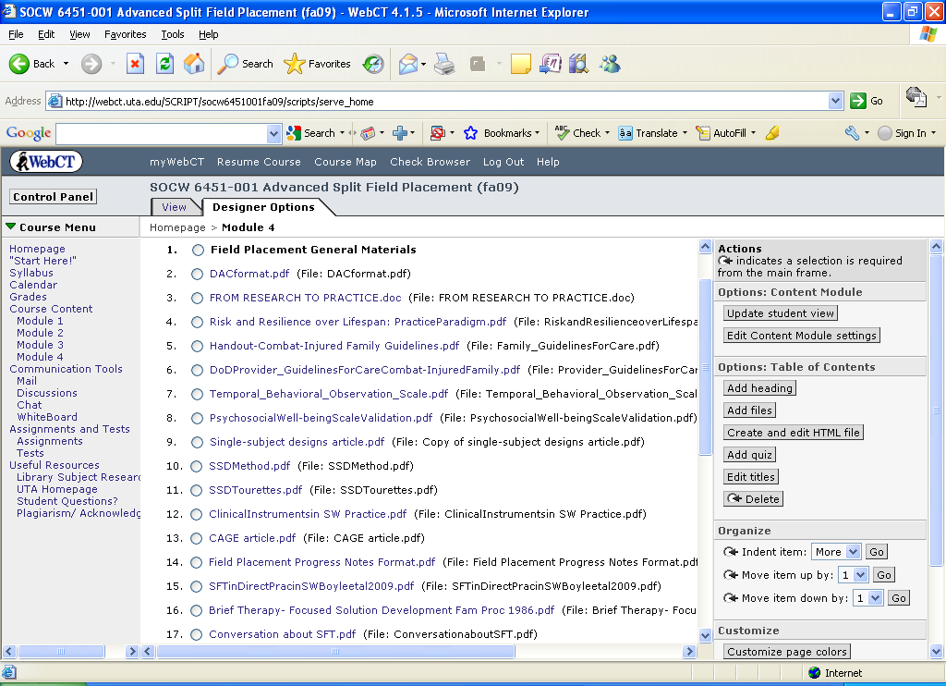

Table 3
Sample Online Module for Hybrid Course
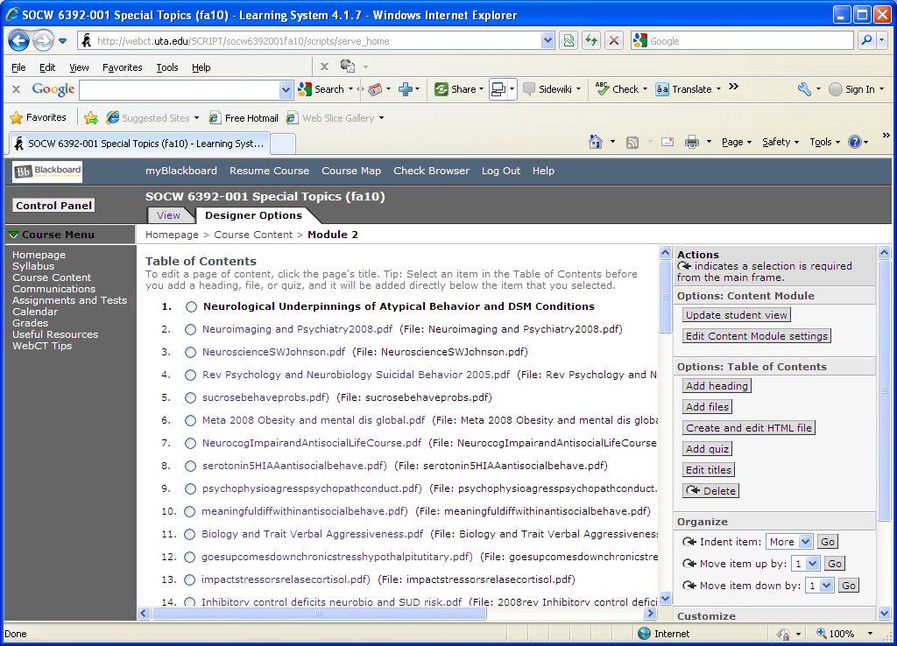

Table 4
Quantitative Results for Field Instruction and Tutorial Site
Most used segments Field 2007-2008 | # Hits
Manual:Creating Spending Plan Eval | 33
Manual: Introduction | 32
Manual: Evaluating Decisions Eval | 32
Article: Choose Get Keep Supported Educ. Model | 32
Manual: Creating Spending Plan Lesson | 30
Manual: Examples- Skills Programs | 29
Manual: Educational Skills Eval | 27
Manual: Evaluating Decisions Lesson | 26
Most used segments Field 2009 | # Hits
Soldiers PowerPoint Slide Show | 30
Project Procedures | 28
Pilot Project Grant Application | 26
EBP Practice Guidelines for PTSD Tx | 16
PTSD Manualized Tx Protocol | 13
Manual: Creating Spending Plan Eval | 8
Manual: Planning Daily Schedule Lesson | 8
Manual: Developing a Study Plan Lesson | 8
GI Bill article | 8
Harm reduction intervention article | 7

 | Student | Type |  | (N = 19)
WebCT  Utilization | BSW Field  (n = 1) | MSW Field:  Foundation  (n = 5) | MSW Field:  Advanced  ( n = 8) | Independent  Study MSW  (n = 2) | VA Field  MSW  (n = 3)
Avg. Use  Per Month Per Student | 133 | 41 | 117 | 92 | 5
Total Use | 795 | 1292 | 14975 | 738 | 42

