SPAN 5315
LITERATURA LATINOAMERICANA Y CARIBEÑA CONTEMPORÁNEA
PRIMAVERA 2014
______________________________________________________________________
Instructora: Dra. S. Watson
Oficina: Hammond Hall 322
Correo electrónico: swatson1@uta.edu
Perfil profesional: https://www.uta.edu/mentis/profile/?2009
Horas de oficina: martes y jueves 11-12; martes 4:30-5:00 (cuando no tenemos una clase virtual)
Sección: 5315-001 (28186)
Clase: martes 5:00-7:50 TH 119
______________________________________________________________________
Textos requeridos:
Course Packet (Eagle Business Center 1720 S. Cooper Street)
El reino de este mundo 1949 Alejo Carpentier
Summa poética Nicolás Guillén
Los cachorros Mario Vargas Llosa
Ariel Rodó
Caribe africano en despertar: versos del negro Blas III Blas Jiménez (edición bilingüe)
Sirena Selena: vestida de pena Mayra Santos Febres

En línea
Este curso se ofrecerá en línea cada otra semana. Todas las clases virtuales se realizarán en casa. Estas ponencias y actividades escritas están en BLACKBOARD, un paquete de software para la creación de cursos y sitios Web basados en el Internet.

Descripción del curso:
Este curso introduce a los estudiantes a la literatura latinoamericana y caribeña (poesía y prosa) de los siglos XX y XXI. Se analizan los textos tomando en cuenta la época histórica, los movimientos literarios y la región geográfica. A lo largo del semestre se desarrollarán actividades como análisis críticos de textos y discusiones en grupos para que los alumnos mejoren su conocimiento de la literatura y cultura latinoamericana.

Objetivos del curso (Student Learning Outcomes):
El objetivo de este curso es proveer al alumno/a con las herramientas de hacer un análisis crítico de un texto latinoamericano. Mientras que se da relevancia a la multiplicidad de perspectivas en la literatura de estas épocas, la lectura de los textos se enfoca en:
- la época histórica y como la retórica nacional afectó a la población negra
2) la construcción de la identidad (nacional, racial, y hasta cierto punto individual)
- las distinciones y la relación entre género y raza
Además hará lo siguiente a lo largo del curso:
- analizará la literatura hispánica y se familiarizará con el “canon” literario latinoamericano y los movimientos literarios correspondientes
- mejorará su capacidad de escribir y pensar críticamente
- mejorará su desempeño analítico

Evaluación:
Asistencia/Participación en clase 10%
Discusiones en línea 10%
Examen 1 25%
Examen 2 25%
Trabajo final 30%

Asistencia/Participación
La asistencia a clase es obligatoria. El/la alumno/a debe venir a clase preparada y lista para participar. Más de una ausencia representará una nota significativamente baja (10%).

Trabajo final
Cada alumno/a debe escribir un trabajo de 10-15 páginas sobre una obra literaria de América latina o el Caribe hispano. No se aceptan trabajos después del plazo indicado.
Fecha límite- 4 de mayo

Drop Policy:
The University has adopted a single drop date for all undergraduate students. For Spring 2014, the last drop date is Friday, March 28, which occurs at the end of the tenth week of classes. As usual, students are allowed to drop until 5:00p.m. CST on that date. Undergraduate students who drop a course on or before the Last Drop Date will receive an automatic grade of “W” regardless of whether they have completed assignments or not. Students seeking to drop a course will be advised to speak with the instructor of record and then, if deemed appropriate, proceed to the Academic Advisor for their major (or designee) who will complete the drop in the MyMav system. A “W” will be placed on the student record automatically by MyMav when the drop is entered.

Americans with Disabilities Act (ADA)
The University of Texas at Arlington is on record as being committed to both the spirit and letter of federal equal opportunity legislation; reference Public Law 92-112-The Rehabilitation Act of 1973 as amended. With the passage of federal legislation entitled Americans with Disabilities Act (ADA), pursuant to section 504 of the Rehabilitation Act, there is renewed focus on providing this population with the same opportunities enjoyed by all citizens. As a faculty member, I am required by law to provide “reasonable accommodations” to students with disabilities, so as not to discriminate on the basis of that disability. Student responsibility primarily rests with informing faculty of their need for accommodation and in providing authorized documentation through designated administrative channels. Information regarding specific diagnostic criteria and policies for obtaining academic accommodations can be found at www.uta.edu/disability. Also, you may visit the Office for Students with Disabilities in room 102 of University Hall or call them at (817) 272-3364.

Academic Integrity
All students enrolled in this course are expected to adhere to the UT Arlington Honor Code:
I pledge, on my honor, to uphold UT Arlington’s tradition of academic integrity, a tradition that values hard work and honest effort in the pursuit of academic excellence. I promise that I will submit only work that I personally create or contribute to group collaborations, and I
will appropriately reference any work from other sources. I will follow the highest standards of integrity and uphold the spirit of the Honor Code.
Instructors may employ the Honor Code as they see fit in their courses, including (but not limited to) having students acknowledge the honor code as part of an examination or requiring students to incorporate the honor code into any work submitted. Per UT System Regents’ Rule 50101, §2.2, suspected violations of university’s standards for academic integrity (including the Honor Code) will be referred to the Office of Student Conduct. Violators will be disciplined in accordance with University policy, which may result in the student’s suspension or expulsion from the University.
*The submission for credit of work attributable to a computer program, such as electronic or Internet translators is also academic dishonesty.

Student Support Services Available
The University of Texas at Arlington supports a variety of student success programs to help you connect with the University and achieve academic success. These programs include learning assistance, developmental education, advising and mentoring, admission and transition, and federally funded programs. Students who require assistance academically, personally, or socially should contact the Office of Student Success Programs at 817-272-6107 for more information and appropriate referrals.
Electronic Communication Policy: The University of Texas at Arlington has adopted the University “MavMail” address as the sole official means of communication with students. MavMail is used to remind students of important deadlines, advertise events and activities, and permit the University to conduct official transactions exclusively by electronic means. For example, important information concerning registration, financial aid, payment of bills, and graduation are now sent to students through the MavMail system. All students are assigned a MavMail account. Students are responsible for checking their MavMail regularly. Information about activating and using MavMail is available at http://www.uta.edu/oit/email/. There is no additional charge to students for using this account, and it remains active even after they graduate from UT Arlington.

Student Feedback Survey: At the end of each term, students enrolled in classes categorized as lecture, seminar, or laboratory will be asked to complete an online Student Feedback Survey (SFS) about the course and how it was taught. Instructions on how to access the SFS system will be sent directly to students through MavMail approximately 10 days before the end of the term. UT Arlington’s effort to solicit, gather, tabulate, and publish student feedback data is required by state law; student participation in the SFS program is voluntary.

Final Review Week: A period of five class days prior to the first day of final examinations in the long sessions shall be designated as Final Review Week. The purpose of this week is to allow students sufficient time to prepare for final examinations. During this week, there shall be no scheduled activities such as required field trips or performances; and no instructor shall assign any themes, research problems or exercises of similar scope that have a completion date during or following this week unless specified in the class syllabus. During Final Review Week, an instructor shall not give any examinations constituting 10% or more of the final grade, except makeup tests and laboratory examinations. In addition, no instructor shall give any portion of the final examination during Final Review Week. During this week, classes are held as scheduled. In addition, instructors are not required to limit content to topics that have been previously covered; they may introduce new concepts as appropriate.

Emergency Exit Procedures: Should we experience an emergency event that requires us to vacate the building, students should exit the room and move toward the nearest exit. Upon leaving the classroom, exit left through the double doors and then exit immediately to your left or right outside. When exiting the building during an emergency, one should never take an elevator but should use the stairwells. Faculty members and instructional staff will assist students in selecting the safest route for evacuation and will make arrangements to assist handicapped individuals.

PROGRAMA DE CLASE
14 de enero
Lecturas:
Ariel de Rodó
“Nuestra América”; “A Roosevelt” (lecturas suplementarias)

21 de enero CLASE VIRTUAL
Lecturas:
Roy-Féquière, Magali. “Speaking for and Speaking With: The Limits of Negrismo’s Cultural Discourse”
Manuel del Cabral 1907-1999 (la República Dominicana)
“Negro con pala en la tierra,”“Aire negro,” “Islas de azúcar amarga”
Luis Palés Matos (Puerto Rico), (Selecciones de Tuntún de pasa y grifería: “Pueblo negro,” “Majestad negra,” “Danza negra” y “Mulata-Antilla”)
Luis Palés Matos (Prosa): “Pueblo de negros,” “Hablando con don Luis Palés Matos,” “Hacia una poesía antillana”

28 de enero
Lectura: LO REAL MARAVILLOSO y Alejo Carpentier (Cuba) El reino de este mundo 1949

4 de febrero CLASE VIRTUAL
Lecturas: Julia de Burgos (Puerto Rico)
“Ay, ay, ay de la grifa negra”
Carmen Colón Pellot (Puerto Rico)
“Motivos de envidia mulata,” “Canto a la raza mulata”y ”¡Ay, señor, que yo quiero ser blanca!”

Artículos: Williams, Claudette. “’Oh Lord, I Want to be White’: The Ambivalence of Mulatez in Carmen Colón Pellot’s Ambar mulato.” Watson, Sonja Stephenson.“'Double Bind/ Double Consciousness' in the Poetry of Carmen Colón Pellot and Julia de Burgos”; Springfield, Consuelo López. “I am the Life, the Strength, the Woman: Feminism in Julia de Burgos’ Autobiographical Poetry.”

11 de febrero
Nicolás Guillén Summa poética.
Animan, Clément. “El sujeto cultural negro y su ‘alter ego’ identitario en ‘Balada de los dos abuelos’ de Nicolás Guillén.”
Smart, Ian. “The Central Creative Conflict, Mulatez.”

18 de febrero CLASE VIRTUAL
Nancy Morejón Poesía selecta (Course Packet); Williams, Claudette. “Rewriting the History of the Afro-Cuban Woman: Nancy Morejón’s ‘Mujer negra’”

25 de febrero
Examen #1 (take-home)

4 de marzo CLASE VIRTUAL
EL BOOM; Los cachorros Mario Vargas Llosa

18 de marzo
Lecturas: Blas Jiménez (la República Dominicana) Caribe africano en despertar: versos del negro Blas III
Tillis,Antonio.“Awakening the Caribbean African: The Socio-Political Poetics of Blas Jiménez.”

25 de marzo CLASE VIRTUAL
Quince Duncan (Costa Rica)
Lecturas: Los cuatro espejos (1973)
"Invisibility, Double Consciousness and the Crisis of Identity"

1 de abril
Carlos Wilson (Panamá)
Lecturas: Chombo 1981
Watson, Sonja Stephenson. “Are Panamanians of Caribbean Ancestry an Endangered Species? Critical Literary Debates on Panamanian Blackness in the Works of Carlos Wilson,
Gerardo Maloney, and Carlos Russell.”
Entregar la introducción del trabajo final con bibliografía

8 de abril CLASE VIRTUAL
CUENTOS. (Course packet) Horacio Quiroga. “El hombre muerto”; Juan Rulfo.“No oyes ladrar los perros”; Julio Cortázar. “La noche boca arriba”; Rosario Ferré. “La muñeca menor”; Elena Garro. “La culpa es de los Tlaxcaltecas”

15 de abril
Examen #2 (en clase)
22 de abril CLASE VIRTUAL
Lecturas: Sirena Selena
"Sirena Selena vestida de pena: economía, identidad y poder" y "Los caminos torcidos en Sirena Selena vestida de pena."

29 de abril
Lecturas: Sirena Selena
"Sirena Selena vestida de pena: economía, identidad y poder" y "Los caminos torcidos en Sirena Selena vestida de pena."
TRABAJO FINAL 4 DE MAYO ENTREGAR POR BLACKBOARD

SPAN 5315
LITERATURA LATINOAMERICANA Y CARIBEÑA CONTEMPORÁNEA

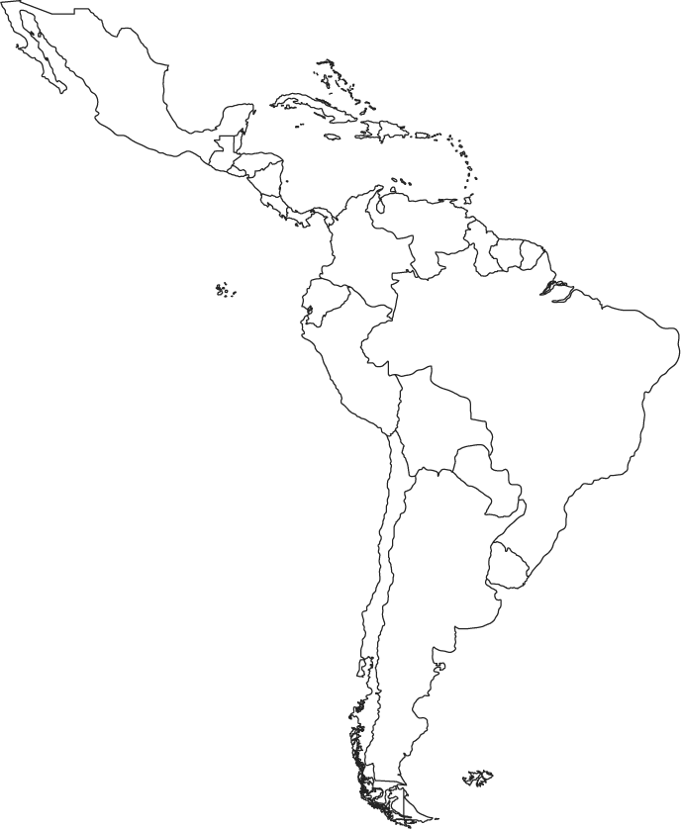

DRA. WATSON

