NURS 5362 – 401 Nursing Education Practicum
Semester: ____Spring 2014_______

Instructor: Wendy Barr, PhD

Office Number: Pickard Hall, RM 512A

Telephone Number:

Email Address: barr@uta.edu

Office Hours: By appointment

Section Information: N5362-401

Time and Place of Class Meetings:

Course Description:
Preceptorship in selected health care sites with opportunities to apply clinical and educational
knowledge, skills, and concepts in a guided, progressive context of nursing education.

Course Topics:
Individual topics relevant to practicum experience.
- Current issues impacting nursing education
- Reflective practice as a nurse educator
Others, as determined by request of students.

Prerequisites
N5301, 5302, 5308, 5309, 5315, 5418, 5327, 5328, 5329, 5360, 5361

Student Learning Outcomes:
Upon completion of the course, the student will be able to:

- Use evidence based knowledge to facilitate learning of selected student populations within a defined patient population.

- Use formative and summative evaluation to assess learning outcomes and modify teaching activities.

- Collaborate with faculty and staff to provide student learning experiences.

- Implement the educator role in selected settings.

Required Textbooks and Other Course Materials:
No required textbook.
[Type a quote from the document or the summary of an interesting point. You can position the text box anywhere in the document. Use the Text Box Tools tab to change the formatting of the pull quote text box.]
Texts and readings identified in collaboration with Instructor to meet specific learning objectives.
Webcam, smart phone, or other device to record and upload video.

Recommended Materials:
Billings, D. & Halstead, J. (2012). Teaching in Nursing: A Guide for Faculty, Fourth Edition. Saunders, ISBN: 9781455705511.

Penn, B.K. (2008). Mastering the teaching role: A guide for nurse educators. F.A. Davis Company.
ISBN: 9780803618237.

Utley, R. (2011). Theory and research for academic nurse educators: Application to practice. Jones and Bartlett Publishers. ISBN: 9780763774134.

Graduate Student Handbook. Students are responsible for knowing and complying with all policies and information contained in the Graduate Student handbook online at: http://www.uta.edu/nursing/msn/msn-students

The Publication Manual of the American Psychological Association (APA) Sixth Edition, for preparation of papers. ISBN: 9781433805615

Major Course Requirements:
1. Role enactment of selected faculty responsibilities
a) Teaching in the clinical and classroom settings (77% of grade)
- 15 hours to include seminar, journaling and class/clinical preparation time
- 120 hours of clinical experiences
- Clinical journal (8% of grade)
- Submission 5 minute video clip of teaching in practicum during specific weeks during the course. (10% of grade,week10)
- Plan for clinical submitted week 1 (2% of grade)
2. Self-assessment of current skills and competencies to NLN Educator Core Competencies at the beginning and end of the semester. (2% of grade)
4. Preceptor evaluation 1% of grade

Writing Guidelines
The APA Publication Manual is the guide used in the College of Nursing. It is expected that all writing will be completed using the style and format described in the APA Publication Manual.
- The Basics of APA Style at http://www.apastyle.org/learn/tutorials/basics-tutorial.aspx
- Harvard Graduate School of Education at http://gseacademic.harvard.edu/~instruct/articulate/APA/player.html
- The Ohio State University: How do I cite resources at http://library.osu.edu/sites/guides/apagd.php
- Purdue Online Writing Lab at http://owl.english.purdue.edu/owl/resource/560/01/
Students in the MSN program are expected to purchase a copy of the most recent Publication Manual of the American Psychological Association. APA style manual will be used by the UTACON with some specific requirements for graduate courses. http://www.uta.edu/nursing/APAFormat.pdf.
Save copies of all of your work! Create a folder on your computer that is specifically for this course. As you create a new Word document for each assignment, save it in your course folder, and then submit it by the due date.

Please note: Wikipedia is not an acceptable reference for journals.

Teaching Methods/Strategies:
Faculty/student seminars, responses to electronic communication, practicum experiences tailored to personal learning plan.

Grading Policy:
As a seminar/practicum, the instructor will evaluate student performance as pass or fail. Passing performance includes completion of clinical experiences with indication of reflection, synthesis of existing knowledge, and self-assessment and completion of all course assignments.

Attendance Policy: Regular participation is expected of all students. Students are responsible for all missed course information.

Drop Policy: Students may drop or swap (adding and dropping a class concurrently) classes through self-service in MyMav from the beginning of the registration period through the late registration period. After the late registration period, students must see their academic advisor to drop a class or withdraw. Undeclared students must see an advisor in the University Advising Center. Drops can continue through a point two-thirds of the way through the term or session. It is the student's responsibility to officially withdraw if they do not plan to attend after registering. Students will not be automatically dropped for non-attendance. Repayment of certain types of financial aid administered through the University may be required as the result of dropping classes or withdrawing. Contact the Financial Aid Office for more information.

Graduate students who wish to change a schedule by either dropping or adding a course must first consult with their Graduate Advisor. Regulations pertaining to adding or dropping courses are described below. Adds and drops may be made through late registration either on the Web at MyMav or in person through the student’s academic department. Drops can continue through a point two-thirds of the way through the term or session. It is the student's responsibility to officially withdraw if they do not plan to attend after registering. Students will not be automatically dropped for non-attendance. Repayment of certain types of financial aid administered through the University may be required as the result of dropping classes or withdrawing. Contact the Financial Aid Office for more information. The last day to drop a course is listed in the Academic Calendar available at http://www.uta.edu/uta/acadcal.
- A student may not add a course after the end of late registration.
- A student dropping a graduate course after the Census Date but on or before the end of the 10th week of class may with the agreement of the instructor, receive a grade of W but only if passing the course with a C or better average. A grade of W will not be given if the student does not have at least a C average. In such instances, the student will receive a grade of F if he or she withdraws from the class. Students dropping a course must: (1) complete a Course Drop Form (available online http://www.uta.edu/nursing/MSN/drop_resign_request.pdf or Graduate Nursing office rooms 512 or 606); (2) obtain faculty signature and current course grade; and (3) submit the form to Graduate Nursing office rooms 512 or 606.
- A student desiring to drop all courses in which he or she is enrolled is reminded that such action constitutes withdrawal (resignation) from the University. The student must indicate intention to withdraw and drop all courses by completing a resignation form in the Office of the Registrar or by: (1) Completing a resignation form (available online http://www.uta.edu/nursing/MSN/drop_resign_request.pdf or Graduate Nursing office rooms 512 or 606; (2) obtaining faculty signature for each course enrolled and current course grade; (3) Submitting the resignation form in the College of Nursing office room 512 or 606; and (4) The department office will send resignation form to the office of the Registrar.
- In most cases, a student may not drop a graduate course or withdraw (resign) from the University after the 10th week of class. Under extreme circumstances, the Dean of Graduate Studies may consider a petition to withdraw (resign) from the University after the 10th week of class, but in no case may a graduate student selectively drop a course after the 10th week and remain enrolled in any other course. Students should use the special Petition to Withdraw for this purpose. See the section titled Withdrawal (Resignation) From the University for additional information concerning withdrawal. http://www.grad.uta.edu/handbook
Last Day to Drop or Withdraw: April 4, 2014

Americans with Disabilities Act: The University of Texas at Arlington is on record as being committed to both the spirit and letter of all federal equal opportunity legislation, including the Americans with Disabilities Act (ADA). All instructors at UT Arlington are required by law to provide "reasonable accommodations" to students with disabilities, so as not to discriminate on the basis of that disability. Any student requiring an accommodation for this course must provide the instructor with official documentation in the form of a letter certified by the staff in the Office for Students with Disabilities, University Hall 102. Only those students who have officially documented a need for an accommodation will have their request honored. Information regarding diagnostic criteria and policies for obtaining disability-based academic accommodations can be found at www.uta.edu/disability or by calling the Office for Students with Disabilities at (817) 272-3364.

Academic Integrity: It is the philosophy of The University of Texas at Arlington that academic dishonesty is a completely unacceptable mode of conduct and will not be tolerated in any form. All persons involved in academic dishonesty will be disciplined in accordance with University regulations and procedures. Discipline may include suspension or expulsion from the University. According to the UT System Regents’ Rule 50101, §2.2, "Scholastic dishonesty includes but is not limited to cheating, plagiarism, collusion, the submission for credit of any work or materials that are attributable in whole or in part to another person, taking an examination for another person, any act designed to give unfair advantage to a student or the attempt to commit such acts." As a licensed registered nurse, graduate students are expected to demonstrate professional conduct as set forth in the Texas Board of Nursing rule §215.8. in the event that a graduate student holding an RN license is found to have engaged in academic dishonesty, the college may report the nurse to the Texas BON using rule §215.8 as a guide.

Plagiarism: Copying another student’s paper or any portion of it is plagiarism. Copying a portion of
published material (e.g., books or journals) without adequately documenting the source is plagiarism.
Consistent with APA format, if five or more words in sequence are taken from a source, those words must be placed in quotes and the source referenced with author’s name, date of publication, and page number of publication. If the author’s ideas are rephrased, by transposing words or expressing the same idea using different words, the idea must be attributed to the author by proper referencing giving the author’s name and date of publication. If a single author’s ideas are discussed in more than one paragraph, the author must be referenced, according to APA format. Authors whose words or ideas have been used in the preparation of a paper must be listed in the references cited at the end of the paper. Students are expected to review the plagiarism module from the UT Arlington Central Library via http://library.uta.edu/tutorials/Plagiarism

Student Support Services Available: The University of Texas at Arlington provides a variety of resources and programs designed to help students develop academic skills, deal with personal situations, and better understand concepts and information related to their courses. These resources include tutoring, major-based learning centers, developmental education, advising and mentoring, personal counseling, and federally funded programs. For individualized referrals to resources for any reason, students may contact the Maverick Resource Hotline at 817-272-6107 or visit www.uta.edu/resources for more information.

Electronic Communication Policy: The University of Texas at Arlington has adopted the University “MavMail” address as the sole official means of communication with students. MavMail is used to remind students of important deadlines, advertise events and activities, and permit the University to conduct official transactions exclusively by electronic means. For example, important information concerning registration, financial aid, payment of bills, and graduation are now sent to students through the MavMail system. All students are assigned a MavMail account. Students are responsible for checking their MavMail regularly. Information about activating and using MavMail is available at http://www.uta.edu/oit/email/. There is no additional charge to students for using this account, and it remains active even after they graduate from UT Arlington.

To obtain your NetID or for logon assistance, visit https://webapps.uta.edu/oit/selfservice/. If you are unable to resolve your issue from the Self-Service website, contact the Helpdesk at helpdesk@uta.edu.

Research Information on Nursing:
http://libguides.uta.edu/nursing

College of Nursing additional information:

Student Requirement for Preceptor Agreements/Packets:
- All Preceptor Agreements must be signed by the first day the student attends clinical (may be signed on that day).
- Student is responsible to ensure that all of his/her preceptor agreements are signed before beginning clinical experience and those agreements are given to Felicia Chamberlain (with a copy to Dr. Barr) by the second week of the semester.
- Felicia Chamberlain or designated support staff will enter the agreement date into Partners database. The Agreement Date” field in Partners is the date that the preceptor signed the Agreement. If this is the first time a preceptor is precepting a graduate nursing student for The University of Texas at Arlington, please have him/her complete the Preceptor Biographical Data Sheet and submit it with his/her Curriculum Vitae.
- The signed preceptor agreement is part of the clinical clearance process. Failure to submit it in a timely fashion may result in clinical failure.

Status of RN Licensure: All graduate nursing students must have an unencumbered license as designated by the Texas Board of Nursing (BON) to participate in graduate clinical nursing courses. It is also imperative that any student whose license becomes encumbered by the BON must immediately notify their Associate Dean for the MSN Program, Department of Advanced Practicum Dr. Gray/Dr. Schira. The complete policy about encumbered licenses is available online at: www.bon.state.tx.us

MSN Graduate Student Dress Code: Policy: The University of Texas at Arlington College of Nursing expects students to reflect professionalism and maintain high standards of appearance and grooming in the clinical setting. Clinical faculty has final judgment on the appropriateness of student attire and corrective action for dress code infractions.
Students not complying with this policy will not be allowed to participate in clinical.

Please View the College of Nursing Student Dress Code on the nursing website: www.uta.edu/nursing.

UTA Student Identification: MSN Students MUST be clearly identified as UTA Graduate Students and wear a UTA College of Nursing ID in the clinical environment.

Unsafe Clinical Behaviors: Students deemed unsafe or incompetent will fail the course and receive a course grade of “F”. Any of the following behaviors constitute a clinical failure:

1. Fails to follow standards of professional practice as detailed by the Texas Nursing Practice Act * (available at www.bon.state.tx.us)
2. Unable to accept and/or act on constructive feedback.
3. Needs continuous, specific, and detailed supervision for the expected course performance.
4. Unable to implement advanced clinical behaviors required by the course.
5. Fails to complete required clinical assignments.
6. Falsifies clinical hours.
7. Violates student confidentiality agreement.

*Students should also be aware that violation of the Nursing Practice Act is a “reportable offense” to the Texas Board of Nursing.

Blood and Body Fluids Exposure: A Health Verification form was signed by all MSN students at start of the program documenting personal health insurance coverage. All MSN students have mandatory health insurance and will need to manage exposure to blood and fluids. Current CDC guidelines can be found at: http://www.cdc.gov/

Confidentiality Agreement: You signed a Confidentiality Form in orientation and were provided a copy of the form. Please take your copy of this Confidentiality Form with you to your clinical sites. Please do not sign other agency confidentiality forms. Contact your faculty if the agency requires you to sign their confidentiality form.

Graduate Student Handbook: Students are responsible for knowing and complying with all policies and information contained in the Graduate Student handbook online at: http://www.uta.edu/nursing/handbook/toc.php

Student Code of Ethics: The University of Texas at Arlington College of nursing supports the Student Code of Ethics Policy. Students are responsible for knowing and complying with the Code. The Code can be found in the student handbook online: http://www.uta.edu/nursing/handbook/toc.php

No Gift Policy: In accordance with Regent Rules and Regulations and the UTA Standards of Conduct, the College of Nursing has a “no gift” policy. A donation to one of the UTA College of Nursing Scholarship Funds, found at the following link: http://www.uta.edu/nursing/scholarship_list.php would be an appropriate way to recognize a faculty member’s contribution to your learning. For information regarding Scholarship Funds, please contact the Dean’s office.

Course Evaluation: Course evaluation is a continuous process and is the responsibility of both the faculty and the students. Ongoing feedback (formative evaluation) is the only way to improve the course and to assure that it meets your needs and those of the discipline of nursing. It is your responsibility to give immediate, constructive feedback regarding class structure and process.

Formal evaluation of the course and the instructor occurs at the end of the course. You will receive instructions at your University of Texas at Arlington e-mail address about how to complete the course evaluations online. Your ratings and comments are sent to a computer not connected to the College of Nursing, and faculty members do not receive the results until after they have turned in course grades.

Bomb Threats: If anyone is tempted to call in a bomb threat, be aware that UTA will attempt to trace the phone call and prosecute all responsible parties. Every effort will be made to avoid cancellation of presentations/tests caused by bomb threats. Unannounced alternate sites will be available for these classes. Your instructor will make you aware of alternate class sites in the event that your classroom is not available.

Online Conduct: The discussion board should be viewed as a public and professional forum for course-related discussions. Students are free to discuss academic matters and consult one another regarding academic resources. The tone of postings should be professional in nature.
It is not appropriate to post statements of a personal or political nature, or statements criticizing classmates or faculty. Inappropriate statements/language will be deleted by the course faculty and may result in denied access to the Discussion boards. Refer to UTACON Student Handbook for more information.

For this course Blackboard communication tools, discussion boards, and UTA MAV email will be used extensively and should be checked often.

Departmental Office/Support Staff
Department of MSN Administration, Education, and PhD Programs

Jennifer Gray, RN, PhD
Associate Dean and Chair, Graduate Advisor
Email: jgray@uta.edu

Vivian Lail-Davis, Administrative Assistant II
Office # 512-Pickard Hall, (817)-272-1038
Email: vivian@uta.edu

Felicia Chamberlain, Coordinator
Office # 515- Pickard Hall (817)-272-0659
Email: chamberl@uta.edu

Suzanne Despres, AP Program, Assistant Graduate Advisor
Office # 512A- Pickard Hall (817)-272-1039
Email: sdepres@uta.edu

Nursing 5362
Course Schedule
.
Week | Clinical Activities | Course Assignments
Before Semester Begins | Collaborate with Mrs. Lindley to discuss the types of experiences you need to meet your learning objectives.  Meet requirements of academic institution to obtain desired experiences (might include clinical agreements, seeking approval of dean or department chair at home university of preceptor).
Week 1 -week of 2/24 | Meet with Clinical Preceptor  Share learning objectives with preceptor. | Submit initial self-evaluation using NLN educator competencies DUE FRI 2/28 at 5pm  Submit 1 page summary of your projected clinical activities (with time frame) for the semester DUE Fri 2/28/14
Week 2 - 3/3 | Maintain record of clinical experiences. | Submit weekly journal
Week 3 3/10 | Maintain record of clinical experiences. | Submit weekly journal
Week 4 - 3/17 | Maintain record of clinical experiences. | Submit weekly journal
Week 5 - 3/24 | Maintain record of clinical experiences. | Submit weekly journal
BREAK - 3/31
Week 6 - 4/7 | Maintain record of clinical experiences. | Submit weekly journal
Week 7 -4/14 | Maintain record of clinical experiences. | Submit weekly journal
Week 8 - 4/21 | Maintain record of clinical experiences. | Submit weekly journal
Week 9 - 4/28 | Maintain record of clinical experiences. | 1.Submit weekly journal  2. Video submission
Week 10 - 5/5 | End of semester conference | - Submit preceptor evaluation of student.  - Submit final self-evaluation using NLN educator competencies  - Submit student evaluation of preceptor  - Submit clinical log  - Complete course completion survey  - Meet with lead teacher

NLN Tool for Self-Evaluation of Academic Role

Name ___ _____________________________ Date___

Nurse Educator Competencies | Self Rating |  |  |  |  | Rationale
 | 1 | 2 | 3 | 4 | 5
 | Low | Some | Beginning | More | Expert
Competency 1 – Facilitate Learning
Nurse educators are responsible for creating an environment in classroom, laboratory, and clinical settings that facilitates student learning and the achievement of desired cognitive, affective, and psychomotor outcomes.

Competency 2 – Facilitate Learner Development and Socialization
Nurse educators recognize their responsibility for helping students develop as nurses and integrate the values and behaviors expected of those who fulfill that role.

Competency 3 – Use Assessment and Evaluation Strategies
Nurse educators use a variety of strategies to assess and evaluate student learning in classroom, laboratory and clinical settings, as well as in all domains of learning.

Competency 4 – Participate in Curriculum Design and Evaluation of Program Outcomes
Nurse educators are responsible for formulating program outcomes and designing curricula that reflect contemporary health care trends and prepare graduates to function effectively in the health care environment.
Competency 5 - Function as a Change Agent and Leader
Nurse educators function as change agents and leaders to create a preferred future for nursing education and nursing practice.

Competency 6 - Pursue Continuous Quality Improvement in the Nurse Educator Role
Nurse educators recognize that their role is multidimensional and that an ongoing commitment to develop and maintain competence in the role is essential.

Competency 7 – Engage in Scholarship
Nurse educators acknowledge that scholarship is an integral component of the faculty role, and that teaching itself is a scholarly activity.

Competency 8 – Function within the Educational Environment
Nurse educators are knowledgeable about the educational environment within which they practice and recognize how political, institutional, social and economic forces impact their role.

Summary
Reference

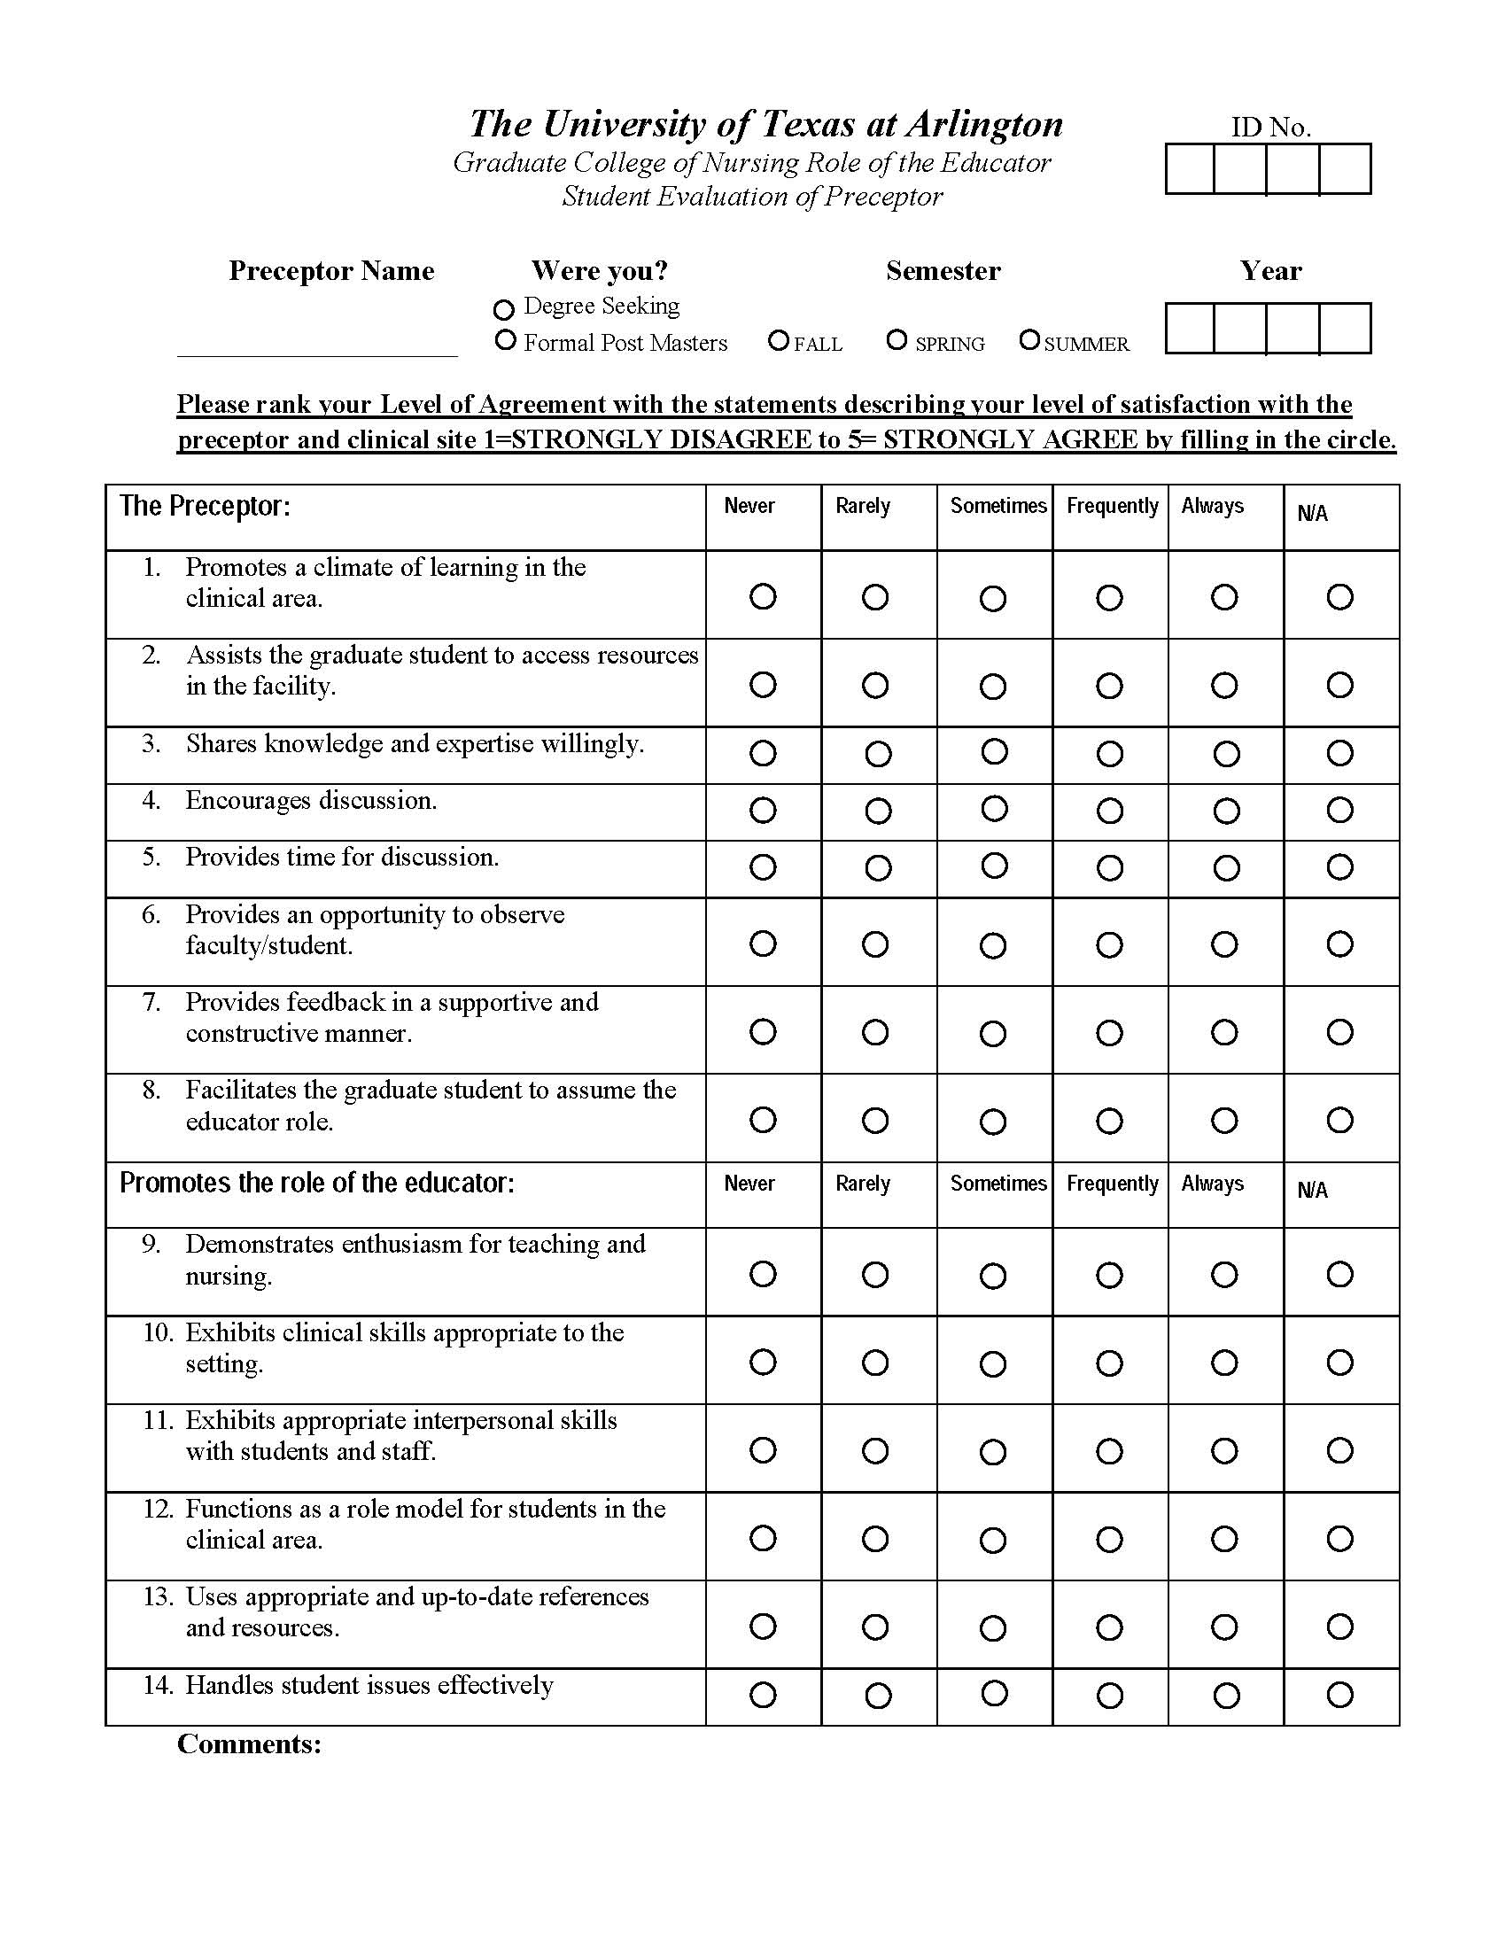

PRECEPTOR EVALUATION OF STUDENT IN EDUCATOR ROLE

Student Name ___ _____________________________ Semester______________

Nurse Educator Competencies | Self Rating |  |  |  |  | Rationale
 | 1 | 2 | 3 | 4 | 5
 | Low | Some | Beginning | More | Expert
Competency 1 – Facilitate Learning
Nurse educators are responsible for creating an environment in classroom, laboratory, and clinical settings that facilitates student learning and the achievement of desired cognitive, affective, and psychomotor outcomes.

Competency 2 – Facilitate Learner Development and Socialization
Nurse educators recognize their responsibility for helping students develop as nurses and integrate the values and behaviors expected of those who fulfill that role.

Competency 3 – Use Assessment and Evaluation Strategies
Nurse educators use a variety of strategies to assess and evaluate student learning in classroom, laboratory and clinical settings, as well as in all domains of learning.

Competency 4 – Participate in Curriculum Design and Evaluation of Program Outcomes
Nurse educators are responsible for formulating program outcomes and designing curricula that reflect contemporary health care trends and prepare graduates to function effectively in the health care environment.
Competency 5 - Function as a Change Agent and Leader
Nurse educators function as change agents and leaders to create a preferred future for nursing education and nursing practice.

Competency 6 - Pursue Continuous Quality Improvement in the Nurse Educator Role
Nurse educators recognize that their role is multidimensional and that an ongoing commitment to develop and maintain competence in the role is essential.

Competency 7 – Engage in Scholarship
Nurse educators acknowledge that scholarship is an integral component of the faculty role, and that teaching itself is a scholarly activity.

Competency 8 – Function within the Educational Environment
Nurse educators are knowledgeable about the educational environment within which they practice and recognize how political, institutional, social and economic forces impact their role.

Preceptor Name_______________________________
Preceptor Singature____________________________
Date_______________________

