Dr. Stacy Alaimo

Fall 2015 TR 11-12:20

ENGL 3366: Topics in Literature and Environment:

Environmental Film, Literature, Theory

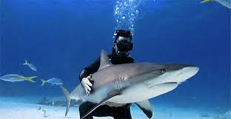

Join us!

English 3366: Topics in Literature and Environment: Film and Theory

Tuesday/Thursday 11-12:20.

This course counts for the English major, the Environmental and Sustainability Studies minor, the Environment concentration in the English major and the Theory concentration in the English major.

We will watch and discuss a wide range of films about environmentalism, environmental justice, and animal studies, ranging from animation (anime), science fiction, documentary, dramas, and activist films. We will also read environmental and animal studies theory and criticism.

This lively, discussion-oriented class will introduce how to analyze and interpret films, as it introduces major concepts in environmental studies and sustainability. For the final project, students will have a choice between writing a research paper, doing a service-learning project, or creating a digital media project or short video.

[NOTE: I was assigned this course very recently, so I am still constructing the actual syllabus. Please stay posted. I will upload the syllabus as soon as it is completed.]

If there is a film or topic you would really like to see included in the course, feel free to email me: alaimo@uta.edu. More information about my classes and teaching can be found at: http://www.uta.edu/english/alaimo/teaching.html and http://www.uta.edu/english/alaimo/For%20Undergrads.html

