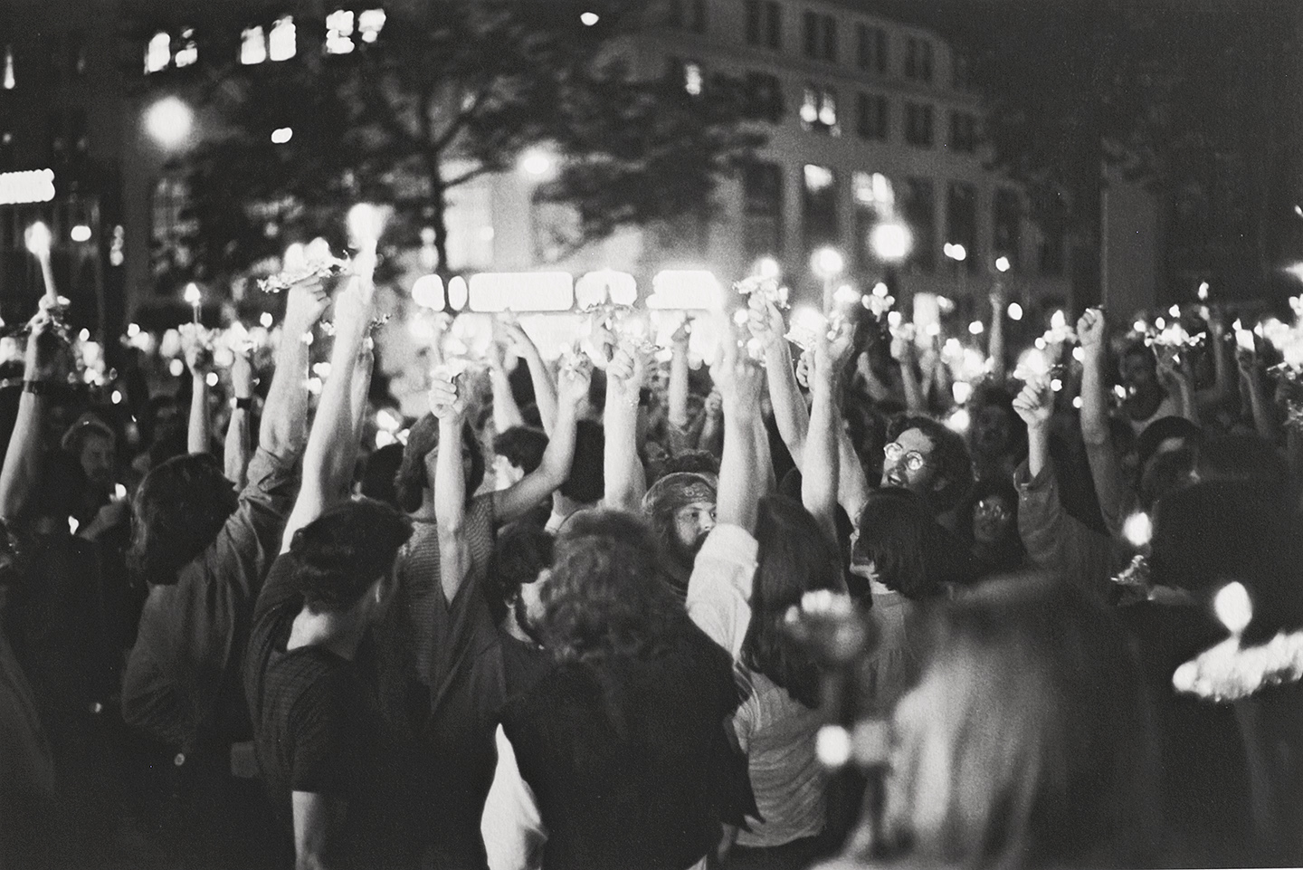Objectives specific to this section:
ENGLISH 2303.005 LGBT LITERATURE
Spring 2016 University Hall 25 MW 4-5:20 pm
Dr. Wayne Gay Office: Preston Hall 201
Contact: wgay@uta.edu Office Hours: 3-4 pm MW
& by appointment

General course objectives:

This course satisfies the University of Texas at Arlington core curriculum requirements in Language, Philosophy, and Culture. The required objectives of these courses are the development of students’ critical thinking, communication skills, personal responsibility, and social responsibility. Many elements of this course foster development of these objectives, which are explicitly addressed in the “Signature Assignment” (see below). The departmental guidelines for sophomore literature can be found by typing “sophomore literature” in the “Search UT Arlington” box on the University website: http://www.uta.edu/uta.

We are everywhere . . .

Obviously, this section of English 2303 will deal specifically with selections from the rich and varied literature dealing with the homosexual experience as well as the experience of transcending gender. The principal method of approaching this literature will be “reader response,” based on the philosophy that the reader is the most important element in a work of literature—without whom, indeed, the work of literature does not exist.

We will explore material ranging from works written in cultures in which same-gender love was taken for granted to works written in extraordinarily oppressive communities (such as the United States before 1970), as well as works of literature in which the expression of same-gender love as well as transcendence of gender roles is ambivalent or even unconscious on the part of the author.

REQUIRED TEXTS AND MATERIALS

Because a good deal of the material for this course will be posted for downloading, and because taking notes during discussion is a good idea, students are urged to acquire a three-ringed binder with space for storage of printouts and paper for note-taking.

Students should arrange to own or rent ALL of the following texts ASAP. Electronic copies are acceptable when available. All of these texts are available at the university bookstore, as well as various other sources, including Amazon and Barnes & Noble online. Be aware that the university bookstore withdraws these texts from its stock fairly early in the semester.

Bechdel, Alyson. Fun Home. New York: Mariner, 2007.
• ISBN-10: 0618871713 • ISBN-13: 978-0618871711

Carson, Anne, ed. and trans. If Not, Winter: Fragments of Sappho. New York: Vintage, 2005.
• ISBN-10: 0375724516 • ISBN-13: 978-0375724510

Edwards, Dylan. Transposes. Seattle: Northwest Press, 2012.
• ISBN-10: 0984594086 • ISBN-13: 978-0984594085

Hartland, Claude. The Story of a Life. Foreword by C.A. Tripp. Fredonia Books, 2005.
• ISBN-10: 1410108716 • ISBN-13: 978-1410108715

Highsmith, Patricia. The Price of Salt. New York: W.W. Norton, 2008.
• ISBN-10: 9780393332148 • ISBN-13: 978-0393332148

Holleran, Andrew. Dancer from the Dance. New York: Harper Perennial, 2001.
• ISBN-10: 0060937068 • ISBN-13: 978-0060937065

COURSE POLICIES AND GRADING

The bulk of the work outside of the class sessions in this course will consist of writing short responses to the reading assignments before those assignments are discussed in class. Each student will submit, on Blackboard, by noon on the Saturday preceding most weeks of classes, a 300-word response to any portion of the week’s reading assignment. Those assignments will be graded on a pass-fail basis, without regard to grammar or punctuation. All papers in this course must be submitted electronically in a Microsoft word document. All students have access to Microsoft word via the university computer system.

Since this course includes elements of lecture and group discussion, attendance and participation in class is required. To that end, your level of attendance will directly affect your final grade, as noted below.

The course will also include two open-book essay exams (a mid-term and a final) written in class, and graded on a pass-fail basis. The written portion of the final exam will be administered primarily on Wednesday, April 20; the official final exam period, which will consist of a discussion period, at which ATTENDANCE IS MANDATORY, will take place on Wednesday, May 11, at 2-4:30 pm in the regular classroom space.

The course also requires a “Signature Assignment” paper written outside of class in proper MLA formatting. This is the one assignment in which grammar, punctuation, formatting, structure, and citation will be taken into consideration in evaluation and grading.

I. SHORT RESPONSES

Failure to turn in all 8 responses on time will result in a drop of the final grade, as follows:
1 or 2 responses missing: final grade drops to B or lower
3 or 4 responses missing: final grade drops to C or lower
5 or 6 responses missing: final grade drops to D or lower
7 responses missing: final grade will be an F

II. ATTENDANCE

Death of an immediate family member, attendance at officially-sanctioned University business, military service, and observance of a religious holiday are excused absences, all of which require documentation on the part of the student for the instructor.
Observance of a religious holiday should be documented WITHIN THE FIRST TWO WEEKS OF THE SEMESTER.
Illness, work assignments, car trouble, traffic, childcare issues, alarm clocks that didn’t go off, hangovers, job interviews, and falling in love over a cup of coffee ARE NOT EXCUSED ABSENCES. The student may take four unexcused absences, which is a generous allowance, without his or her grade falling. Do not take an unexcused absence frivolously; if you come down with the flu or have an important, life-changing event such as a job interview late in the semester, you will need your free unexcused absences!

Your final grade will fall as follows on the basis of attendance:
Five or six unexcused absences: final grade falls to a B or lower
Seven or eight unexcused absences: final grade falls to a C or lower
Nine or ten unexcused absences: final grade falls to a D or lower
Eleven or more unexcused absences: final grade of F

III. MIDTERM EXAM

Students should be prepared to bring a working laptop equipped with Microsoft word to class on Wednesday, Wednesday, March 9, as well as all notes and texts read so far for an open-book exam.. The exam will be graded on a pass-fail basis based on ideas; students who fail to write satisfactory essays totaling 750 words will fail the exam. Failure to complete the midterm exam satisfactorily will result in the final course grade being lowered by one letter. The exam will be graded on ideas. Punctuation, grammar, spelling, and sentence structure will not be taken into consideration in evaluation.

IV. FINAL EXAM

The final exam will consist of two portions: a written exam administered
on Wednesday, April 20, and a discussion section administered on Wednesday, May 11, at 2-4:30 pm . The written portion will follow exactly the same format as the written midterm exam, and will be graded on a pass-fail basis; failure to complete the written portion of the exam will result in dropping of the final grade by one full letter. Attendance at the final discussion portion of the exam is mandatory; failure to attend the discussion portion will result in lowering of the final course grade by one letter. DO NOT SCHEDULE PLANE TRIPS OR JOB INTERVIEWS to take place at 2-4:30 pm on Wednesday, May 11.

V. SIGNATURE ASSIGNMENT

The signature assignment is a short paper well within the capabilities of any
university student; the details are further outlined below. This is the one paper
in this course in which improper formatting, structure, and mechanics will result in a lowered final grade. (See “More About the Signature Assignment” below.) A good deal of attention will be given in class toward compliance with the requirements of this paper. Failure to comply with these instructions will result in lowering of the final course grade by one letter.

VI. PLAGIARISM POLICIES AND TUTORIAL

All students are required to participate in the UTA plagiarism tutorial; link and deadline for the tutorial will be announced early in the semester. Although there are many aspects of participation in this course, failure to complete and submit evidence of completion of the plagiarism tutorial will result in a grade of F for the course. Understanding the concept of plagiarism is fundamental to this course, in other coursework, and in your future career.

To summarize, plagiarism consists of willfully representing someone else’s work as your own. This includes presenting ideas without adequate documentation as well as allowing friends, acquaintances, or associates to do your work for you. University penalties for violation of plagiarism policy will be applied to short papers, exams, and the signature assignment.

A FINAL WORD ABOUT GRADES:

The alert student will observe that any student, even one who is not particularly talented in terms of academic literary criticism, can, by attending and participating regularly, by turning in all papers on time, and by complying with the instructions for the signature assignment, reasonably expect to earn a grade of A in this course. While making an A in a literature class should not be the core of your being, it can have profound effect on issues such as admission to graduate or professional school, the awarding of financial aid, or presenting an impressive GPA on initial job applications. University policy permits this instructor to award the grade of A to as many students as have earned it; nothing would make me happier than to be able to give an A to every student in this class. However, the grade of A is reserved for students who attend and participate regularly, who turn in all assignments on time, and who comply with the other very reasonable requirements of the course. Do not expect to turn in papers late, attend haphazardly, or fail to comply with the requirements of the Signature Assignment and receive an A in this course.

FOOD & ELECTRONIC DEVICES

Students who because of scheduling or medical reasons need to consume a small amount of food or water in the classroom should do so discretely, and should remove trash on leaving.

Recent studies have demonstrated that handwritten note-taking is considerably more effective as a learning tool than electronic note-taking. Because of this, and the tendency of some individuals to shop, communicate with friends, study for other classes, or engage in otherwise distracting activities, the use of electronic devices, including iPads, phones, or laptops, will not be permitted during regular classes. The exception is in the case of the midterm and final exam, and instances in which a student chooses to access an assigned reading electroinically.

PERSONAL ACCESSORIES POLICY: I reserve the right to prohibit from my classroom concealed or unconcealed guns, swords, hand grenades, rocket launchers, killer robots, flamethrowers, ninja equipment, and other deadly weapons. I assure you that you will not need any of these things here. I trust you to follow my no-weapon rule our of respect of your classmates’ physical and emotional well-being and mine. Anyone found “packing” will be required to leave the room and the course. The only non-fashion medical personal accessories you should bring with you to class are your books and handouts, syllabus, pen, pencil, paper, reasonable beverage of choice, and, when appropriate (see above), laptop or tablet. Concealed cell phones only, please.

COURSE SCHEDLUE

WEEK I: January 20

Wednesday: Introduction

WEEK II: January 25 & 27

Before class: Download and read “Introductory Readings” posted on Blackboard.

Monday and Wednesday: Continued Introduction

WEEK III: February 1 & 3

Before class: Read If Not, Winter (book) and the posted excerpt from Plato’s Symposium. Submit Response No. 1 on Blackboard before 12 noon on Saturday, January 30.

Monday and Wednesday: Discuss the assigned readings in class.

WEEK IV: February 8 & 10

Before class: Download and read short selections, group 1, posted on Blackboard.
Submit Response No. 2 on Blackboard before 12 noon on Saturday, February 6.

Monday and Wednesday: Discuss the assigned readings in class.

WEEK V: February 15 & 17

Before class: Download and read short selections, group 2, posted on Blackboard.
Submit Response No. 3 on Blackboard before 12 noon on Saturday, February 13.

Monday and Wednesday: Discuss the assigned readings in class.

WEEK VI: February 22 & 24

Before class: read Bechdel’s Fun Home. Submit Response No. 3 on Backboard before 12 noon on Saturday, February 20.

Monday and Wednesday: Discuss Bechdel’s Fun Home in class.

WEEK VI: February 29 & March 2

No reading assignment.

Monday and Wednesday: Introduction to Signature Assignment
WEEK VII: March 7 & 9

Before Class: Read The Story of a Life by Hartland. Submit Response No. 4 on Blackboard before 12 noon Saturday, March 5.

Monday: Discuss The Story of a Life in class

Wednesday: Midterm exam

WEEK VIII: March 14 & 16

SPRING BREAK!

WEEK IX: March 21 & 23

No reading assignment

Monday and Wednesday: view selected cinema in class

WEEK X: March 28 & 31

Monday: group editing of Signature Assignment;
Begin watching Marlowe’s Edward II

Wednesday: continue watching Marlowe’s Edward II

WEEK XI: April 4 & 6

Before class: Read Holleran’s Dancer from the Dance; submit Response No. 5 on
Blackboard before noon on Saturday, April 2. Submit final version of the Signature
Assignment on Blackboard by noon on Monday, April 4.

Monday & Wednesday: Discuss Dancer from the Dance in class.

WEEK XII: Apr 11 & 13

Before class: Read Highsmith’s The Price of Salt; submit Response No. 6 on
Blackboard before noon on Saturday, April 9.

WEEK XIII: April 18 & 20

Before class: read Edwards’ Transposes; submit Response No. 7 on Blackboard before noon on Saturday, April 16.

Monday: Discuss Transposes in class.

Wednesday: Written portion of final exam.

WEEK XIV: April 25 & 27

Before class: Submit Response No. 8 on Blackboard before noon on Saturday,
April 23.

Monday and Wednesday: Discuss Cultural Artifacts in class.

WEEK XV: May 2 & 4

Monday and Wednesday: Continued discussion of Cultural Artifacts in class.

FINAL EXAM, discussion portion: Wednesday, May 11, 2-4:30 pm.

TITLE IX
Title IX of the Education Amendments of 1972 is a federal law that prohibits sex discrimination in education. It reads: "No person in the United States shall, on the basis of sex, be excluded from participation in, be denied the benefits of, or be subjected to discrimination under any education program or activity receiving Federal financial assistance."
The University of Texas at Arlington is committed to maintaining a learning environment that is free from discrimination based on gender, including inappropriate conduct of a sexual nature. Sexual harassment (including sexual violence, stalking, domestic violence and/or dating violence) and sexual misconduct in any form are prohibited and will not be tolerated. Any individuals who engage in such conduct will be subject to disciplinary action.
Complaint against a UTA student, visitor, or staff or faculty member for sexual harassment, sex discrimination, or sexual assault, should be made to the Title IX Coordinator or Deputy Coordinators. Victims of sexual assault should also consider contacting the UTA Police Department at (817) 272-3003.

OTHER PERTINANT ISSUES:
Students with disabilities or special needs should identify themselves at the beginning of the semester and provide the instructor with authorized documentation from the Office for Students with Disabilities (817-272-3364). Students needing academic counseling should consult their Undergraduate Advisor; for other types of counseling, contact the University College Hotline (817-272-6107). To prepare for emergencies, be aware of classroom exits. For on campus problems requiring police assistance, dial 817-272-3003

*******************************************************************************************

More about the Signature Assignment

The signature assignment addresses all four of the course University prescribed objectives. Personal responsibility: This essay includes the integration of outside sources; it therefore requires students to demonstrate personal responsibility as they use the words and ideas of other writers in an accurate and ethical manner. Citing sources properly isn’t just a matter of mechanics. It’s a question of personal responsibility (with real consequences for students) that overlaps with students’ responsibility to the academic community of which they are a part. The construction of a clearly articulated thesis statement supported by a careful analysis of textual evidence demonstrates critical thinking and communication skills. The development of a well-organized essay that demonstrates the correct use of grammar and other writing mechanics and demonstrates an awareness of the how to appeal convincingly to an audience further addresses the communication objective. The critical analysis of the way the selected text engages a significant issue of social responsibility related to current issues in American life addresses the social responsibility outcome.

Specific Requirements :

Write a well-organized, effectively developed 3-page argument identifying and expanding on a contemporary issue identified in one of the texts studied in the course. Write coherent sentences and paragraphs exercising grammar, spelling, and punctuation appropriate for a sophomore English course. Practice standard MLA formatting including consistent double-spacing (no extra space between paragraphs!), 1-inch margins, and Times New Roman 12-point type.

Students must properly integrate material from three secondary sources into their analysis in a way that gives credit to the authors whose ideas and language they are incorporating. This is not a research paper or a summary of the work of literature, but a paper in which students draw on the selected text and secondary sources to communicate an interpretive argument about their chosen text through the lens of social responsibility. Students will be required to complete the UTA Library plagiarism tutorial and submit the results on Blackboard. The due date and information for the link will be forthcoming early in the semester.

Appropriate Secondary Sources:

- National newspapers (e.g., New York Times, Washington Post, USA Today, Dallas Morning News, Fort Worth Star-Telegram)
- Print magazines (e.g., The Atlantic, Harper’s, New Yorker, Time, Newsweek)
- Online magazines (e.g., Slate, Salon)
- Scholarly articles (e.g., academic articles published in peer-reviewed journals; you can find citations for these articles by using the MLA International Bibliography database, JSTOR, or Project Muse—all of which UTA’s library gives you access to online)
- Scholarly books or book chapters (it’s a good bet a book is scholarly if it’s published by an academic press, such as Duke University Press; if you’re not sure, ask your instructor)
- Historical documents (e.g., old newspaper articles, letters, speeches, journal entries) from academic databases (see the History subject guide on the library website for ideas)
Students interested in using a source that isn’t listed here should check with the instructor.

In order to receive a grade of C or higher on the signature assignment, students must
- write an essay that is at least 3 pages long
- integrate three appropriate sources (besides the literary text)
- have a thesis
- have a title
- incorporate at least one quotation from the literary text
- have a Works Cited page using MLA form (not counted in the 3-page length requirement)
7. format the paper in correct MLA style, including correct line-spacing and
type face

A sample signature assignment, written by the instructor, will be posted on Blackboard.

