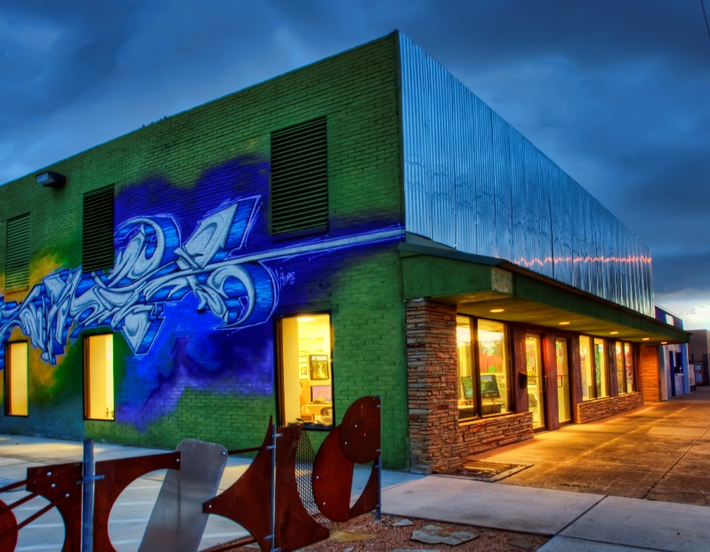
CIRP 5324/URPA 5313
Community Development and Planning

Spring 2016

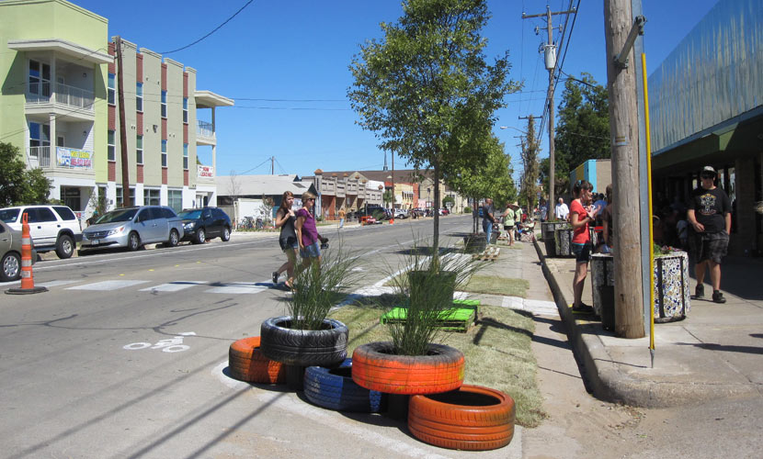

Photo Credit http://rosemariemercado.com/ and http://fortworthtexas.gov/

College of Architecture, Planning and Public Affairs
Department of Planning and Landscape Architecture
Instructor: Professor Ivonne Audirac, audirac@uta.edu,
TA: Ali Mohammed Adil alimohammed.adil@uta.edu
Time and Classroom: Thursday 7:00PM - 9:50PM, Room ARCH 304
Office: ARCH 422, Tel: 817-272-3338
Office Hours: Wednesday 3:00 - 5:00 and by appointment

Course Description
Community development is a field of study and practice that aims to enhance the economic opportunities, social institutions, physical and environmental conditions, as well as the political power of neighborhoods and communities. The provision of affordable housing, job training, community organizing, and local capacity building are typical community development activities conducted jointly by the public, private and non-profit sectors with participation from the people who make up the community.
In this course, we will take an action-research oriented approach to examine the challenges facing communities and community stakeholders. Through hand-on application of traditional and emerging literature on community development and planning, we will focus on the issue of homelessness in Fort Worth, and devote the semester in developing innovative solutions for affordable housing, improving physical, social and natural capital of the community, and engaging in reflexive learning.
STUDENT LEARNING OUTCOMES
Upon completion of the course, students should be able to:
- apply socio-ecological systems thinking and action research methodology to a community development project
- critically discuss the environmental, economic, and institutional context of community development practice
- critically discuss the central theories and rationales driving community development practice

Module | Date | Topic | Guest Speaker(s) | Speaker  Topic
11 | Week 0 1/21 | Introduction--What is Community Development?  Introduction to the Service Learning Project | Palm Tree Team | Panel Discussion
 | Week 1  1/28 | Introduction to the Socio-Ecological Framework and Action Research/ Soft Systems Methodology.  The Role of Assets in CD and CD's Historical and Political Context
Module 1: Physical and Financial Capital | Week 2  2/4 | Physical Capital: The Role of Housing in CD | Dana Burghoff, Director of Planning FW | Planners, Gentrification and Mixed Use Development
 | Week 3  2/11 | Financial Capital: Community Investment, Banks and Business Development | Pretlow Riddick, Developer and Property Owner Race Street | Property Development success factors

Module 2: Social and Natural Capital | Week 4  2/18 | Sustainability and the Community Development
 | Week 5  2/25 | Natural Capital: Food, Energy and Community
 | Week 6  3/3 | Human Capital: Building Assets and Community Capacity | Otis Thornton, Exec. Dir. Tarrant County Homeless Coalition | Success and Failures of PSH projects
 | Week 7  3/10 | Social Capital | Dr. James Petrovich (TCU) and Dr. Emily Spence-Almaguer (UNT), Chief Evaluators of FW's homeless 10 year homeless plan | Street Outreach and Victimization
 | Week 8  3/17 | Spring Break
 | Week 9  3/24 | Documentary Film(s)  Midterm Exam |  | Project Update
Module 3: Political and Cultural Capital | Week 10  3/31 | Cultural Capital: Art and Culture in Community Development | Debby Stein, Director, Riverside Arts District | DIY arts and small business events
 | Week 11  4/7 | Role of Community-based Organizations | Dr. Karabi Bezboruah, Assistant Professor CAPPA | Non-profits in Community Development
 | Week 12  4/14 | Political Capital: Organizing for Power
 | Week 13  4/21 | Project Review
 | Week 14  4/28 | Presentation
 | Week 15  5/5 | Final Project Due

COURSE FORMAT & EXPECTATIONS
Classes have a seminar format. They are a forum to raise questions and debate issues that pertain to class topics. To participate fully, students will need to complete the appropriate readings prior to class and come with thoughtful questions for further discussion. Each student will be responsible for presenting and leading the discussion at least once.
All written assignments are due on the designated date. Late assignments will be penalized.
READINGS:
Required Textbooks:
Green, Gary Paul and Anna Haines (2015). Asset Building & Community Development, 4nd edition. Thousand Oaks, CA: Sage Publications (noted G & H in this syllabus).
DeFilippis, James and Susan Saegert (eds.) 2012. The Community Development Reader, 2nd edition. New York: Routledge, ISBN: 978-0-415-50776-9. (noted in this syllabus as CDR).
Recommended:
Ferguson, Ronald F. and William T. Dickens (eds.) 1999. Urban Problems and Community Development. Washington, DC: The Brookings Institution.
Unless noted, all other readings are available in this course's Blackboard section, denoted with Bb.
COURSE REQUIREMENTS & ASSIGNMENTS
- Participation (10%): based on attendance and involvement in class discussions.
- Weekly Briefs (10%): 1 page reflection paper for each session readings and the basis for student engagement in class discussion. The reflection paper should not exceed 1 page (1.5 line spacing , Times-New-Roman font). At least 10 reflection papers are required to earn full participation points.

- Student-led Discussion (20%):
Ph.D. Students will individually lead a mini-lecture for one class session and additionally co-lead the discussion with Masters Students.
Master’s Students co-leading the discussion are expected to summarize the discussion after the session within one week of the class and post it on blackboard.
These assignments may change depending on Master and PhD student composition. Further details will be given in class.

- Mid-term exam/Literature Review (20%): The exam is based on short essay responses to a series of questions from the course readings (up to the exam date) and the documentary films that will be shown in class. The exam will take place on March 25th and further instructions will be provided in class.
Ph.D. students have the option to substitute a 6-8 page literature review on one of the class topics that bear relevance to their research area. Proposals for the same must be submitted by February 18th (Week 5). No late proposals will be accepted.

- Class Project and Presentation (40%): Students will be grouped into project teams depending on the size of the class. Each team will produce a project report that addresses the anticipated deliverables for the client. First drafts of the report will be due on April 22nd.
On April 29th, students will present their ideas to the client. For the presentation (and the report), each student will be responsible for a stand-alone component and will be expected to deliver a short 10-12 minute presentation for the client.
As a whole, student teams are expected to demonstrate knowledge of the topics discussed in class as well as ability to apply them to the project in producing the deliverables. The final reports are due on May 6th. At least 3 visits to the project site during the semester are required from every student and will count toward the student's contribution to the project.

ASSESSMENT:
Student performance in this class will be assessed based on the following criteria:
Component | Master |  |  |  | Ph.D.
Participation | 10% |  |  | 10%
Weekly Briefs | 10% |  |  | 10%
Student-led Discussion | 20% |  | Mini-Lecture | 20%
Mid-term exam | 25% |  | Literature Review (See #4 above) | 20%
Class Project and Presentation | 35% |  |  | 40%

Lateness & Course Deliverables Policy
Late submissions will conflict with the course grading process, so they are not acceptable. If extenuating circumstances prevent you from meeting a deadline, please contact me immediately. Incomplete grading or extensions are not available unless severe illness or documented extenuating circumstances justify it.
Expectations for Out-of-Class Study
Beyond the time required to attend each class meeting, students enrolled in this course should expect to spend at least an additional 9 hours per week of their own time in course-related activities, including reading required materials, completing assignments, and preparing for class.
CONTACT ME
If at any time you feel the need to discuss any issue related to the class or your performance in this class, do not hesitate to email me or to schedule an appointment during my office hours (shown on the first page). If you need to meet outside office hours, e-mail me or call to set an appointment. Do not leave it until later if I can help make this course a fun and fruitful learning experience.
IMPORTANT NOTES
- Seminar – The course will be run as a seminar with active student-instructor interaction. Students are required to attend class and to make high-quality presentations and contributions to the class discussion. Students will be expected to have read the assigned material thoroughly and to have thought through its relationship to material from previous sessions.

- Blackboard – The syllabus and other materials for this course will be available from Blackboard. Go to: https://elearn.uta.edu/webapps/login/

- Writing Quality – Written assignments and presentations for this class must be of professional quality. Students should carefully edit and proofread all written work for typing, stylistic, spelling, and grammatical errors, and for clarity. Writing quality will affect the student’s grade. It is very important to consult Turabian, K.L. (2007). A manual for writers of research papers, theses, and dissertations, (7th edition), which provides detail guidance in this matter and in the use and application of the Chicago Manual of Style.

Other useful sources by John R. Trimble:-- Writing with Style:
http://uts.cc.utexas.edu/~rhart/courses/materials/papers/trimble.html

- Class Rubric – Written assignments, and postings will be assessed using the following rubrics:
The style (not the substance) of any written component of your assignments will be graded based on the MCRP Term Paper Rubric available at:
https://mavspace.uta.edu/xythoswfs/webview/sharelogin.action?sharedFileID=1692656_1&ticketID=t_1xO6ATUZ

- Academic Honesty – Students enrolled in this course are expected to adhere UT Arlington Honor Code:

I pledge, on my honor, to uphold UT Arlington’s tradition of academic integrity, a tradition that values hard work and honest effort in the pursuit of academic excellence.
I promise that I will submit only work that I personally create or contribute to group collaborations, and I will appropriately reference any work from other sources. I will follow the highest standards of integrity and uphold the spirit of the Honor Code.
UT Arlington faculty members may employ the Honor Code as they see fit in their courses, including (but not limited to) having students acknowledge the honor code as part of an examination or requiring students to incorporate the honor code into any work submitted. Per UT System Regents’ Rule 50101, §2.2, suspected violations of university’s standards for academic integrity (including the Honor Code) will be referred to the Office of Student Conduct. Violators will be disciplined in accordance with University policy, which may result in the student’s suspension or expulsion from the University.

- What is PLAGIARISM? – Although most students will be familiar with the term and would not deliberately incur in plagiarism, it is always important to review the following description to make sure your assignments uphold the highest standards of academic integrity. Basic examples of plagiarism include:
  - Word-for-word copying of sentences or paragraphs without quoting and citing the source and page number;
  - Closely paraphrasing sentences or paragraphs without clearly citing the source; and
  - Using another person’s ideas, work, data, or research without appropriate acknowledgment or citation of the source.

“If five or more words in sequence are taken from a source, those words must be placed in quotes and the source referenced with author’s name, date of publication, and page number of publication.
If the author’s ideas are rephrased, by transposing words or expressing the same idea using different words, the idea must be attributed to the author by proper referencing, giving the author’s name and date of publication.
If a single author’s ideas are discussed in more than one paragraph, the author must be referenced at the end of each paragraph.
Authors whose words or ideas have been used in the preparation of a paper must be listed in the references cited at the end of the paper.

Students are encouraged to review the plagiarism module from the UT Arlington Central Library at: http://library.uta.edu/tutorials/Plagiarism “Source: College of Nursing, Student Handbook, p. 8, accessed 8/16/2013 from:
http://www.uta.edu/nursing/handbook/msn_policies.php

- Student Feedback Survey – At the end of each term, students enrolled in classes categorized as “lecture,” “seminar,” or “laboratory” shall be directed to complete an online Student Feedback Survey (SFS). Instructions on how to access the SFS for this course will be sent directly to each student through MavMail approximately 10 days before the end of the term. Each student’s feedback enters the SFS database anonymously and is aggregated with that of other students enrolled in the course. UT Arlington’s effort to solicit, gather, tabulate, and publish student feedback is required by state law; students are strongly urged to participate. For more information, visit http://www.uta.edu/sfs.

- Americans With Disabilities Act – The University of Texas at Arlington is on record as being committed to both the spirit and letter of all federal equal opportunity legislation, including the Americans with Disabilities Act (ADA). All instructors at UT Arlington are required by law to provide "reasonable accommodations" to students with disabilities, so as not to discriminate on the basis of that disability. Any student requiring an accommodation for this course must provide the instructor with official documentation in the form of a letter certified by the staff in the Office for Students with Disabilities, University Hall 102. Only those students who have officially documented a need for an accommodation will have their request honored. Information regarding diagnostic criteria and policies for obtaining disability-based academic accommodations can be found at www.uta.edu/disability or by calling the Office for Students with Disabilities at (817) 272-3364.

- Drop Policy – Students may drop or swap (adding and dropping a class concurrently) classes through self- service in MyMav from the beginning of the registration period through the late registration period. After the late registration period, students must see their academic advisor to drop a class or withdraw. April 1 is last day to drop a class. Undeclared students must see an advisor in the University Advising Center. Drops can continue through a point two-thirds of the way through the term or session. It is the student's responsibility to officially withdraw if they do not plan to attend after registering. Students will not be automatically dropped for non-attendance. Repayment of certain types of financial aid administered through the University may be required as the result of dropping classes or withdrawing. For more information, contact the Office of Financial Aid and Scholarships (http://wweb.uta.edu/aao/fao/).

- Student Support Services – UT Arlington provides a variety of resources and programs designed to help students develop academic skills, deal with personal situations, and better understand concepts and information related to their courses. Resources include tutoring, major-based learning centers, developmental education, advising and mentoring, personal counseling, and federally funded programs. For individualized referrals, students may visit the reception desk at University College (Ransom Hall), call the Maverick Resource Hotline at 817-272-6107, send a message to resources@uta.edu, or view the information at www.uta.edu/resources.

- Electronic Communication – UT Arlington has adopted MavMail as its official means to communicate with students about important deadlines and events, as well as to transact university-related business regarding financial aid, tuition, grades, graduation, etc. All students are assigned a MavMail account and are responsible for checking the inbox regularly. There is no additional charge to students for using this account, which remains active even after graduation. Information about activating and using MavMail is available at http://www.uta.edu/oit/cs/email/mavmail.php.

- Emergency Exit Procedures – Should we experience an emergency event that requires us to vacate the building, students should exit the room and move toward the nearest exit. When exiting the building during an emergency, one should never take an elevator but should use the stairwells. Faculty members and instructional staff will assist students in selecting the safest route for evacuation and will make arrangements to assist handicapped individuals.

The course's updated and detailed schedule of readings available in Black board.

DETAILED COURSE SCHEDULE
- Required Readings
- Recommended readings, especially for Ph.D. students
- Browse or watch
0 | January 21
Introduction to the course: What is Community Development (CD)?
Introduction to the Service Learning Project: Permanent Supportive Housing by Paulos Foundation and PF Residential LLC.
- CDR Chapter 1 (p 1-10)
- Ferguson & Dickens. Chapters 1 (p 1-20)
- Young 2009. Chapter 3 Soft Systems Methodology (Excerpt).

1 | January 28
Introduction to Social Ecological Framework and Action Research/Soft Systems Methodology
The Role of Assets in CD and CD's Historical and Political Context

- G & H, Chapter 1: The Role of Assets in Community-Based Development
- Perkins, D. et al. 2004. Community Development as a response to community-based adversity: Ecological Theory and research and Strengths based policy
https://my.vanderbilt.edu/perkins/files/2011/09/Perkins-et-al.2004.CD-as-response-to-comm-level-adversity.APA_.pdf
- Williams, R. (2005) Soft Systems Methodology, Kellogs Foundation.

- Crane, Randall and Michael Manville. 2008. People or Place?: Revisiting the Who Versus the Where of Urban Development. Lincoln Land Lines.
- Checkland, P. 2000 Soft Systems Methodology: A Thirty Year Retrospective. Systems Research and Behavioral Science, 17, S11–S58.
- CDR, Chapter 2, O'Connor: A brief history of federal policy in poor communities;
Browse
- Shelterforce at National Housing Institute http://shelterforce.org/archive/cat/C125/
- Gaining Ground Trailer: https://www.youtube.com/watch?v=CnHRodEb5no
- Holding Ground Trailer: https://www.youtube.com/watch?v=9uPzl_RZpqA
- Holding Ground: Rebirth of Dudley Street: https://www.youtube.com/watch?v=TElaNRPBXP0

2 | February 4
Physical Capital: The Role of Housing in CD
- G & H, Chapter 8, Physical Capital the role of housing in community development housing issues.
- CDR Chapter 8, Stone: Social Housing
- CDR Chapter 9, Immergluck: Community response to foreclosure.
- Keating, Larry. 2000. “Redeveloping Public Housing: Relearning Urban Renewal’s Immutable Lessons” Journal of the American Planning Association 66: 84-97
- Austin Homestead Preservation District
https://austintexas.gov/sites/default/files/files/Housing/Reports_and_Publications/Presentations/HPD_Overview_forCouncilHousingCommittee_032515_final.pdf
- Newman, Kathe and Elvin Wyly. 2006. The Right to Stay Put, Revisited: Gentrification and Resistance to Displacement in New York City. Urban Studies 43, 1:23–57
- Is Urban Revitalization Without Gentrification Possible?
http://dirt.asla.org/2014/09/26/is-urban-revitalization-without-gentrification-possible/
Browse
- Smith, Janet, 2002, HOPE VI and the New Urbanism: Eliminating Low-Income Housing to Make Mixed-Income Communities. Planners Network http://www.plannersnetwork.org/2002/04/hope-vi-and-the-new-urbanism-eliminating-low-income-housing-to-make-mixed-income-communities/
- Gentrification and Displacement in East Austin (Anti-gentrification policy) http://www.texashousing.org/webnews/issues/news008.pdf
- The Problem with East Austin Real Estate (The gentrifier perspective)
http://crosslandteam.com/blog/2006/11/28/the-problem-with-east-austin-real-estate/
- Gentrification & the Slums of Beverly Hills (NHI Rooflines, 2015) http://www.rooflines.org/4341/gentrification_and_the_slums_of_beverly_hills/

3 | February 11
Financial Capital, Community Investment: Banks and Business Development
- G & H, Chapter 9, Financial capital, community credit institutions
- CDR Chapter 10, Benjamin et al.: Community development financial institutions
- CDR Chapter 11, Wiewel et al.: The economic development of neighborhoods and localities.
- Dreier, Peter. 2003. The Future of Community Reinvestment: Challenges and Opportunities in a Changing Environment. Journal of the American Planning Association. 69, 4.
- Ferguson & Dickens. Chapter 11: Inner city business development and entrepreneurship.
- Zuk et al. 2015. Gentrification, Displacement –The Role of Public Investment—Literature Review –Federal Reserve Bank of San Francisco http://www.frbsf.org/community-development/files/wp2015-05.pdf
- Stein, Eric. 2008 Testimony Before the U.S. Senate Committee on Banking, Housing and Urban Affairs “Turmoil in the U.S. Credit Markets: The Genesis of the Current Economic Crisis.” http://www.banking.senate.gov/public/_files/STEINTestimony101608Final.pdf
4 | February 18
Sustainability and the Community Development Process & Practice
- G & H, Chapter 3 Community Sustainability
- G & H, Chapter 4 The Community Development Process
- CDR, Chapter 4, Sites et al. Reframing Community Practice for the 21st Century.
- CDR, Chapter 19, Wheeler, Sustainability in Community Development
- Ferguson & Dickens. Chapters 2: Reconceiving the Community Development Field.
A Case Study:
- Holtzman, David. 2006. Planning Beyond the Project: Neighborhood planning allows CDCs to move beyond housing development and become community catalysts. Shelterforce 146. http://www.nhi.org/online/issues/146/planningbeyondprojects.html
Browse:
Avenue Community Development Corporation Houston: http://www.avenuecdc.org/
SouthFair Development Community Development Corporation: http://www.southfaircdc.org/
Texas Association of CDCs: http://www.tacdc.org/
5 | February 25
Natural Capital: Food, Energy and Community
- G & H, Chapter 13, Food, Energy and Community
- CDR, Chapter 18, Dixon: Diverse food economies, multivariant capitalism, and the community dynamic shaping contemporary food systems.
- Irazabal, Clara and Anita Punja. 2009. Cultivating Just Planning and Legal Institutions: A Critical Assessment of the South Central Farm Struggle in Los Angeles. Journal of Urban Affairs 31 (1): 1–23.
- Sloane, David, et al. 2003. “Improving the Nutritional Resource Environment for Healthy Living through Community-Based Participatory Research” Journal of General Internal Medicine (July): 568-575.
- Twiss, Joan et al. 2003. Community Gardens: Lessons Learned From California Healthy Cities and Communities. American Journal of Public Health 93, 9: 1435-1438.
Browse:
- Community Gardens, Center for Disease Control and Prevention, http://www.cdc.gov/healthyplaces/healthtopics/healthyfood/community.htm
- Renee Henry (2011) Building Social and Community Capital Through Gardening in Ypsilanti, Michigan. University of Michigan, MS Thesis. http://deepblue.lib.umich.edu/bitstream/handle/2027.42/86075/Henry,%20Renee_Practicum.pdf?sequence=1
- South Central Farm: http://www.southcentralfarmers.com/ and http://www.lacitybeat.com/article.php?id=3200&IssueNum=138
- Dallas Community Gardens: http://www.gardendallas.org/index.html
- Oakland Mobile Market: http://www.sfgate.com/cgi-bin/article.cgi?file=/g/a/2005/03/09/gree.DTL
- Green Guerillas: http://www.greenguerillas.org/
6 | March 3
Human Capital: Building Assets and Community Capacity
- G & H, Chapter 6, Human capital & workforce development
- CDR, Chapter 23, Traynor: Community building limitations and promise
- CDR, Chapter 24, Saegert: Building civic capacity in urban neighborhoods
- Weber, Rachel and Janet Smith. 2003. “Assets and Neighborhoods: The Role of individual Assets in Neighborhood Revitalization.” 14 1 & 2 Housing Policy Debate. http://www.fanniemaefoundation.org/programs/hpd/pdf/hpd_1401_Weber.pdf
- CDR, Chapter 22, Stall & Stoecker: Community organizing or organizing community?
Browse:
- Community-Wealth.org brings together information about the broad range of community wealth building activity. http://community-wealth.org
7 | March 10
Social Capital
- G & H, Chapter 7, Social capital, building trust, norms and networks
- CDR 17, Mayer & Keyes, City government's role in the community development system
- CDR, 12 Conceptual Overview of What We Know about Social Entrepreneurship
- DeFilippis, James. 2001. The Myth of Social Capital in Community Development. Housing Policy Debate 12, 4: 781-806.
8 | March 17 Spring Break
9 | March 24
Documentary Film(s) and Mid-term Exam; Project Update
https://www.youtube.com/watch?v=b3MYndOmXVM&spfreload=10
https://www.youtube.com/watch?v=Z7iymBGusKY
10 | March 31
Cultural Capital Art and Culture in Community Development
- G & H, Chapter 12, Cultural Capital
- Leavitt, Jacqueline. 2006. Art and the Politics of Public Housing. Planners Network. http://www.plannersnetwork.org/2005/10/art-and-the-politics-of-public-housing/
- Henry Sanoff. 2006. “Progressive Community Design”: Origins of Community Design, Planners Network. http://www.plannersnetwork.org/2006/01/origins-of-community-design/ and Kathy Dorgan. Diversity in Practice. http://www.plannersnetwork.org/2006/01/diversity-in-practice/
- How the Arts & Culture Catalyze Economic Vitality (APA)
https://www.planning.org/research/arts/briefingpapers/vitality.htm
- The Role of Arts and Culture in Planning (APA)
https://www.planning.org/research/arts/briefingpapers/overview.htm

- How Arts & Culture is Fueling Economic Growth in New York City Neighborhoods
https://nycfuture.org/pdf/The_Creative_Engine.pdf
- Stern, Mark. 2002. Performing Miracles. Center for an Urban Future. https://nycfuture.org/research/publications/performing-miracles
- Time to Be Creative (2010) https://nycfuture.org/research/publications/time-to-be-creative
- Project Row Houses, Houston: http://www.projectrowhouses.org/ and http://www.rowhousecdc.org/projects.html
- Artists as Change Agents http://artsfwd.org/category/topics/artists-as-change-agents/
11 | April 7
The Role of Community-Based Organizations (CBOs)
- G & H Chapter 5 The Role of Community-Based Organizations
- CDR, Chapter 7, Rohe et al.: Learning from adversity: the CDC school of hard knocks.
- CDR, Chapter 36, Sampson. What community supplies
- CDR, Chapter 15, Owens: Capacity building: the case of faith-based organizations
- Kretzman, John and John McKnight. 1993. Building Communities from the Inside Out.
12 | April 14
Political Capital: Organizing for Power
- G & H, Chapter 11, Political Capital
- CDR, Chapter 27 DeRienzo: Organizing for power and democracy: lessons leanred from life in the trenches.
- Kleidman, Robert. 2004. “Community Organizing and Regionalism.” City and Community 3, 4: 403-421.
- Fraser, James et al. 2003. “The Construction of the Local and the Limits of Contemporary Community-Building in the United States.” Urban Affairs Review 38, 3: 417-445.
Pastor, Manuel et al. 2006. The Regional Nexus: The Promise and Risk of Community-Based Approaches to Metropolitan Equity, in Paul Ong and Anastasia Loukaitou-Sideris (Eds.). Jobs and Economic Development in Minority Communities, pp. 63-85.
Browse:
- Association of Community Organizations for Reform Now: http://en.wikipedia.org/wiki/Association_of_Community_Organizations_for_Reform_Now and http://www.acorn.org
- Los Angeles Alliance for a New Economy: http://www.laane.org/
13 | April 21 Project Review
14 | April 28 Presentation
15| May 5 Final Project due

