How do I enroll into a self-study course?
Follow the steps below to enroll into an Instructor-led course on Evolve.
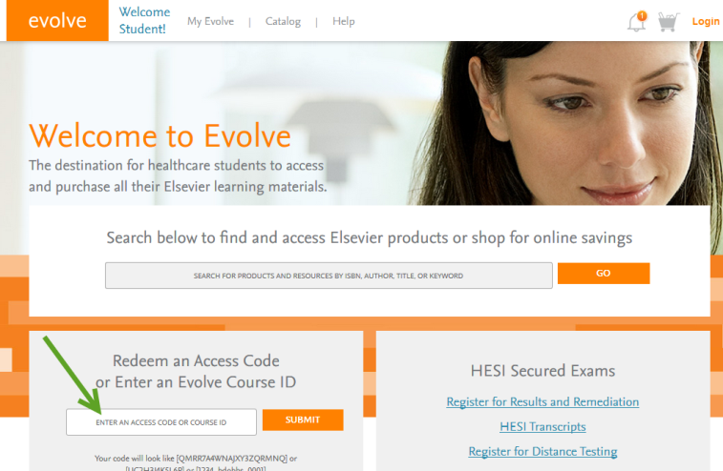
- Go to http://evolve.elsevier.com
- Enter your access code and click Submit
NOTE: Course access codes are valid for a single use
- Click the Redeem/Checkout button.
- Either log into Evolve or create a new account
  - If you are a returning user enter your Evolve username and password and click the LOGIN button.
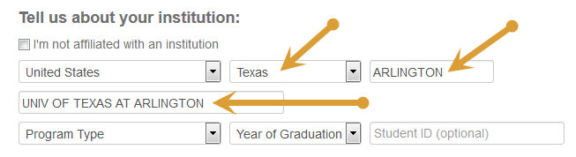
  - If you are new to Evolve enter your name, e-mail, desired password, current institution (Univ of Texas at Arlington) information, and click the Continue button.
  - *You must enter University of Texas at Arlington in your information to properly register for the course. Start with the country, state, city (Arlington), begin typing “university” and then select Univ of Texas at Arlington.
- Click the Registered User Agreement link located at the bottom right. Once you have read this information check the "Yes, I accept the Registered user Agreement" box if you agree.
- Click the Submit button.
- This course will be a self-study course.
- Your enrolment confirmation will appear on the next page. A confirmation e-mail will additionally be sent to your instructor to inform them of your enrollment. If you are a new user, your Evolve username and password will also be e-mailed to you.
- Click the Get Started link to get to your course located in the My Evolve area. Visit and bookmark http://evolve.elsevier.com/student for future log in.

