Adding UTA to your Elsevier Evolve account
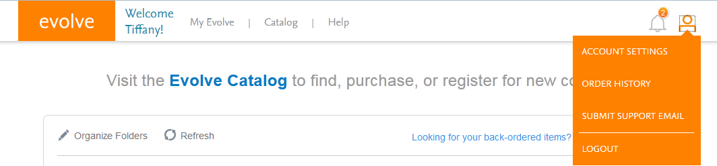
- Login to your evolve account. Evolve.elsevier.com
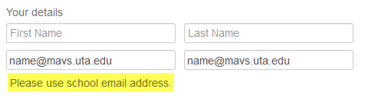
- Click My Account > Account Settings (orange stick figure in the top right).
- In the details, you must use your school issued mavs.uta.edu email address.
- For the Institution, select United States, Texas and then type Arlington.
- Begin typing University of into the institution field. Choose UNIV OF TEXAS AT ARLINGTON from the drop down if the field auto-populates.
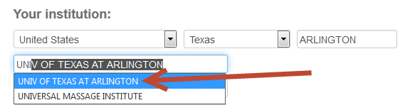

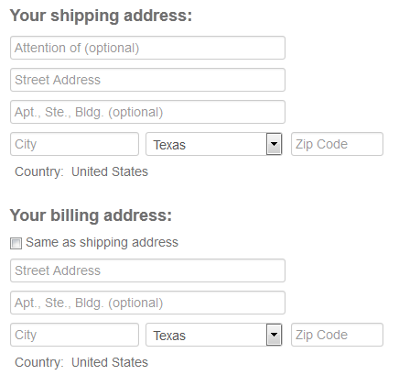
- You do not have to fill out your shipping address unless you are purchasing something that needs to be mailed to you.
- Scroll to the bottom of the page and click SUBMIT.

