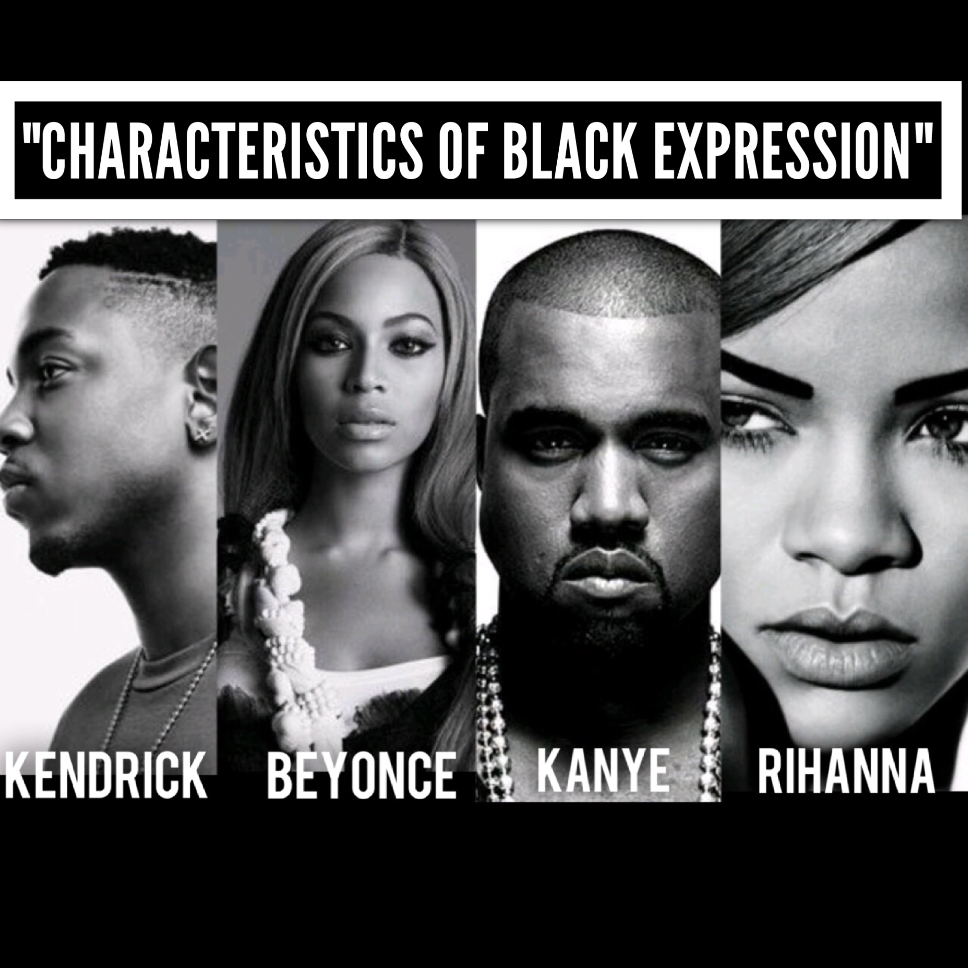

ENGL 4399 - 001
“Characteristics of Black Expression”
Fall 2017

Class Meetings: T/TH, 102A Carlisle Hall (CARH), 12:30 – 1:50 PM
Instructor: Dr. Kenton Rambsy Office Number: 413 Carlisle
Email: kenton.rambsy@uta.edu

Office Hours:
Tuesday & Thursday 11:00 - 12:15 AM / 2:00 – 2:30
And, by appointment

Course Description: “Characteristics of Black Expression” uses Zora Neale Hurston’s 1934 essay, “Characteristics of Negro Expression,” as a framework as we analyze notable features, document linguistic trends, and make divergent connections among four artists: Beyonce, Kanye West, Kendrick Lamar, and Rihanna. In this digital humanities course, we will use text-mining software to aid in our analyses as we quantify the number and types of words and characterizing specific aspects of an artist’s style. Ultimately, we will consider the possible ways in which metadata can be used to understand contemporary African American cultural expression and expand our conceptions literature.

The main objectives will involve developing:

- Identify defining features of African American literary and cultural expression
- Apply critical and literary terms to textual analyses.
- Explain and analyze how context shapes the composition, reception and interpretation of texts.

Grade Descriptions

* 30% — Daily Attendance (2200 Points)
- Because this is a discussion course that covers topics in African American literary history and digital humanities, class attendance is mandatory to fully master concepts.

*30% — Daily Grade (2200 Points)
- Every week, there will be at least two quizzes given at the beginning of each class. The question quizzes will cover basic information from the day’s reading such as author biographical information and story content. If you are absent or tardy, you will not be able to make up the quiz.

* 30% — Case Studies (Due Dates: October 3, October 24, November 7, November 21)
- You will be required to perform 4 case studies throughout the semester. Each case study will be completed in an assigned group. For each assignment, you will receive an individual grade and an overall group grade.

*10% — Revision Project (Due Date: Dec. 5)
- For the final project, you will be required to revise one of your previously submitted case studies.

Course Reading Schedule

Week 1
August 24 – Class Introduction

Week 2 – Characteristics of Black Expression

August 29 - Characteristics of Negro Expression
- Reading: Characteristics of Negro Expression – Zora Neale Hurston

August 31 - Characteristics Continued
- Reading: Characteristics of Negro Expression

Week 3 - Using Text Mining Software in Research

September 5 - What is Text Mining?
- Reading: Why Text Mining May Be The Next Big Thing – Time Magazine, Gary Belsky, March 20, 2012
- Getting Started with Voyant -
- Standard Elements of Voyant -
- Tools of Voyant -

September 7 – Visualizing Data
- Reading: Five Ways to Create Engaging Data-Driven Stories

Week 4 - Collecting and Visualizing Data

September 12: Creating Charts in Excel using Quantitative Data
- Reading: Create a Chart from Start to Finish

September 14 Dataset continued
- Reading: The Language of the State of the Union, The Atlantic, Benjamin Schmidt and Mitch Fraas

Week 5: The Characteristics of Feminism (Beyonce)

September 19 – The Evolution of Beyoncé
- Reading: Beyoncé explains why she performed in front of the word 'feminist' - The Independent, Olivia Blair

September 21 – My Type of Feminist
- Reading: Beyonce is my type of Feminist – Essence Magazine, Ginger McKnight-Chavers

Week 6: The Beyoncé Case Study

September 26 - Beyonce Dataset (Overview of Beyonce and Voyant Tools)
September 28 - Visualizing Beyonce’s Lyrics

Week 7 Case Studies

October 3 - (No Class) Case Study #1 Due
October 5 TBA

Week 8: The Characteristics of Fresh (Kanye West)

October 10 - Kanye West Overview
- Reading: Explaining the ‘Yeezy’ Effect – Harper Bazar, Grace O’Neill

October 12 - Kanye West and Fashion
- Reading: Kanye West Talks Creative Process with Director Steve McQueen – Behind the Hustle

Week 9 Kanye West Case Study
October 17 Kanye West Lyrical Overview
October 19 Visualizing Kanye West’s Lyrics

Week 10 The Characteristics of Faith (Kendrick Lamar)

October 24 - Kendrick Lamar Overview (Case Study #2 Due)
- Reading: Dave Chappelle Interviews Kendrick Lamar – Interview Magazine

October 26 - The Spirituality of Kendrick Lamar
- Reading: Kendrick Lamar on His New Album and the Weight of Clarity- New York Times, Joe Coscarelli

Week 11 Kendrick Lamar Case Study

October 31- The Kendrick Lamar Dataset
November 2 Visualizing Kendrick Lamar’s Lyrics

Week 12 The Characteristics of Sex Appeal (Rihanna)

November 7 - Rihanna Overview (Case Study #3 Due)
- Reading: A Very Revealing Conversation With Rihanna- New York Times, Miranda Judy

November 9 - Text Mining Rihanna
- Reading: The Music Theory Behind Why Rihanna's "Sex With Me" Is So Sexy- https://noisey.vice.com/en_us/article/xwx8z4/why-rihanna-sex-with-me-sounds-so-sexy-to-you-music-theory
- Rihanna Talks Fame, Being A Sex Symbol -

Week 13 The Rihanna Case Study

November 14: The Rihanna Dataset
November 16: Visualizing Rihanna

Week 14 Thanksgiving

November 21 TBA – (Case Study #4 Due)
November 23

Week 15 Professional Development

November 28 - Professional Development
November 30 – Professional Development

Week 16 Revision Project
December 5 (Final Projects Due)

Classroom Policies

Civility Statement: I enjoy student ideas and welcome them! Comments, questions, and opinions about the topics covered in class are encouraged, but please be mindful to express yourself using respectful and appropriate language. We would like to maintain a constructive learning environment. Therefore, no one is permitted to make offensive, intimidating, or malicious comments or behave in a disruptive manner. Additionally, the use of cell phones and other electronic communication devices will not be tolerated. Thank you in advance for adhering to the policy.

Attendance Policy: Because this course is a discussion course and the work we do in the class is designed to help you understand the reading and improve your writing, you must attend class.

To be excused, you must present sufficient documentation. Approved forms of documentation include medical excuses, police records, and documentation of funeral attendance. Of course, you are excused from class for religious holidays. If you are a member of a group that travels on behalf of the University (intramural teams are non-applicable), you must provide a letter from your coach or director along with a schedule of the classes you will miss due to travel.

Late Work: In the event that you are absent, you are STILL RESPONSIBLE for turning in all work by the dates listed on the syllabus. Unless we have made other plans together, in advance of the absence or missed assignment, I will not accept late work, so I encourage you to make arrangements with a classmate to submit any assignments if you will be absent.

University Policies

Academic Integrity: Students enrolled all UT Arlington courses are expected to adhere to the UT Arlington Honor Code:

I pledge, on my honor, to uphold UT Arlington’s tradition of academic integrity, a tradition that values hard work and honest effort in the pursuit of academic excellence.
I promise that I will submit only work that I personally create or contribute to group collaborations, and I will appropriately reference any work from other sources. I will follow the highest standards of integrity and uphold the spirit of the Honor Code.

Electronic Communication: UT Arlington has adopted MavMail as its official means to communicate with students about important deadlines and events, as well as to transact university-related business regarding financial aid, tuition, grades, graduation, etc. All students are assigned a MavMail account and are responsible for checking the inbox regularly. There is no additional charge to students for using this account, which remains active even after graduation. Information about activating and using MavMail is available at http://www.uta.edu/oit/cs/email/mavmail.php.

Drop Policy: Students may drop or swap (adding and dropping a class concurrently) classes through self-service in MyMav from the beginning of the registration period through the late registration period. After the late registration period, students must see their academic advisor to drop a class or withdraw. Undeclared students must see an advisor in the University Advising Center. Drops can continue through a point two-thirds of the way through the term or session. It is the student's responsibility to officially withdraw if they do not plan to attend after registering. Students will not be automatically dropped for non-attendance. Repayment of certain types of financial aid administered through the University may be required as the result of dropping classes or withdrawing. For more information, contact the Office of Financial Aid and Scholarships (http://wweb.uta.edu/aao/fao/).

Disability Accommodations: UT Arlington is on record as being committed to both the spirit and letter of all federal equal opportunity legislation, including The Americans with Disabilities Act (ADA), The Americans with Disabilities Amendments Act (ADAAA), and Section 504 of the Rehabilitation Act. All instructors at UT Arlington are required by law to provide “reasonable accommodations” to students with disabilities, so as not to discriminate on the basis of disability. Students are responsible for providing the instructor with official notification in the form of a letter certified by the Office for Students with Disabilities (OSD). Students experiencing a range of conditions (Physical, Learning, Chronic Health, Mental Health, and Sensory) that may cause diminished academic performance or other barriers to learning may seek services and/or accommodations by contacting:
The Office for Students with Disabilities, (OSD) www.uta.edu/disability or calling 817-272-3364.
Counseling and Psychological Services, (CAPS) www.uta.edu/caps/ or calling 817-272-3671.

Only those students who have officially documented a need for an accommodation will have their request honored. Information regarding diagnostic criteria and policies for obtaining disability-based academic accommodations can be found at www.uta.edu/disability or by calling the Office for Students with Disabilities at (817) 272-3364.

Title IX: The University of Texas at Arlington does not discriminate on the basis of race, color, national origin, religion, age, gender, sexual orientation, disabilities, genetic information, and/or veteran status in its educational programs or activities it operates. For more information, visit uta.edu/eos. For information regarding Title IX, visit www.uta.edu/titleIX.

Emergency Exit Procedures: Should we experience an emergency event that requires us to vacate the building, students should exit the room and move toward the nearest exit. When exiting the building during an emergency, one should never take an elevator but should use the stairwells. Faculty members and instructional staff will assist students in selecting the safest route for evacuation and will make arrangements to assist individuals with disabilities.

Student Feedback Survey: At the end of each term, students enrolled in classes categorized as “lecture,” “seminar,” or “laboratory” shall be directed to complete an online Student Feedback Survey (SFS). Instructions on how to access the SFS for this course will be sent directly to each student through MavMail approximately 10 days before the end of the term. Each student’s feedback enters the SFS database anonymously and is aggregated with that of other students enrolled in the course. UT Arlington’s effort to solicit, gather, tabulate, and publish student feedback is required by state law; students are strongly urged to participate. For more information, visit http://www.uta.edu/sfs.

Final Review Week: A period of five class days prior to the first day of final examinations in the long sessions shall be designated as Final Review Week. The purpose of this week is to allow students sufficient time to prepare for final examinations. During this week, there shall be no scheduled activities such as required field trips or performances; and no instructor shall assign any themes, research problems or exercises of similar scope that have a completion date during or following this week unless specified in the class syllabus. During Final Review Week, an instructor shall not give any examinations constituting 10% or more of the final grade, except makeup tests and laboratory examinations. In addition, no instructor shall give any portion of the final examination during Final Review Week. During this week, classes are held as scheduled. In addition, instructors are not required to limit content to topics that have been previously covered; they may introduce new concepts as appropriate.
The English Writing Center (411LIBR): Hours are 9 am to 8 pm Mondays-Thursdays, 9 am to 3 pm Fridays and Noon to 5 pm Saturdays and Sundays. Walk In Quick Hits sessions during all open hours Mon-Thurs. Register and make appointments online at http://uta.mywconline.com. Classroom Visits, Workshops, and advanced services for graduate students and faculty are also available. Please see www.uta.edu/owl for detailed information

