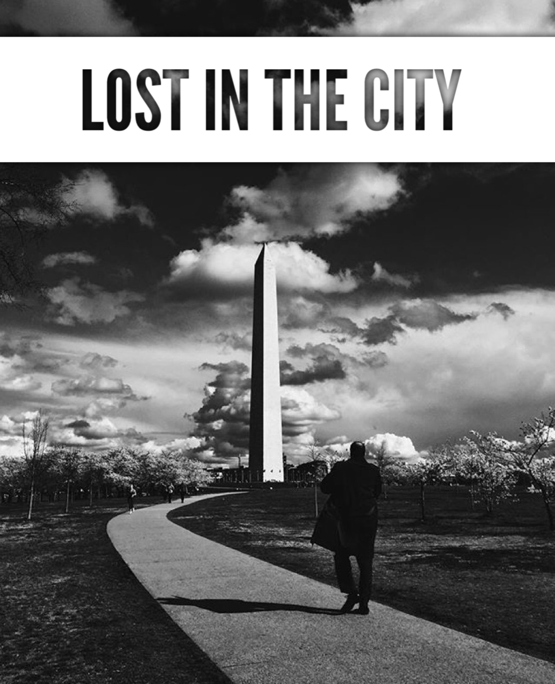

ENGL 5324 – 001: “Lost in the City”
Professor: Dr. Kenton Rambsy
Wednesday, 2:00 – 4:50 PM
Preston Hall (PH) 311

Office Hours:
T – 11:00 AM – 12:15 PM
W- 12:45 PM – 1:45 PM
TH – 11:00 AM – 12:15 PM
And by appointment
Course Description: “Lost in the City,” documents Edward P. Jones’s consistent focus on Washington D.C. as a setting in his two short story collections. The course sheds new light on the development of short fiction in the contemporary era as we use the concept “cultural geo-tagging” to analyze Jones’s extensive reliance upon specific streets, landmarks, and neighborhoods.

In this digital humanities course, we will use text mining and visualization software to prepare a proposal for submission to Publishing Without Walls. This multi-modal publication will highlight the racial-spatial dimensions of Washington, DC in Jones’s short fiction. We will draw on concepts from the emerging spatial humanities discipline and incorporate public census records to uncover literary patterns in Jones’s work, analyze the diverse representations of black characters, and map linguistic features in a select geographic region.

Ultimately, our analyses will present findings related to why Jones’s short stories, focusing on predominately black neighborhoods in Washington, D.C., offer unique and enriching opportunities for analyzing, or more accurately, “geocoding” an African American author’s repeated treatments of the nation’s capital.

Required Texts: Edward P. Jones’s Lost in City (1992) & All Aunt Hagar’s Children (2006)

Course Requirements:

- Create custom dataset from using 1 story from each of Edward P. Jones’s collections (story will be assigned)
- Contribute to Publishing Without Walls project proposal
- Complete peer review for partner
- Give oral presentation on findings
- Submit individual contribution to PWW project/proposal

Tableau Public Resources

- How to use videos (Brief Overview)
- Free Training Videos (Extended Training Overview)
- Gallery
- Tableau Blog

Course Reading Schedule

Week 1- Class Introduction - Intro to Digital Literary Study & Edward P. Jones

August 30 – We will go over the course syllabus, discuss final project, and discuss broad overview of digital humanities and Edward P. Jones

Reading:
- “What Is Digital Humanities and What’s It Doing in English Departments?” - Matthew G. Kirschenbaum
- “Where Is Cultural Criticism in the Digital Humanities?” – Alan Liu
- “The Known World of Edward P. Jones” – Neely Tucker

Week 2- Distant Reading & Voyant Tools

September 6 – We will discuss the concept of ‘distant reading,’ go over Voyant Tools, and discuss text mining methods/strategies

Reading:
- “Distant Reading and Recent Intellectual History” – Ted Underwood
- “The Equivalence of ‘Close’ and ‘Distant’ Reading: Or, Towards a New Object for Data-Rich Literary History” – Katherine Bode
- “Term Weighting for Humanists” - Peter Organisciak

Week 3- Overview of African American Short Fiction

September 13 – We will discuss and use Voyant Text Mining Software to analyze the characteristics of the 7 most frequently anthologized black short stories.

Reading:
- Charles Chesnutt – “The Wife of His Youth”
- Zora Neale Hurston – “Sweat”
- Richard Wright – “Almos’ a Man”
- Ralph Ellison – “Battle Royal”
- James Baldwin – “Sonny’s Blues”
- Toni Cade Bambara – “The Lesson”
- Alice Walker – “Everyday Use”

Week 4- A History of Chocolate City – Washington, DC Overview

September 20 (Datasets Due) – We will discuss the history of Washington, D.C. and explain how it figures into our discussion of Edward P. Jones’s short fiction. We will analyze the significance of black geography.

Individual datasets on assigned Jones stories are due my midnight. Email your Excel Workbook to Kenton.rambsy@uta.edu

Reading:
- A Short History of Black Washington - Sam Smith, Progressive Review
- A Population Changes, Uneasily – Sabrina Tavernise, NYTimes
- From Chocolate City to Latte City: Being black in the new D.C. – Petula Dvorak, The Washington Post
- D.C., Long 'Chocolate City,' Becoming More Vanilla – Alex Kellogg, NPR
- Quadrants of Washington, D.C. – Wikipedia

Week 5 – Lost in the City

September 27 – We will discuss Edward P. Jones’s first collection of short stories and interpret the significance of landmarks and directions

Reading:
- Lost in the City – Edward P. Jones

Week 6 (Work on Proposals/Project Outline – No Class)

October 4 – I will be presenting at Arcadia University. Being thinking about the project thesis and start constructing an outline in groups of 3

Week 7 – All Aunt Hagar’s Children

October 11 – We will discuss Edward P. Jones’s second collection of short stories and how it fits in with the second collection.

Reading:
- All Aunt Hagar’s Children – Edward P. Jones

Week 8 – Project Proposal Completion & Edward P. Jones Dataset Overview

October 18 – We will complete the project proposal and outline. We will also assign specific project roles. We will explore our dataset in preparation for the next two week’s conversation on digitization.

Reading:
- Digital visualization as a scholarly activity- Martyn Jessop
- “Humanities Approaches to Graphical Display” – Johanna Drucker

Week 9 – Visualizing Data
October 25 – TBA

Week 10 –Visualizing Data Continued

November 1 - TBA

Week 11- Presentation of Findings

November 8 – During this session, half of the class will present on their findings and describe

Reading:
- The first 5 submissions

Week 12- Peer Review

November 15 – A continuation of last week: Individuals will present their individual components of the final project. We will offer constructive criticism and provide at least 3 comments to help improve the writing.

Reading:
- The remaining submissions

Week 13- Thanksgiving (No class)

November 22 – Work on final revisions

Week 14- Project Construction

November 29 – Upload and submit the digital article to Publishing Without Walls

Week 15 – Final Review
December 6 – T

Notations on grades on the writing

A few notations on participation

The A level (100 – 94) participants are among the leading voices and thoughtful listeners and closest readers in the class. These participants are drawing ideas from the readings and class conversations, not just talking off the top of their heads based solely on personal experiences. These participants display a sense of intellectual curiosity, which is to say they are not know-it-alls. They raise useful questions that assist in advancing our overall discussions and considerations of course materials. The quantity and quality and diversity of their contributions are also notable. Do they do the assigned readings? Always. Do they make useful contributions to group assignments? Always.

The A- level (93 – 90) participants are right on the edge of A level contributions. They do most everything along with the highest level participants. They probably just slightly fall short, though, in terms of intellectual curiosity or thoughtful listening or with consistency. But only barely. These participants are really sharp, leading voices.

The B+ level (89 – 86) participants are really good. They make regular important contributions. They don’t always take a visible leading role in projects, but they do so enough. They are well above-average contributors. They are mostly consistent, and they are willing to speak up and offer ideas when prompted to do so.

Mid-level B (85 – 80) participants are good. They make somewhat regular contributions. They do almost all of the work. They make adequate contributions to group assignments and other projects, and perhaps just waiting to build up to do a little more.

High C level (79- 77) participants are average. Not a problem, but mostly just moving along with the flow. They make some contributions. They are somewhat dependable for projects.

************************

A-level work:
● Identifies, addresses a problem concerning issues that we – the folks in the class – have actually been considering
● Offers vibrant, creative, and critical argument and purposeful analysis
● Pays attention to detail. Stretches out within the context of the actual assignment
● Projects a sophisticated or hip prose style
● Moves beyond simple observations and also offers adequate evidence
● Entices readers to re-read or re-consider select materials with renewed interest
● Contains almost no grammatical errors
● Demonstrates intellectual curiosity

B-level work:
● Begins to raise a problem, but somewhat vague
● Contains some thoughtful observations; lacks a strong thesis
● Presents fairly good writing style
● Gives readers a fairly good sense of important issue
● Slightly entices readers to re-read select pieces of literature
● Has some but not too many grammatical errors

High C/Low B level work
● Offers somewhat vague or over-generalized problem
● Lacks a thesis, has mostly summary
● Shows little attentiveness to style and purpose
● Begins to develop an argument. Kind of.
● Does little to entice readers to re-read select piece of literature
● Has some grammatical errors

Mid C:
● Shows little attentiveness to sense of purpose
● Has mostly summary, no thesis
● Avoids making a real argument
● Lacks a major aspect of the assignment
● Does not entice readers to re-read
● Has a number of recurring grammatical errors

Classroom Policies

Civility Statement: I enjoy student ideas and welcome them! Comments, questions, and opinions about the topics covered in class are encouraged, but please be mindful to express yourself using respectful and appropriate language. We would like to maintain a constructive learning environment. Therefore, no one is permitted to make offensive, intimidating, or malicious comments or behave in a disruptive manner. Additionally, the use of cell phones and other electronic communication devices will not be tolerated. Thank you in advance for adhering to the policy.

Attendance Policy: Because this course is a discussion course and the work we do in the class is designed to help you understand the reading and improve your writing, you must attend class.

To be excused, you must present sufficient documentation. Approved forms of documentation include medical excuses, police records, and documentation of funeral attendance. Of course, you are excused from class for religious holidays. If you are a member of a group that travels on behalf of the University (intramural teams are non-applicable), you must provide a letter from your coach or director along with a schedule of the classes you will miss due to travel.

Late Work: In the event that you are absent, you are STILL RESPONSIBLE for turning in all work by the dates listed on the syllabus. Unless we have made other plans together, in advance of the absence or missed assignment, I will not accept late work, so I encourage you to make arrangements with a classmate to submit any assignments if you will be absent.

University Policies

Academic Integrity: Students enrolled all UT Arlington courses are expected to adhere to the UT Arlington Honor Code:

I pledge, on my honor, to uphold UT Arlington’s tradition of academic integrity, a tradition that values hard work and honest effort in the pursuit of academic excellence.
I promise that I will submit only work that I personally create or contribute to group collaborations, and I will appropriately reference any work from other sources. I will follow the highest standards of integrity and uphold the spirit of the Honor Code.

Electronic Communication: UT Arlington has adopted MavMail as its official means to communicate with students about important deadlines and events, as well as to transact university-related business regarding financial aid, tuition, grades, graduation, etc. All students are assigned a MavMail account and are responsible for checking the inbox regularly. There is no additional charge to students for using this account, which remains active even after graduation. Information about activating and using MavMail is available at http://www.uta.edu/oit/cs/email/mavmail.php.

Drop Policy: Students may drop or swap (adding and dropping a class concurrently) classes through self-service in MyMav from the beginning of the registration period through the late registration period. After the late registration period, students must see their academic advisor to drop a class or withdraw. Undeclared students must see an advisor in the University Advising Center. Drops can continue through a point two-thirds of the way through the term or session. It is the student's responsibility to officially withdraw if they do not plan to attend after registering. Students will not be automatically dropped for non-attendance. Repayment of certain types of financial aid administered through the University may be required as the result of dropping classes or withdrawing. For more information, contact the Office of Financial Aid and Scholarships (http://wweb.uta.edu/aao/fao/).

Disability Accommodations: UT Arlington is on record as being committed to both the spirit and letter of all federal equal opportunity legislation, including The Americans with Disabilities Act (ADA), The Americans with Disabilities Amendments Act (ADAAA), and Section 504 of the Rehabilitation Act. All instructors at UT Arlington are required by law to provide “reasonable accommodations” to students with disabilities, so as not to discriminate on the basis of disability. Students are responsible for providing the instructor with official notification in the form of a letter certified by the Office for Students with Disabilities (OSD). Students experiencing a range of conditions (Physical, Learning, Chronic Health, Mental Health, and Sensory) that may cause diminished academic performance or other barriers to learning may seek services and/or accommodations by contacting:
The Office for Students with Disabilities, (OSD) www.uta.edu/disability or calling 817-272-3364.
Counseling and Psychological Services, (CAPS) www.uta.edu/caps/ or calling 817-272-3671.

Only those students who have officially documented a need for an accommodation will have their request honored. Information regarding diagnostic criteria and policies for obtaining disability-based academic accommodations can be found at www.uta.edu/disability or by calling the Office for Students with Disabilities at (817) 272-3364.

Title IX: The University of Texas at Arlington does not discriminate on the basis of race, color, national origin, religion, age, gender, sexual orientation, disabilities, genetic information, and/or veteran status in its educational programs or activities it operates. For more information, visit uta.edu/eos. For information regarding Title IX, visit www.uta.edu/titleIX.

Emergency Exit Procedures: Should we experience an emergency event that requires us to vacate the building, students should exit the room and move toward the nearest exit. When exiting the building during an emergency, one should never take an elevator but should use the stairwells. Faculty members and instructional staff will assist students in selecting the safest route for evacuation and will make arrangements to assist individuals with disabilities.

Student Feedback Survey: At the end of each term, students enrolled in classes categorized as “lecture,” “seminar,” or “laboratory” shall be directed to complete an online Student Feedback Survey (SFS). Instructions on how to access the SFS for this course will be sent directly to each student through MavMail approximately 10 days before the end of the term. Each student’s feedback enters the SFS database anonymously and is aggregated with that of other students enrolled in the course. UT Arlington’s effort to solicit, gather, tabulate, and publish student feedback is required by state law; students are strongly urged to participate. For more information, visit http://www.uta.edu/sfs.

Final Review Week: A period of five class days prior to the first day of final examinations in the long sessions shall be designated as Final Review Week. The purpose of this week is to allow students sufficient time to prepare for final examinations. During this week, there shall be no scheduled activities such as required field trips or performances; and no instructor shall assign any themes, research problems or exercises of similar scope that have a completion date during or following this week unless specified in the class syllabus. During Final Review Week, an instructor shall not give any examinations constituting 10% or more of the final grade, except makeup tests and laboratory examinations. In addition, no instructor shall give any portion of the final examination during Final Review Week. During this week, classes are held as scheduled. In addition, instructors are not required to limit content to topics that have been previously covered; they may introduce new concepts as appropriate.
The English Writing Center (411LIBR): Hours are 9 am to 8 pm Mondays-Thursdays, 9 am to 3 pm Fridays and Noon to 5 pm Saturdays and Sundays. Walk In Quick Hits sessions during all open hours Mon-Thurs. Register and make appointments online at http://uta.mywconline.com. Classroom Visits, Workshops, and advanced services for graduate students and faculty are also available. Please see www.uta.edu/owl for detailed information.

