MUSI 1325-001 Theory 1
Fall 2018

Instructor: Dr. John Burton

Office Number: Fine Arts Building room 304B

Office Telephone Number: 817-272-2483

Email Address: jrburton@uta.edu

Faculty Profile: https://www.uta.edu/profiles/john-burton

Office Hours: MWF 8-9 am, other times by appointment

Section Information: MUSI 1325-001

Time and Place of Class Meetings: Fine Arts room 309 9:00 -9:50 am MWF

Description of Course Content: Scales, intervals, triads, and part writing with primary triads. Prerequisite: Open to music majors or faculty approval.

Student Learning Outcomes: The student will become familiar with the fundamental structures of music theory such as intervals, scales, keys, triads and seventh chords, inversions, rules of part writing. Knowledge of rhythm including note values and meters will also be learned.

Required Textbooks and Other Course Materials: “Concise Introduction to Tonal Harmony” by L. Poundie Burstein and Joseph Straus. Norton Publishers, text and accompanying workbook. You will also need computer access to the internet for the online materials throughout the semester.

Descriptions of major assignments and examinations: Homework from the workbook is a large part of the grade in this class. Homework is due at the beginning of class and is not accepted late. The instructor reserves the right to make some of the homework assignments a completion grade rather than a full homework grade. These will be self graded in class and will form part of the review for the exams. There will be 3 exams and a final. There is a composition project due at the end of the semester. A complete breakdown of how your grade is calculated is in this syllabus under Grading.

Attendance: At The University of Texas at Arlington, taking attendance is not required but attendance is a critical indicator in student success. Each faculty member is free to develop his or her own methods of evaluating students’ academic performance, which includes establishing course-specific policies on attendance. As the instructor of this section, I will institute the following attendance policy:

Excused absences – no penalty if documentation is provided to the instructor for excuses such as illness, university approved trips, etc. The student MUST notify the instructor before the absence occurs.

Unexcused absences – 2 absences are allowed in this category for the occasional oversleeping, illness not sufficient to go to the health center or doctor, or other life events that keep you from class. Please note that 3 late arrivals will equal one unexcused absence!

After 3 unexcused absences, 3 points for each absence will be deducted from the final average of you grade for the semester. For example – if a student ends the class with a grade of 95 (A) and has 5 unexcused absences, the final grade for the class will be an 89 (B).

However, while UT Arlington does not require instructors to take attendance in their courses, the U.S. Department of Education requires that the University have a mechanism in place to mark when Federal Student Aid recipients “begin attendance in a course.” UT Arlington instructors will report when students begin attendance in a course as part of the final grading process. Specifically, when assigning a student a grade of F, faculty report the last date a student attended their class based on evidence such as a test, participation in a class project or presentation, or an engagement online via Blackboard. This date is reported to the Department of Education for federal financial aid recipients.

Grading: Final grades for this class are based on the following percentages:

Homework 30%
Exam 1 15%
Exam 2 15%
Exam 3 15%
Final Exam 20%
Composition Project 5%

Note for Music Majors – It is necessary to earn a grade of “C” or better to count for degree credit as a music major. A grade of “D”, while technically passing, is not sufficient to count for degree credit and the course must be re-taken.

Students are expected to keep track of their performance throughout the semester and seek guidance from available sources (including the instructor) if their performance drops below satisfactory levels; see “Student Support Services,” below.

Final Exam is scheduled for Monday December 10, 2018 from 8-10:30 am. NO exceptions can be made for any changes to this time.

Expectations for Out-of-Class Study: Beyond the time required to attend each class meeting, students enrolled in this course should expect to spend at least an additional 9 hours per week of their own time in course-related activities, including reading required materials, completing assignments, preparing for exams, etc.

Grade Grievances: Any appeal of a grade in this course must follow the procedures and deadlines for grade-related grievances as published in the current University Catalog.
.
Drop Policy: Students may drop or swap (adding and dropping a class concurrently) classes through self-service in MyMav from the beginning of the registration period through the late registration period. After the late registration period, students must see their academic advisor to drop a class or withdraw. Undeclared students must see an advisor in the University Advising Center. Drops can continue through a point two-thirds of the way through the term or session. It is the student's responsibility to officially withdraw if they do not plan to attend after registering. Students will not be automatically dropped for non-attendance. Repayment of certain types of financial aid administered through the University may be required as the result of dropping classes or withdrawing. For more information, contact the Office of Financial Aid and Scholarships (http://wweb.uta.edu/aao/fao/).

Disability Accommodations: UT Arlington is on record as being committed to both the spirit and letter of all federal equal opportunity legislation, including The Americans with Disabilities Act (ADA), The Americans with Disabilities Amendments Act (ADAAA), and Section 504 of the Rehabilitation Act. All instructors at UT Arlington are required by law to provide “reasonable accommodations” to students with disabilities, so as not to discriminate on the basis of disability. Students are responsible for providing the instructor with official notification in the form of a letter certified by the Office for Students with Disabilities (OSD). Only those students who have officially documented a need for an accommodation will have their request honored. Students experiencing a range of conditions (Physical, Learning, Chronic Health, Mental Health, and Sensory) that may cause diminished academic performance or other barriers to learning may seek services and/or accommodations by contacting: The Office for Students with Disabilities, (OSD) www.uta.edu/disability or calling 817-272-3364. Information regarding diagnostic criteria and policies for obtaining disability-based academic accommodations can be found at www.uta.edu/disability.

Counseling and Psychological Services (CAPS) www.uta.edu/caps/ or calling 817-272-3671 is also available to all students to help increase their understanding of personal issues, address mental and behavioral health problems and make positive changes in their lives.

Non-Discrimination Policy: The University of Texas at Arlington does not discriminate on the basis of race, color, national origin, religion, age, gender, sexual orientation, disabilities, genetic information, and/or veteran status in its educational programs or activities it operates. For more information, visit uta.edu/eos.

Title IX Policy: The University of Texas at Arlington (“University”) is committed to maintaining a learning and working environment that is free from discrimination based on sex in accordance with Title IX of the Higher Education Amendments of 1972 (Title IX), which prohibits discrimination on the basis of sex in educational programs or activities; Title VII of the Civil Rights Act of 1964 (Title VII), which prohibits sex discrimination in employment; and the Campus Sexual Violence Elimination Act (SaVE Act). Sexual misconduct is a form of sex discrimination and will not be tolerated. For information regarding Title IX, visit www.uta.edu/titleIX or contact Ms. Jean Hood, Vice President and Title IX Coordinator at (817) 272-7091 or jmhood@uta.edu.

Academic Integrity: Faculty are encouraged to discuss the Honor Code and the consequences of cheating, including plagiarism with their students.

I pledge, on my honor, to uphold UT Arlington’s tradition of academic integrity, a tradition that values hard work and honest effort in the pursuit of academic excellence.
I promise that I will submit only work that I personally create or contribute to group collaborations, and I will appropriately reference any work from other sources. I will follow the highest standards of integrity and uphold the spirit of the Honor Code.

UT Arlington faculty members may employ the Honor Code in their courses by having students acknowledge the honor code as part of an examination or requiring students to incorporate the honor code into any work submitted. Per UT System Regents’ Rule 50101, §2.2, suspected violations of university’s standards for academic integrity (including the Honor Code) will be referred to the Office of Student Conduct. Violators will be disciplined in accordance with University policy, which may result in the student’s suspension or expulsion from the University. Additional information is available at https://www.uta.edu/conduct/. Students are encouraged to review these guides on plagiarism http://libguides.uta.edu/researchprocess/plagiarism
http://libguides.uta.edu/copyright/plagiarism

Electronic Communication: UT Arlington has adopted MavMail as its official means to communicate with students about important deadlines and events, as well as to transact university-related business regarding financial aid, tuition, grades, graduation, etc. All students are assigned a MavMail account and are responsible for checking the inbox regularly. There is no additional charge to students for using this account, which remains active even after graduation. Information about activating and using MavMail is available at http://www.uta.edu/oit/cs/email/mavmail.php.

Campus Carry: Effective August 1, 2016, the Campus Carry law (Senate Bill 11) allows those licensed individuals to carry a concealed handgun in buildings on public university campuses, except in locations the University establishes as prohibited. Under the new law, openly carrying handguns is not allowed on college campuses. For more information, visit http://www.uta.edu/news/info/campus-carry/

Student Feedback Survey: At the end of each term, students enrolled in face-to-face and online classes categorized as “lecture,” “seminar,” or “laboratory” are directed to complete an online Student Feedback Survey (SFS). Instructions on how to access the SFS for this course will be sent directly to each student through MavMail approximately 10 days before the end of the term. Each student’s feedback via the SFS database is aggregated with that of other students enrolled in the course. Students’ anonymity will be protected to the extent that the law allows. UT Arlington’s effort to solicit, gather, tabulate, and publish student feedback is required by state law and aggregate results are posted online. Data from SFS is also used for faculty and program evaluations. For more information, visit http://www.uta.edu/sfs.

Final Review Week: for semester-long courses, a period of five class days prior to the first day of final examinations in the long sessions shall be designated as Final Review Week. The purpose of this week is to allow students sufficient time to prepare for final examinations. During this week, there shall be no scheduled activities such as required field trips or performances; and no instructor shall assign any themes, research problems or exercises of similar scope that have a completion date during or following this week unless specified in the class syllabus. During Final Review Week, an instructor shall not give any examinations constituting 10% or more of the final grade, except makeup tests and laboratory examinations. In addition, no instructor shall give any portion of the final examination during Final Review Week. During this week, classes are held as scheduled. In addition, instructors are not required to limit content to topics that have been previously covered; they may introduce new concepts as appropriate.

Emergency Exit Procedures: Should we experience an emergency event that requires us to vacate the building, students should exit the room and move toward the nearest exit, which is located [insert a description of the nearest exit/emergency exit]. When exiting the building during an emergency, one should never take an elevator but should use the stairwells. Faculty members and instructional staff will assist students in selecting the safest route for evacuation and will make arrangements to assist individuals with disabilities.

Student Support Services: UT Arlington provides a variety of resources and programs designed to help students develop academic skills, deal with personal situations, and better understand concepts and information related to their courses. Resources include tutoring, major-based learning centers, developmental education, advising and mentoring, personal counseling, and federally funded programs. For individualized referrals, students may visit the reception desk at University College (Ransom Hall), call the Maverick Resource Hotline at 817-272-6107, send a message to resources@uta.edu, or view the information at http://www.uta.edu/universitycollege/resources/index.php.

University Tutorial & Supplemental Instruction (Ransom Hall 205): UTSI offers a variety of academic support services for undergraduate students, including: 60 minute one-on-one tutoring sessions, Start Strong Freshman tutoring program, and Supplemental Instruction. Office hours are Monday-Friday 8:00am-5:00pm. For more information visit www.uta.edu/utsi or call 817-272-2617.

The IDEAS Center (2nd Floor of Central Library) offers FREE tutoring to all students with a focus on transfer students, sophomores, veterans and others undergoing a transition to UT Arlington. Students can drop in, or check the schedule of available peer tutors at www.uta.edu/IDEAS, or call (817) 272-6593.
The English Writing Center (411LIBR): The Writing Center offers FREE tutoring in 15-, 30-, 45-, and 60-minute face-to-face and online sessions to all UTA students on any phase of their UTA coursework. Register and make appointments online at https://uta.mywconline.com. Classroom visits, workshops, and specialized services for graduate students and faculty are also available. Please see www.uta.edu/owl for detailed information on all our programs and services.
The Library’s 2nd floor Academic Plaza offers students a central hub of support services, including IDEAS Center, University Advising Services, Transfer UTA and various college/school advising hours. Services are available during the library’s hours of operation. http://library.uta.edu/academic-plaza
Librarian to Contact: [Insert the name and contact information – look up here: http://www.uta.edu/library/help/subject-librarians.php ]

Course Schedule
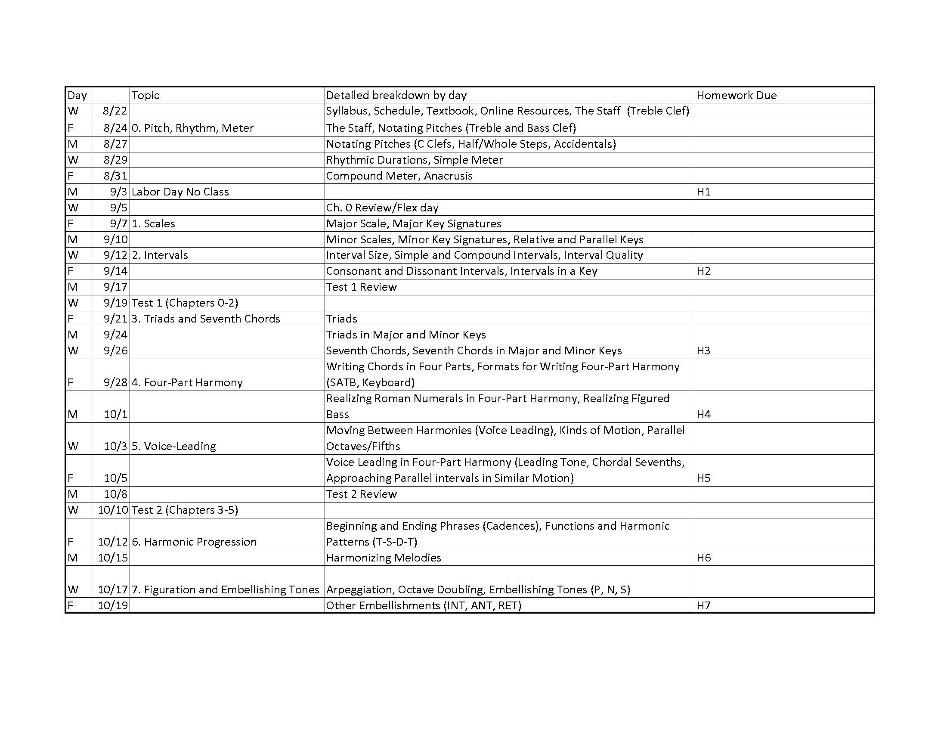

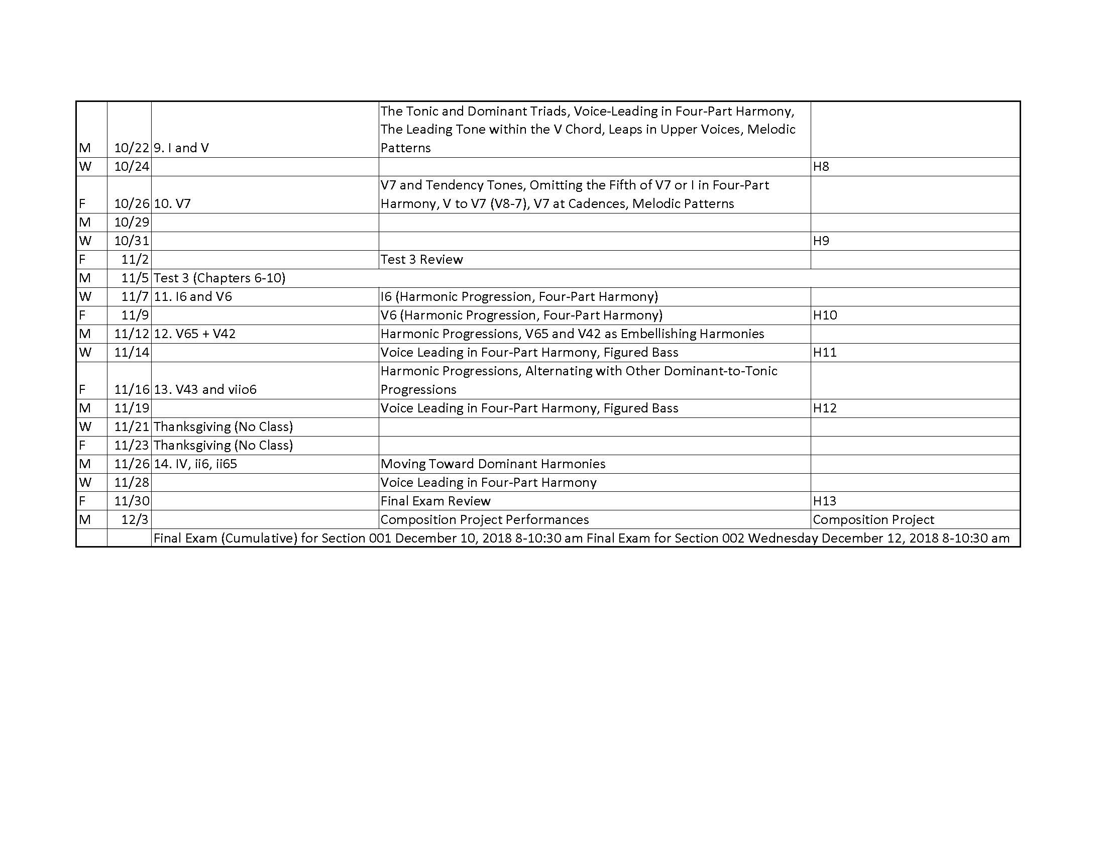
Emergency Phone Numbers: In case of an on-campus emergency, call the UT Arlington Police Department at 817-272-3003 (non-campus phone), 2-3003 (campus phone). You may also dial 911. Non-emergency number 817-272-3381

