LING 5322: Laboratory Phonology
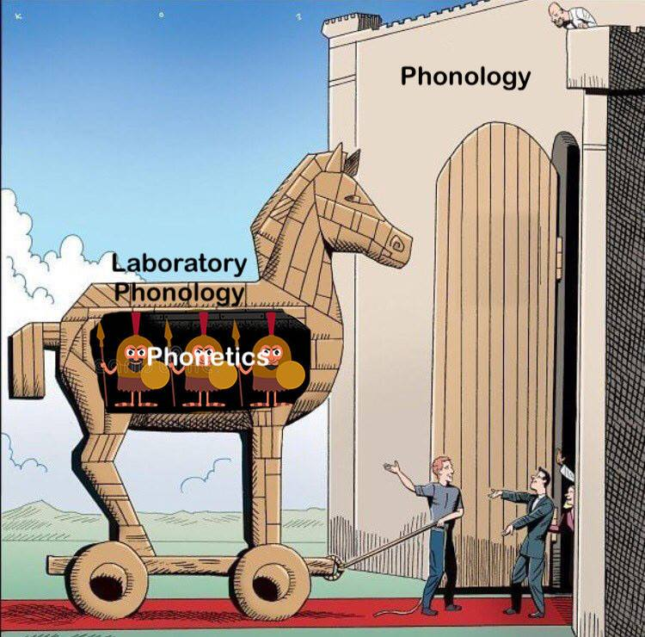
Description of Course Content
Ling 5322 is focused on becoming familiar with different ways to gather empirical data that informs questions of phonological theory. The course will cover basic acoustic and articulatory phonetics, as well as additional instrumental techniques that can be used to experimentally investigate and analyze the production and perception of speech sounds. Course readings, class discussions, and hands-on laboratory sessions will help students acquire the necessary skills to complete work in laboratory phonology. Students will be expected to conduct an independent research project using the tools acquired in class.
Student Learning Outcomes
After successfully completing this course, students should be able to:
1) Measure acoustic and articulatory aspects of different sounds
2) Read and understand published work in laboratory phonology
3) Analyze instrumental data from different theoretical perspectives
4) Argue for a phonological analysis using empirical data
5) Present results and analyses in appropriate format and style
6) Identify interesting phonetic or phonological patterns, and discuss appropriate ways to gather related empirical data
Grading and Course Requirements
The course grade will be determined in the following manner:
Lab Assignments -- 50%
Final Project Presentation -- 15%
Final Project -- 35%
Lab Assignments
On most weeks, there will be lab sessions in which students learn and practice some aspect of laboratory phonology. Students will have an assignment most weeks to work on in lab, due no later than the end of the following week. Work completed within lab sessions cannot be made up unless students arrange it beforehand with the instructor.
Final Project
The final project for this class will take the form of a write-up of an experiment that students will develop and run over the course of the semester. This will include recording of production data, segmentation and possible manipulation of the production data, and/or creating a perception experiment within Praat or another appropriate experimental program, running the experiment with actual participants, and analyzing the results. The write-up will include detailed description of each of the steps mentioned. In the last few weeks of class, students will do a presentation of the work done so far (15% of final grade).
Calendar
Week 1 | What is Laboratory Phonology?
Week 2 | Acoustic Phonetics
Week 3 | Acoustic Phonetics
Week 4 | Acoustic Phonetics
Week 5 | Experimental Design / IRB
Week 6 | Speech Perception
Week 7 | Speech Perception
Week 8 | Speech Perception
Week 9 | SPRING BREAK
Week 10 | Speech Perception
Week 11 | Speech Production
Week 12 | Speech Production
Week 13 | Speech Production
Week 14 | Speech Production
Week 15 | Presentations
Week 16 | Presentations
Finals Week | Final Paper Due

More Course Policies
Classroom behavior. Class sessions require your full attention. All cell phones, iPods, MP3 players, laptops, and other electronic devices should be turned off and put away when entering the classroom; all earpieces should be removed. Store homework from other classes, newspapers, crosswords, magazines, bulky bags, and other distractions so that you can concentrate on the readings and discussions each day. In some cases, you will need to use a laptop, tablet, or phone for an activity, please try to not be distracted by other applications on your device at that time. Note: I reserve the right to ask you to leave the classroom if you are being disruptive.
According to Student Conduct and Discipline, "students are prohibited from engaging in or attempting to engage in conduct, either alone or in concert with others, that is intended to obstruct, disrupt, or interfere with, or that in fact obstructs, disrupts, or interferes with any instructional, educational, research, administrative, or public performance or other activity authorized to be conducted in or on a University facility. Obstruction or disruption includes, but is not limited to, any act that interrupts, modifies, or damages utility service or equipment, communication service or equipment, or computer equipment, software, or networks” (UTA Handbook or Operating Procedures, Ch. 2, Sec. 2-202). Students who do not respect the guidelines listed above or who disrupt other students’ learning may be asked to leave class and/or referred to the Office of Student Conduct.
And a further note on civility in the classroom: Students are expected to assist in maintaining a classroom environment that is conducive to learning. In order to assure that all students have the opportunity to gain from time spent in class, unless otherwise approved by the instructor, students are prohibited from engaging in any other form of distraction. Inappropriate behavior in the classroom shall result, minimally, in a request to leave class. Appropriate student behavior (whether online, in person, or over the telephone) creates a better environment for learning and teaching.
Blackboard. This course will utilize Blackboard this semester. Handouts and other materials will be available via Blackboard. It can be accessed by logging into the Blackboard website: https://elearn.uta.edu. It is your responsibility to make sure that you are able to access Blackboard, and to check it regularly.
Electronic Communication Policy. All students must have access to a computer with Internet capabilities. Students should check email daily for course information and updates. I will send group emails through MyMav and/or through BlackBoard. I am happy to communicate with students through email. However, I ask that you be wise in your use of this tool. I check my email periodically during the school week and occasionally on the weekend. I do not monitor my email 24 hours a day; however, I do try to respond to emails within 24 hours of receiving them. If you don’t have a response from me by email within 24 hours of sending it, please come see me in class or resend your email as there may be a chance it was lost in cyberspace. (Also, please make sure that you use your MavMail address—not your hotmail, gmail, yahoo, etc. addresses—when emailing me.)
The University of Texas at Arlington has adopted the University “MavMail” address as the sole official means of communication with students. MavMail is used to remind students of important deadlines, advertise events and activities, and permit the University to conduct official transactions exclusively by electronic means. For example, important information concerning registration, financial aid, payment of bills, and graduation are now sent to students through the MavMail system. All students are assigned a MavMail account. Students are responsible for checking their MavMail regularly. There is no additional charge to students for using this account, which remains active even after graduation. Information about activating and using MavMail is available at http://www.uta.edu/oit/cs/email/mavmail.php.
Syllabus and Schedule Changes. Instructors try to make their syllabuses as complete as possible; however, during the course of the semester they may be required to alter, add, or abandon certain policies/assignments. Instructors reserve the right to make such changes as they become necessary. Students will be informed of any changes in writing.
Important Academic and Administrative Policies

Drop Policy: Students may drop or swap (adding and dropping a class concurrently) classes through self-service in MyMav from the beginning of the registration period through the late registration period. After the late registration period, students must see their academic advisor to drop a class or withdraw. Undeclared students must see an advisor in the University Advising Center. Drops can continue through a point two-thirds of the way through the term or session. It is the student's responsibility to officially withdraw if they do not plan to attend after registering. Students will not be automatically dropped for non-attendance. Repayment of certain types of financial aid administered through the University may be required as the result of dropping classes or withdrawing. For more information, contact the Office of Financial Aid and Scholarships (http://wweb.uta.edu/aao/fao/).

Disability Accommodations: UT Arlington is on record as being committed to both the spirit and letter of all federal equal opportunity legislation, including The Americans with Disabilities Act (ADA), The Americans with Disabilities Amendments Act (ADAAA), and Section 504 of the Rehabilitation Act. All instructors at UT Arlington are required by law to provide “reasonable accommodations” to students with disabilities, so as not to discriminate on the basis of disability. Students are responsible for providing the instructor with official notification in the form of a letter certified by the Office for Students with Disabilities (OSD). Students experiencing a range of conditions (Physical, Learning, Chronic Health, Mental Health, and Sensory) that may cause diminished academic performance or other barriers to learning may seek services and/or accommodations by contacting:
The Office for Students with Disabilities, (OSD) www.uta.edu/disability or calling 817-272-3364.
Counseling and Psychological Services, (CAPS) www.uta.edu/caps/ or calling 817-272-3671.

Only those students who have officially documented a need for an accommodation will have their request honored. Information regarding diagnostic criteria and policies for obtaining disability-based academic accommodations can be found at www.uta.edu/disability or by calling the Office for Students with Disabilities at (817) 272-3364.
Title IX: The University of Texas at Arlington does not discriminate on the basis of race, color, national origin, religion, age, gender, sexual orientation, disabilities, genetic information, and/or veteran status in its educational programs or activities it operates. For more information, visit uta.edu/eos. For information regarding Title IX, visit www.uta.edu/titleIX.
Academic Integrity: Students enrolled all UT Arlington courses are expected to adhere to the UT Arlington Honor Code:

I pledge, on my honor, to uphold UT Arlington’s tradition of academic integrity, a tradition that values hard work and honest effort in the pursuit of academic excellence.
I promise that I will submit only work that I personally create or contribute to group collaborations, and I will appropriately reference any work from other sources. I will follow the highest standards of integrity and uphold the spirit of the Honor Code.

UT Arlington faculty members may employ the Honor Code as they see fit in their courses, including (but not limited to) having students acknowledge the honor code as part of an examination or requiring students to incorporate the honor code into any work submitted. Per UT System Regents’ Rule 50101, §2.2, suspected violations of university’s standards for academic integrity (including the Honor Code) will be referred to the Office of Student Conduct. Violators will be disciplined in accordance with University policy, which may result in the student’s suspension or expulsion from the University.

While the Department of Linguistics and TESOL hopes to foster a sense of community in which students can enhance their educational experience by conferring with each other about the lectures, readings, and assignments, all work submitted must be the product of each student's own effort. Students are expected to know and honor the standards of academic integrity followed by American universities; ignorance of these standards is not an excuse for committing an act of academic dishonesty (including plagiarism or collusion). If you have questions, please speak with your instructor, your academic advisor, or the department chair.

In this class, you will be required to do research and be able to properly cite that research in prose. If you are unfamiliar with citing other people’s work, please either set up an appointment with me, contact Jody Bailey, a research librarian, at jbailey@uta.edu, or visit the Writing Center.

Please be advised that departmental policy requires instructors to formally file charges with the Office of Student Conduct, following procedures as laid out for faculty (http://www.uta.edu/studentaffairs/conduct/faculty.html), as well as notify the department chair of the filing of the charges.

Student Support Services: UT Arlington provides a variety of resources and programs designed to help students develop academic skills, deal with personal situations, and better understand concepts and information related to their courses. Resources include tutoring, major-based learning centers, developmental education, advising and mentoring, personal counseling, and federally funded programs. For individualized referrals, students may visit the reception desk at University College (Ransom Hall), call the Maverick Resource Hotline at 817-272-6107, send a message to resources@uta.edu, or view the information at http://www.uta.edu/universitycollege/resources/index.php.

Final Review Week: A period of five class days prior to the first day of final examinations in the long sessions shall be designated as Final Review Week. The purpose of this week is to allow students sufficient time to prepare for final examinations. During this week, there shall be no scheduled activities such as required field trips or performances; and no instructor shall assign any themes, research problems or exercises of similar scope that have a completion date during or following this week unless specified in the class syllabus. During Final Review Week, an instructor shall not give any examinations constituting 10% or more of the final grade, except makeup tests and laboratory examinations. In addition, no instructor shall give any portion of the final examination during Final Review Week. During this week, classes are held as scheduled. In addition, instructors are not required to limit content to topics that have been previously covered; they may introduce new concepts as appropriate.

Student Feedback Survey: At the end of each term, students enrolled in classes categorized as “lecture,” “seminar,” or “laboratory” shall be directed to complete an online Student Feedback Survey (SFS). Instructions on how to access the SFS for this course will be sent directly to each student through MavMail approximately 10 days before the end of the term. Each student’s feedback enters the SFS database anonymously and is aggregated with that of other students enrolled in the course. UT Arlington’s effort t solicit, gather, tabulate, and publish student feedback is required by state law; students are strongly urged to participate. For more information, visit http://www.uta.edu/sfs.

Librarians to Contact: The reference librarians for Linguistics and TESOL are Diane Shepelwich and Gretchen Trkay: modling@uta.edu.

Writing Center: Hours are 9 am to 8 pm Mondays-Thursdays, 9 am to 3 pm Fridays and Noon to 5 pm Saturdays and Sundays. Walk In Quick Hits sessions during all open hours Mon-Thurs. Register and make appointments online at http://uta.mywconline.com. Classroom Visits, Workshops, and advanced services for graduate students and faculty are also available. Please see www.uta.edu/owl for detailed information.

Emergency Exit Procedures: Should we experience an emergency event that requires us to vacate the building, students should exit the room and move toward the nearest exit, which is located to the right and up the stairs. When exiting the building during an emergency, one should never take an elevator but should use the stairwells. Faculty members and instructional staff will assist students in selecting the safest route for evacuation and will make arrangements to assist handicapped individuals.
The IDEAS Center (2nd Floor of Central Library) offers free tutoring to all students with a focus on transfer students, sophomores, veterans and others undergoing a transition to UT Arlington. To schedule an appointment with a peer tutor or mentor email IDEAS@uta.edu or call (817) 272-6593.
Title IX Policy: The University of Texas at Arlington (“University”) is committed to maintaining a learning and working environment that is free from discrimination based on sex in accordance with Title IX of the Higher Education Amendments of 1972 (Title IX), which prohibits discrimination on the basis of sex in educational programs or activities; Title VII of the Civil Rights Act of 1964 (Title VII), which prohibits sex discrimination in employment; and the Campus Sexual Violence Elimination Act (SaVE Act). Sexual misconduct is a form of sex discrimination and will not be tolerated. For information regarding Title IX, visit www.uta.edu/titleIX or contact Ms. Jean Hood, Vice President and Title IX Coordinator at (817) 272-7091 or jmhood@uta.edu.

