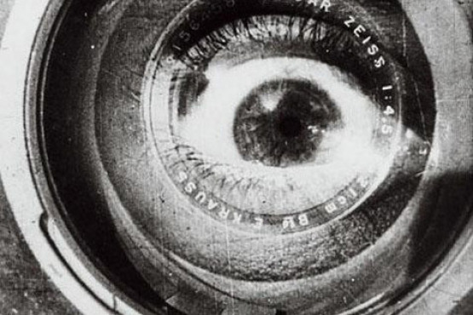

Documentary Film/Video
Fall 2011 MW 2-4:50

Bart Weiss
Office FA 160
Office hours Monday and tues noon to 1 and by appt.
Office.817 272 2891
Note this is the art dept office You can leave a message there
home.214 948 7300.mobile 214 207 7696
E-mail: bart@uta.edu
please use your uta email address

Course Description:
A class in the history, aesthetics and production techniques of Documentary Film and Video.
Students produce individual and group projects integrating technical quality with conceptual, and esthetic values, Students will produce several exercises and make presentations on the history of documentary .May be repeated for up to six hours credit. Prerequisite: sound and post. Topics covered include preproduction, treatments, budgets, production, framing, lighting, location recoding, editing, sound editing, titles and graphics

This course will serve as a technical and conceptual immersion in documentary production. We will focus on the production of independent documentary. We will screen a variety of documentary works with a focus on contemporary makers. The emphasis of the course will be on hands-on experience in pre-production, production and post-production. Students will be expected to create work throughout the semester and present works in progress as well as finished pieces. Collaboration is encouraged, however collaborators will be expected to share all roles in production. Class will be formatted as an advanced workshop of active documentarians. Group feedback and critique are essential components of a successful production dynamic.

Course Objectives
Students will learn how to produce and direct documentary videos, and they will be understood the history and aesthetics of the documentary form.
- To learn fundamental elements of documentary storytelling.
- To make moving, effective, short-form, small-format video documentaries.
- To use documentary as community enhancing resource as well as a personal means of expression
- As a benefit to yourself to become a more effective, more powerful filmmaker
- To become familiar, or more familiar, with the use of fundamental tools of DV format documentary including cameras, microphones, wireless systems, and a non-linear editing program
- To learn interview skills and skills for working collaboratively with crew and “subjects.”
- To become aware of our own assumptions about cultures, our own and others’.
- To see that culture, community, and even documentary is a living, varied, and changing phenomenon.

Ground rules
1. All written work must be typed and stapled, along with a cover page containing name, assignment, date, and version.
2. All DVD’s and files submitted must be labeled with name, and assignment.
3. You are expected to attend class on time.
4. You are expected to do a significant of work outside of class and lab time.
5. You are expected to work crew on other student’s projects.
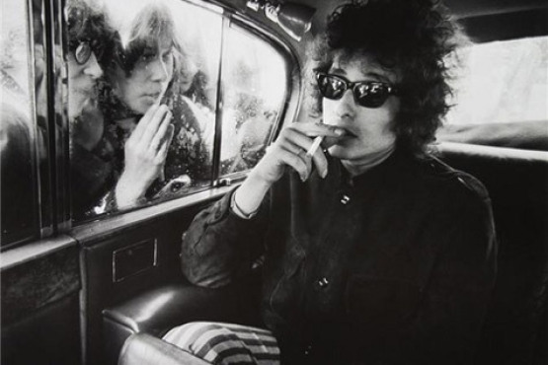

Attendance:

The following attendance policy is shared by all faculty members of the film/video program. Attendance is required to all scheduled classes. However we do understand that there are occasions when absence is necessary and excusable. In accordance to university policy religious holidays are excusable, as is illness with a written note from a physician. The student is responsible for notifying the professor ahead of class if the absence is unavoidable. Unexcused absences over two days, including any absence in which the professor and student do not communicate in writing about before the absence will result in the following grade reductions. Third day absent will result in reduction of one letter for the final semester grade. Fourth day absent will result two letters off the final semester grade. Fifth day absent will result in automatic failure of the class.
The student is responsible for any work missed during an absence, including any handouts given in class and any demonstrations.

It is not the responsibility of faculty to re-teach what the student has missed. Student should be aware that if a demonstration is missed they might not be allowed to utilize that equipment. Attendance is also mandatory for all critiques whether the student has completed the work required or not. Consistent lateness will also have a detrimental effect on the student’s final grade. If you are more then ten minutes late you will be counted as absent.
For this class the following exception will be made

- Given that production dates may depend upon the availability of your subjects, each production team may be excused from ONE CLASS during the semester IF there appears to be an irresolvable conflict in your shooting schedule. This absence must be approved in advance of class and can only be done so by the course Instructor.

The student is responsible for all material presented in class and this should be demonstrated in the work produced. All assignments must be handed in on the due date All written assignments must have a cover sheet. Please read the assignments carefully and plan steps of project with adequate time for completion. Lack of planning will not be accepted as an excuse. Please speak with instructor prior to due date if any problems arise.

Due Dates: Any assignment that is late is will get an f.
Any exceptions must agreed upon by the instructor ahead of the due date IN WRITING.

RESOURCES/BIBLIOGRAPHY
There is not required text for the class but the following is very strongly recommended
DIRECTING THE DOCUMENTARY 3rd edition
By Michael Rabiger

Focal press
Documentary Filmmaking: A Contemporary Field Guide.
By Hewitt, John and Vazquez, Gustavo.
Documentary Filmmaking: A Contemporary Field Guide. New York: Oxford University Press, 2010. New York: Oxford University Press, 2010.

Supplementary Texts:

Technical
AMERICAN CINEMATOGRAPHER VIDEO MANUAL by ASC Press

Compesi and Sherriffs, SMALL FORMAT TELEVISION PRODUCTION
Malkiewicz, CINEMATOGRAPHY
Mathias and Patterson, ELECTRONIC CINEMATOGRAPHY

Reisz, FILM EDITING
Wohl, Michael, Editing Techniques with Final Cut Pro, Peachpit Press

Documentary
Barnouw DOCUMENTARY: A HISTORY OF THE NONFICTION FILM
Ellis, THE DOCUMENTARY IDEA

Hardy, GRIERSON ON DOCUMENTARY, JOHN GRIERSON, A DOCUMENTARY BIOGRAPHY

Jacobs, THE DOCUMENTARY TRADITION
Rosenthal, THE DOCUMENTARY CONSCIENCE, NEW CHALLENGES IN DOCUMENTARY,
And WRITING, DIRECTING AND PRODUCING DOCUMENTARY FILMS AND VIDEOS
Snyder, PARE LORENTZ AND THE DOCUMENTARY FILM

Periodicals
General Information (events, festivals, screenings, essays, jobs, grants, etc.)

FILMMAKER MAGAZINE

THE DOCUMANTARY

Here are some underpinning ideas for this course:
Stories have power. Through stories we make sense of the world. No matter what our background we all live with assumptions about our own culture and how people not in our culture live. Many of our assumptions are shaped by mediated experiences…stories we see on television, in movies, in newspapers, magazines, radio, the Internet, and other media.

To the extent that we accept a story, live with stories, behave by stories⎯stories give meaning to us and to our world. Change the story and change the world; sometimes only a little bit, sometimes fundamentally. “Real life stories” are every bit as powerful, weird, astounding, and profound as fiction. You have chosen this course because you want to be a storyteller. The craft is in the telling.

Something to Consider
When you make a documentary all the material is filtered through you and shaped by you. As documentary makers we have the privilege and opportunity to explore our passions, our interests, and our curiosities and transform these into art. As human beings we have the obligation to do all that and share it with our friends and neighbors. As documentary makers we also have an unspoken contract with our audience not to bore them to tears. But you are finding out something about yourself and telling something about yourself, in the act of telling other people’s stories. You grow as a maker and a person. As documentary makers we must choose subjects that excite us, that call to us. This is how you find your own voice and make filmmaking a life-long activity. This is also how you are true to yourself and to other people.

Some Important Questions:
What are the unspoken stories we tell ourselves about other people? About ourselves? When is a story true? Who gets to tell their own story? What, exactly does it mean to “tell” someone else’s story? -- Or your own story? Who has told your story before? Who tells it now?

Making media is an act of sharing in perceptions and constructing meaning with an audience. What are the responsibilities a documentary filmmaker may have to the people in her or his film? To an audience? To herself or himself?

Course requirements
In order to get a passing grade in the class you must do all of the following on their due dates

Seeing work
You must see at least one documentary in a theater or dvd on Netflix and discuss it with the class.

Documentary Project

Each student will either work individually or in a group to producer a final project that is a FINISHED documentary. There will be no incompletes in the class the work must be done on time (including sound editing). The project must have the following paperwork.

All students will write a project proposal and pitch your story idea to the class. Students will write a timeline, budget, and narrative description of a distribution plan. Students will have signed releases from all of their significant or speaking subjects. Students will screen some of their footage and edits of their films-in-progress for discussion with the class. There will be labs for improving sound recording and sound design and fundraising

Proposal
A proposal must be turned in for all projects.
Proposals must be approved before production can begin.
It is strongly recommended that you create a web site for your project
You can do that for free on word press.

Self Portrait project

This will be created with teams of 2. Each person will create a one-minute documentary portrait about your partner.
Try to get beyond the straight data of a person but who they really are, what drives them, what do we need to know about them? And how can we show this visually and what can we do, other than straight interview or voice over, on the soundtrack to make this more interesting.
Think about who this person is and how can you visually represent who they are and what they do. How can you use sound and picture to tell the story of who this person is?

Notes on this class
- Documentaries raise a rich array of historic, legal, philosophic, ethical, political, and aesthetic issues. Many of the documentaries we will be studying in this class contain powerful and often explicit images. Some may offer pleasure in their appeal while, others may prompt disgust. It should be understood and noted by students enrolled in this course that these programs are being presented for scholarly investigation, analysis, interpretation and discussion. Therefore, the option to substitute programs for alternate viewing is limited. It is incumbent upon the student to notify the instructor of any objection to a program prior to or during screening. Should a student wish to be excused from viewing that program, they will not be penalized.

- Discussions following the screenings may invite personal responses or anecdotes. We must be careful to critically analyze our perceptions within the context of investigating the structure, strategies, and stylistic choices of the works that provoke our reactions. Respect for viewpoints of others that may differ with our own is a course requirement.

- Students enrolled in this course are expected to behave responsibly and professionally toward each other, to faculty, to staff, to other students in the Department, and to their subjects.

- I recognize that the level of cooperation among members of any production group may vary.

However, it is undesirable for a group to work without the full commitment of each member. As this is an advanced course, it is expected that each of you can and will put aside personal differences and work together toward completion of the course objectives and assignments. Those who do not put these differences aside will be counseled to do so. In the event cooperation is not forthcoming, their grade will be affected,

Lectures and class work

Over the semester there will be lectures and screenings of work as well as guest lecturers from working professionals.
Your work: The student is responsible for all work that they produce, including the use of any copyrighted material. Also, at some time in the future (after this class) the instructor may wish to use some of a student’s work in demonstrations, discussions, etc. If the student does not wish for their work to be used, they should notify the instructor in writing.

Work Days On workdays you are fee to work on you current projects. During these sessions I will be available either in the classroom or in my office to discuss your work. If students are not taking advantage of workdays they will turn into lecture days

Materials: You will be shooting and editing HD or HDV and editing in with Final Cit Pro X.
You will need to purchase digital media for production and mastering.
You will also need hard drives for editing , these should NOT be USB drives, They should be firewire or esata drives

At the end of the semester you must turn in a DVD or files with all you work on it. Further you must give a DVD to the subjects in the work, before the last day of class.

Grading
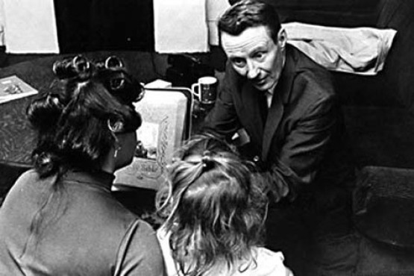
A good video consists of:
- A good idea
- Followed by many other good ideas;
- The Persistence and tenacity to carry through on the many details of the project;
- A mastering of the technical knowledge required, and of the tools and equipment you will be using;
- The ability to communicate with your collaborators insuring you of getting good performances from your actors, subjects, and crew members (if used);
- Consideration of audience and issues of representation;
- Conceptual unity and coherence within the piece;
- A sense of vision and innovation;
- A properly labeled tape handed in on time, with graphics, titles, and a completed, legally cleared, soundtrack.

Some these factors are subjective so it is important to listen to critiques in class.
You have until the end of the semester to incorporate the feedback form the critique in the revised finish work
It is expected that work produced in this class will be submitted to the sfvo festival both in the fall and spring semesters.

Details
Issues of Representation.
Throughout the semester we will be addressing the subject of what it
means to represent someone or something in visual and aural terms. There
is a political aspect to representation, in that you have a certain amount of
power over someone else's image. It follows that as filmmakers we
have a certain responsibility that should be exercised in the process. Your
projects should demonstrate that you have engaged with this issue.

Consideration of Audience.
Issues concerning the audience will also be a focus of this course.
Whether you choose a documentary or narrative, your goal will be to
design a project that communicates a story or message to a broad audience—beyond the class itself, and one that may not previously have been exposed to your subject. Your objective is to define your audience and reach them in an engaging way, while avoiding obstacles that alienate them. Again, your projects should demonstrate that you have engaged with this issue.

Consistent Production Values.

The whole project should be as good as your best shot. In other words,
don't use out-of-focus footage, footage containing jerky camera
movement, footage with bad sound or lighting, etc. If you can't re-shoot, consider striking the shot if your only coverage of it looks bad. It will bring
down the overall level of your movie.

Demonstration of Control of the Medium.

Throughout the semester you will be adding to your knowledge of visual
and aural aesthetics and techniques, and will be expected to demonstrate
your understanding and command of the medium. This includes:

Shot composition, command of focus, zooming, framing, etc.
Everything in the project should have a reason for being there.
Audio and lighting are just as important as shot composition. You
should demonstrate your proficiency in everything we see and hear.

Attention to the Relation between Audio and Picture.

It is said that the least interesting relation between picture and sound
is a one-to-one relation, i.e. where the audio duplicates the
picture--as in a shot of a conversation, where we are always shown the person who is talking.
Keep in mind the motivated use of the cutaway (varying what we see) and
The sound effect (varying what we hear). A relation of contrast between
sound and image is probably more interesting than “Mickey mouseing” .

Shoot to Edit.
Know how you plan to edit your footage before you shoot.
Fresh Ideas; A Critical Evaluation of Concept; Complexity.
Are you telling your audience something they already know? If so, why?
What is there in your project to motivate your audience's interest?
What is there in your project that's unique, that expresses
something individual, different or differently; something we haven't seen before?
How can you increase the (motivated) complexity of your project?

Conceptual Unity and Coherence.
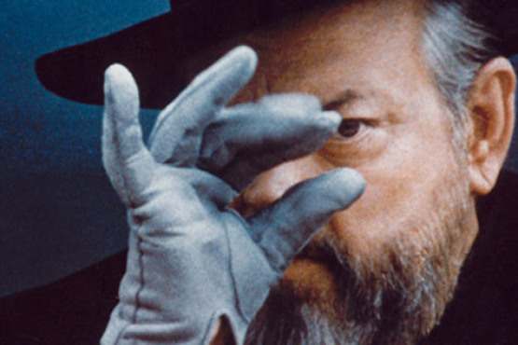
The final movie should hold together as a whole. It should be clear why
each element (shot, sound, sequence, etc.) is included, and what
motivates a directorial decision. If your shots are inexplicable, seem out of place,
it will undermine the audience's confidence in you as a director. This
doesn't mean you can't be innovative, or surprise or challenge your audience,
but you have to consider the difference between innovation with a
thought-out purpose and lazy thinking or lack of self-criticism. Finally, the movie
should fulfill the terms it sets out for itself.

Grading
Final project 75
Self portrait 10
Paperwork /class participation 10
Self critique 5

Drop Policy: Students may drop or swap (adding and dropping a class concurrently) classes through self-service in MyMav from the beginning of the registration period through the late registration period. After the late registration period, students must see their academic advisor to drop a class or withdraw. Undeclared students must see an advisor in the University Advising Center. Drops can continue through a point two-thirds of the way through the term or session. It is the student's responsibility to officially withdraw if they do not plan to attend after registering. Students will not be automatically dropped for non-attendance. Repayment of certain types of financial aid administered through the University may be required as the result of dropping classes or withdrawing. For more information, contact the Office of Financial Aid and Scholarships (http://wweb.uta.edu/ses/fao).

Americans with Disabilities Act
The University of Texas at Arlington is on record as being committed to both the spirit and letter of federal equal opportunity legislation; reference Public Law 93112—The Rehabilitation Act of 1973 as amended. With the passage of new federal legislation entitled Americans with Disabilities Act- (ADA), pursuant to section 504 of The Rehabilitation Act, there is renewed focus on providing this population with the same opportunities enjoyed by all citizens.

As a faculty member, I am required by law to provide “reasonable accommodation” to students with disabilities, so as not to discriminate on the basis of that disability. Student responsibility primarily rests with informing faculty at the beginning of the semester (within one week) and in providing authorized documentation through designated administrative channels.

Electronic Communication: UT Arlington has adopted MavMail as its official means to communicate with students about important deadlines and events, as well as to transact university-related business regarding financial aid, tuition, grades, graduation, etc. All students are assigned a MavMail account and are responsible for checking the inbox regularly. There is no additional charge to students for using this account, which remains active even after graduation. Information about activating and using MavMail is available at http://www.uta.edu/oit/cs/email/mavmail.php.

Student Feedback Survey: At the end of each term, students enrolled in classes categorized as lecture, seminar, or laboratory will be asked to complete an online Student Feedback Survey (SFS) about the course and how it was taught. Instructions on how to access the SFS system will be sent directly to students through MavMail approximately 10 days before the end of the term. UT Arlington’s effort to solicit, gather, tabulate, and publish student feedback data is required by state law; student participation in the SFS program is voluntary.

Academic Dishonesty
It is the philosophy of The University of Texas at Arlington that academic dishonesty is a completely unacceptable mode of conduct and will not be tolerated in any form. All persons involved in academic dishonesty will be disciplined in accordance with University regulations and procedures. Discipline may include suspension or expulsion from the University.

“Scholastic dishonesty includes but is not limited to cheating, plagiarism, collusion, the submission for credit of any work or materials that are attributable in whole or in part to another person, taking an examination for another person, any act designed to give unfair advantage to a student or the attempt to commit such acts.” (Regents’ Rules and Regulations, part One, Chapter VI, Section 3, Subsection 3.2, Subdivision 3.22)

An exception to the definition of scholastic dishonesty is collaboration amongst students in the film/video classes. On some assignments in this class you will be required to work with other students as a group. On other assignments, assigned as individual projects, you may wish to enlist the help of someone in the class to assist with camerawork, lighting, audio, etc. This is in no way considered cheating but rather collaborative effort to produce a polished, professional video project. Collaboration is necessary to satisfactorily succeed in this class and it is encouraged that students assist others in this class and other film/video classes at UTA in order to advance their own expertise. Please be aware however, that if you ask for assistance with something you are unfamiliar with you are required to gain and show expertise in that skill upon completion of the project. Do NOT use classmates to do things you simply do not have the time or desire to do.

Student Support Services

UT Arlington provides a variety of resources and programs designed to help students develop academic skills, deal with personal situations, and better understand concepts and information related to their courses. Resources include tutoring, major-based learning centers, developmental education, advising and mentoring, personal counseling, and federally funded programs. For individualized referrals, students may contact the Maverick Resource Hotline by calling 817-272-6107, sending a message to resources@uta.edu, or visiting www.uta.edu/resources\

Bomb Threats

If anyone is tempted to call in a bomb threat, be aware that UTA will attempt to trace the phone call and prosecute all responsible parties. Every effort will be made to avoid cancellation of presentations/tests caused by bomb threats. Unannounced alternate sites will be available for these classes. Your instructor will make you aware of alternate sites in the event that you classroom is not available.

Final Review Week: A period of five class days prior to the first day of final examinations in the long sessions shall be designated as Final Review Week. The purpose of this week is to allow students sufficient time to prepare for final examinations. During this week, there shall be no scheduled activities such as required field trips or performances; and no instructor shall assign any themes, research problems or exercises of similar scope that have a completion date during or following this week unless specified in the class syllabus. During Final Review Week, an instructor shall not give any examinations constituting 10% or more of the final grade, except makeup tests and laboratory examinations. In addition, no instructor shall give any portion of the final examination during Final Review Week. During this week, classes are held as scheduled. In addition, instructors are not required to limit content to topics that have been previously covered; they may introduce new concepts as appropriate.

Copyright Information
In this class you are not permitted to use copyrighted music without written permission from the musicians and publisher. Create your own, have a musician create a piece, or you may find something that works for online.

You are also not permitted to use copyrighted video images, (period end of story) unless you have written permission.
New there is now a web site that will let you use free archival footage
http://www.moviearchive.org/movie/index.html

Please remember: ultimately you are responsible for all of the material you use in your work. Use your head, think about how things will affect others, and maintain your own ethical guidelines. If you are considering the use of copyrighted material please pursue your own research in additional to reviewing the above information. Links for starting Internet research are:
http://www.utsystem.edu/ogc/intellectualproperty/copypol2.htm
http://www.copyright.com/ http://www.ascap.com http://www.bmi.com/ http://www. LicenseMusic.com

Additional Information For Video Students

Please read and be certain you understand all of the lab policies. You are responsible for understanding and adhering to all of these policies. These policies are designed to facilitate the use of all of the equipment available to you and other students.
Attend demonstrations, take notes, and ask questions if you do not understand something.
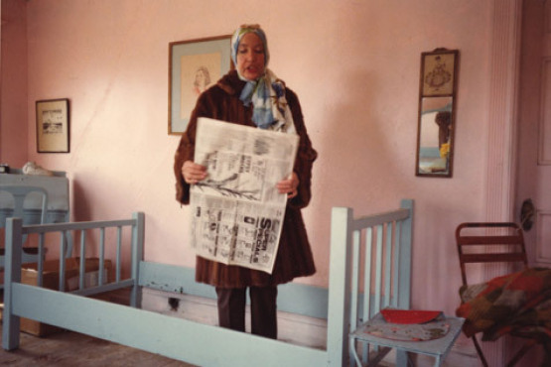
Also understand that as a student you are responsible for adhering to the attendance and due dates in this syllabus and discussed in class. If you do not understand a policy please ask me about it. These policies are not in place to make your life difficult but rather to insure that you get the full benefit of the class. As I’m sure you have all heard before – life in the “real, working world” is different then in college. Any job you have will simply expect you to show up on time and to complete projects on time. It is unlikely they will have a written policy on these things they are simply expected. It is assumed that you learned these in college if not long before. Read and remember these policies and your time in the film/video program will go smoothly.

Throughout this class we will be viewing a wide variety of work from artists in all cultures, religions, languages and lifestyles. This work has been carefully chosen to expose the students to different points of view and the artistic methods utilized to express those points of view. Some of the work may contain material with which some students may not be comfortable. If at any point in time a student becomes excessively uncomfortable with material being viewed they are welcome to exit the class for the remainder of that video piece and to return for the discussion of that piece.

Due to the technical nature of our video/computer/film facilities, certain systems or parts of systems may be unavailable as they are removed for maintenance or repair. The faculty will make every effort to accurately inform students as to when equipment will be available again. If you feel that technical issues will impact your ability to complete a project, you should discuss this with the professor in a timely manner BEFORE the project due date. Please note that technical difficulties are a very standard occurrence in this field and successful professionals are often noted for their abilities to find creative solutions that allow them to complete their projects on time and with artistic excellence despite technical difficulties.
The Fine Arts building is open 24 hours for your usage. If you are working
ate take caution to be safe and secure. Police is x3003 Do not give out codes to anyone!!
Tips for Success in video classes
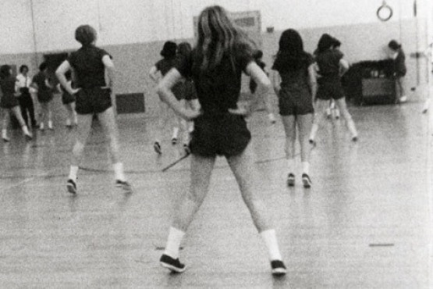
Always show up to class and lab. Be on time. Do not leave early. Pay attention, so do whatever you need to do to be attentive: coffee, food, pinching yourself, whatever it may be. Engage in the material. Ask questions. Read the suggested books in preparation for class. Volunteer. Get in there and work with the equipment; don’t stand back and miss an opportunity to handle the equipment.
Think about your projects very early and talk to me about your ideas. Get your projects done early and I can give you feedback in advance- that is, somewhat of a preview on your possible grade. Allow yourself A LOT of extra time to finish your projects, since there will always be technical complications that you won’t expect. Don’t turn projects in late; Follow the guidelines of the projects, like length and other parameters; there’s no reason to lose points on things you knew about in advance.
As with every production class, you will be required and expected to work many additional hours outside class time to complete your projects. If you have a heavy class or work schedule, you many want to reconsider your decision to take this class. Likewise, snafus and problems – both personal and technical-- are a part of the production process. If you are accustomed to waiting until the last minute to do your work, you should use this class to change your habits. You should build in time to deal with the inevitable problems that may throw you off of schedule, because the deadlines for projects are firm.
Think creatively; don’t resort to clichés. Consider stories that are beyond the typical college experience- push yourself on content. If you have a hard time coming up with original content, then adapt something, like a poem or short story (giving credit to the original work, of course). Cast people of different ages- not just college age students. Don’t work in isolation; help other students and expect others to help you. Find cohorts, teammates, a support system by reaching out to other classmates to share equipment and ideas and to give crew assistance and critical feedback. Create a media-making community.

DOCUMENTARY film video summer Schedule version 1.0
WEEK #1
Monday, June 4
In Class:
- Introduction to course and syllabus
- What is a documentary
- Discuss ideas
- Talk about self portrait and final project
Outside Class: Form teams
____________________________________________________________________
Tuesday, June 5
In Class:
1 Brief history of Documentary
2. Research and preproduction
3. View examples
Outside Class: Research on your documentary topic, locations and subjects
_______________________________________________________________________
Wednesday, June 6
In Class:
1. Preplans
2. View examples
3. Finalize topics
4. Finalize teams
5 Talk about interviewing and observation
Outside Class: Begin preplan for documentary project

Thursday, June 7
In Class:
1.Camera workshop
Outside Class: Shoot a one-minute documentary portrait of your partner. You should shoot at least 15 minutes of material for each portrait.. Include an interview, although visual evidence is the most important element.
Before Monday morning
Cue up footage that you shot over the weekend to screen in class this afternoon. You should be able to show representative footage of the activities you documented. Do NOT spend time editing this at this point.

WEEK #2
Monday, June 11
In Class:
1. Discuss preplans for documentary project
2. Screen select test exercise rushes and discuss any technical problems
3. Assign documentary treatments!
Outside Class:
1. Finish preplan for documentary project
2. Scout locations and take pictures for documentary project
_______________________________________________________________________
Tuesday, June 12
In Class:
- Discuss shooting strategies
- Show pictures of locations
Outside Class:
1. Refine shooting schedules for documentary
2. Work on documentary treatments – 100 words max.
_______________________________________________________________________
Wednesday, June 13
In Class:
1. Discuss shooting plans
2. Review written documentary treatments
3. Shooting schedules due
Outside Class: Begin shooting documentary projects
_______________________________________________________________________
Thursday, June 14
In Class: 1 FCPX workshop
2 data management
3 doc editing flow
Outside Class: Continue Shooting Documentary Projects
Edit one-minute portrait
________________________________________________________________

WEEK #3
Monday, June 18

In Class: 1. View footage from your documentaries.
2. Screen one minute portrait
Outside Class:
1.Continue shooting
2.Log and begin capturing footage
_______________________________________________________________________
Tuesday, June 19
In Class:
1. Screen editing examples, discuss style and structure
2. View footage from your documentaries
3. Discuss shot/segment list, due tomorrow
Outside Class: Begin first edit
_______________________________________________________________________
Wednesday, June 20
In Class:
1. View footage from your documentaries
2. Submit shot/segment list
3 Talk about Archival research
Outside Class: Continue first edit
_______________________________________________________________________
Thursday, June 21
In Class: NO CLASS - continue shooting (if necessary) and editing
Outside Class: Continue editing
_______________________________________________________________________
WEEK #4
Monday, June 25
In Class:
1. View first edits – critique session
2. Shot/segment list due today
Outside Class: Continue editing
Tuesday, June 26
In class:
1. View first edits – critique session
2. Write synopsis for public screening program
Outside Class: Plan final post
_________________________________________________________________
Wednesday, June 27
In Class:
1. Discuss required revisions
2. Final postproduction workshop
3. Sign up for individual team meetings during Monday class
Outside Class:
1. Work on revised edit
2. Any required re-shoots
_______________________________________________________________________
Thursday, June 28
In Class: No class meeting – work on final post/sound, etc.
Outside Class: Any required re-shoots, continue revised edit and working on final post/sound mix
_______________________________________________________________________
WEEK 5
Monday, July 3
In Class: Individual team meetings with your professor
Outside Class: Final postproduction
Final post/sound mix
_______________________________________________________________

Tuesday July 4 Independence Day no class
_______________________________________________________________
Wednesday, July 5 Last class
Final Class Meeting, Self Critiques Due all work due.
Outside Class:
7:00PM screening (tentative)
NOTE: This schedule is subject to revision at the discretion of the instructor.

