**RUSS 3306:Russian Literature in Translation**

**Spring 2016**

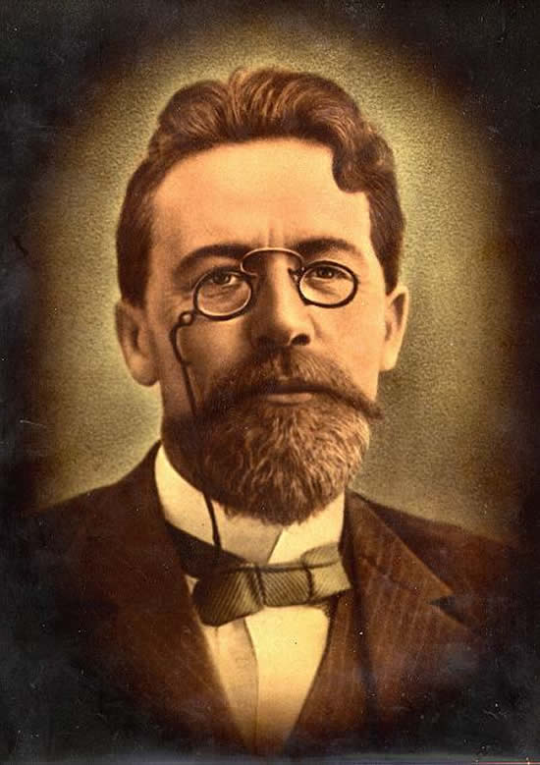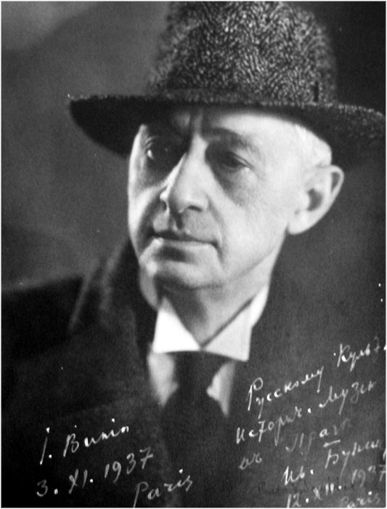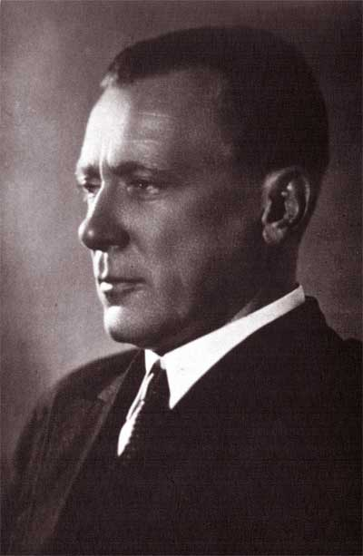

**The University of Texas at Arlington**

**Department of Modern Languages**

**Instructor:** Dr. Tatiana I. Baeva

**Office number:** 221 Hammond Hall

**Office phone:** 817-272-9509

**Email:** [tbaeva@uta.edu](mailto:tbaeva@uta.edu)

**Faculty Profile:** [**https://www.uta.edu/profiles/tatiana-baeva**](https://www.uta.edu/profiles/tatiana-baeva)

**Office hours:** WF 12:00 -1:00 pm or by appointment

**Section information:** RUSS 3306-001 ENGL 3306-001

**Time and place of class meetings:** MWF 9:00-9:50 PH202

**Description of Course Content**:

In Russian Literature 3306, the objective of the course is a familiarization of the students with: the main phases of development of Russian literature during the XX century. This will include the originality of the epoch of the literature of the boundary between 19th and 20th century, pre-Revolutionary and Revolutionary literature, the Silver Age of Russian poetry, the literature of Soviet culture and beyond, Russian Postmodernism, and the changes that occurred in genre system during these periods.

Students will learn the works provided by the program and have clear ideas about the Literary-Historical Process, as well as the interaction of literature with other forms of art, and connections of Russian literature with Folklore and World Literature. It will be necessary to pay particular attention to the poetics of specific works that characterize a special genre, epoch, or writers’ style.

**Student Learning Outcomes:**

1. During the discussions, students should provide their understanding of the regularity of Russian literary process; the role of literature in reflecting and shaping social and political values. Students should also indicate their own interpretation of the pieces of Russian works within the generally accepted viewpoints.
2. For the quizzes, students should have read the appropriate chapters and works from the list of required reading within the syllabus timing, review the notes from lectures, and also watch the movies, provided by the instructor, and be ready to answer questions on the plots of some Russian masterpieces.
3. For the specific discussion of the Silver Age of Russian poetry, students should memorize one of the verses either in Russian or English, as desired. (The poems will be provided by the instructor).

**Readings and Course Materials:**

Twentieth Century Russian Reader by Clarence Brown

Additional on-line resources will be provided in class

**Descriptions of major assignments and examinations**

During **the first month of the course** every student should read **a Russian work** and prepare a Book Review advertising one of the seminal Russian literary works. (The list and some materials will be provided by the instructor).Students will have the opportunity to get extra credits for every other member in the group who shows knowledge of the content of the advertised book, so students might want to negotiate with others to read each other’s books to get more points in the course (5% for each book, maximum 20% as extra credit can be added to a student’s total grade). **The Book Review presentation** will be given **two weeks before the mid-term exam**. No paper is required!

**By mid-semester**, students should complete **the outlines for their Final Project**. This may consists of a report for the group, a power-point presentation, ideas for a future thesis, or an article for a newspaper or magazine. This project should be a ten minute presentation given between the mid-semester and finals**.** **The Final Project presentation** will be given **two weeks before the end of classes**. A **5 page analytical essay** typed double space in Times New Roman 12 point font shall be **submitted with the presentation**.

**Midterm and Quizzes:**

Students should be able to demonstrate:

1) comprehension of the place of Russian literature of XX century in the logic of development of Russian culture and specificity of its poetics;

2) understanding of the unique characteristics of Russian literature and its intertwined nature with the World Literary Process;

3) basic understanding of the history of the Russian society depicted in the literature of the twenties century;

1. ability to argue the date of creation of a work by the features of its poetics;
2. possession of basic concepts from Studies of Literature and Culture analyzing the specific works.

**Attendance:**

At The University of Texas at Arlington, taking attendance is not required. Rather, each faculty member is free to develop his or her own methods of evaluating students’ academic performance, which includes establishing course-specific policies on attendance. As the instructor of this section, I have established following attendance policy: students are supposed to attend all the classes and participate in discussions. All classes and exams are based upon that assumption. You are responsible for acquiring class notes if you have to miss. Ultimately you will find that regular attendance is essential for a satisfactory grade performance.There are approximately 40 hours of classroom activity in this 3-hour course. If one misses less than 10%, such absences will not be counted against him/her, but if one misses over 4 classes (10%), then grade penalties will be assessed. Three instances of tardiness equal one absence.

# **Grading:**

Attendance is mandatory and forms a significant part of the final grade. See the attendance policy above.

Grades are apportioned as follows:

25% Participation and Required Reading (Class Discussions)

25% Quizzes and Written Homework Assignments

15% Midterm

5% Poem Recital

20% Final Project (Essay + Presentation)

10% Book Review (Reading + Creative Presentation)

(+5% extra credit for every additional student to read the book)

**Grading Scale:**

90-100 A

80-89 B

70-79 C

65-69 D

64 and below F

**Expectations for Out-of-Class Study**

Beyond the time required to attend each class meeting, students enrolled in this course should expect to spend at least an additional 9 hours per week of their own time in course-related activities, including reading required materials, completing assignments, preparing for exams, etc.

**Make-up Exam Policy**:

**There will be NO make-up exams or quizzes**. Extreme circumstances MAY be considered by Instructors discretion with valid proof provided, however is NOT guaranteed. A grade of zero will be recorded for a missed exam. Only ONE exam may be missed without a penalty.

**Drop Policy:**

Students may drop or swap (adding and dropping a class concurrently) classes through self-service in MyMav from the beginning of the registration period through the late registration period. After the late registration period, students must see their academic advisor to drop a class or withdraw. Undeclared students must see an advisor in the University Advising Center. Drops can continue through a point two-thirds of the way through the term or session. It is the student's responsibility to officially withdraw if they do not plan to attend after registering. **Students will not be automatically dropped for non-attendance**. Repayment of certain types of financial aid administered through the University may be required as the result of dropping classes or withdrawing. Contact the Financial Aid Office for more information.

**Disability Accommodations:**

**UT** Arlington is on record as being committed to both the spirit and letter of all federal equal opportunity legislation, including *The Americans with Disabilities Act (ADA), The Americans with Disabilities Amendments Act (ADAAA),* and *Section 504 of the Rehabilitation Act.* All instructors at UT Arlington are required by law to provide “reasonable accommodations” to students with disabilities, so as not to discriminate on the basis of disability. Students are responsible for providing the instructor with official notification in the form of a letter certified by the **Office for Students with Disabilities (OSD).** Students experiencing a range of conditions (Physical, Learning, Chronic Health, Mental Health, and Sensory) that may cause diminished academic performance or other barriers to learning may seek services and/or accommodations by contacting:

**The Office for Students with Disabilities, (OSD)** or calling 817-272-3364.

**Counseling and Psychological Services, (CAPS)** or calling 817-272-3671.

Only those students who have officially documented a need for an accommodation will have their request honored. Information regarding diagnostic criteria and policies for obtaining disability-based academic accommodations can be found at or by calling the Office for Students with Disabilities at (817) 272-3364.

**Title IX:** *The University of Texas at Arlington does not discriminate on the basis of race, color, national origin, religion, age, gender, sexual orientation, disabilities, genetic information, and/or veteran status in its educational programs or activities it operates. For more information, visit*[*uta.edu/eos*](http://www.uta.edu/hr/eos/index.php)*. For information regarding Title IX, visit* [www.uta.edu/titleIX](http://www.uta.edu/titleIX).

**Academic Integrity:**

All students enrolled in this course are expected to adhere to the UT Arlington Honor Code:

*I pledge, on my honor, to uphold UT Arlington’s tradition of academic integrity, a tradition that values hard work and honest effort in the pursuit of academic excellence.*

*I promise that I will submit only work that I personally create or contribute to group collaborations, and I will appropriately reference any work from other sources. I will follow the highest standards of integrity and uphold the spirit of the Honor Code.*

Instructors may employ the Honor Code as they see fit in their courses, including (but not limited to) having students acknowledge the honor code as part of an examination or requiring students to incorporate the honor code into any work submitted. Per UT System *Regents’ Rule* 50101, §2.2, suspected violations of university’s standards for academic integrity (including the Honor Code) will be referred to the Office of Student Conduct. Violators will be disciplined in accordance with University policy, which may result in the student’s suspension or expulsion from the University.

**Student Support Services Available:**

UT Arlington provides a variety of resources and programs designed to help students develop academic skills, deal with personal situations, and better understand concepts and information related to their courses. Resources include tutoring, major-based learning centers, developmental education, advising and mentoring, personal counseling, and federally funded programs. For individualized referrals, students may visit the reception desk at University College (Ransom Hall), call the Maverick Resource Hotline at 817-272-6107, send a message to resources@uta.edu, or view the information at [www.uta.edu/resources](http://www.uta.edu/resources).

**Electronic Communication Policy:**

The University of Texas at Arlington has adopted the University “MavMail” address as the sole official means of communication with students. MavMail is used to remind students of important deadlines, advertise events and activities, and permit the University to conduct official transactions exclusively by electronic means. For example, important information concerning registration, financial aid, payment of bills, and graduation are now sent to students through the MavMail system. All students are assigned a MavMail account. ***Students are responsible for checking their MavMail regularly.*** Information about activating and using MavMail is available at http://www.uta.edu/oit/email/. There is no additional charge to students for using this account, and it remains active even after they graduate from UT Arlington.

**Student Feedback Survey:**

At the end of each term, students enrolled in classes categorized as lecture, seminar, or laboratory shall be directed to complete a Student Feedback Survey (SFS). Instructions on how to access the SFS for this course will be sent directly to each student through MavMail approximately 10 days before the end of the term. Each student’s feedback enters the SFS database anonymously and is aggregated with that of other students enrolled in the course. UT Arlington’s effort to solicit, gather, tabulate, and publish student feedback is required by state law; students are strongly urged to participate. For more information, visit <http://www.uta.edu/sfs>.

**Final Review Week:**

A period of five class days prior to the first day of final examinations in the long sessions shall be designated as Final Review Week. The purpose of this week is to allow students sufficient time to prepare for final examinations. During this week, there shall be no scheduled activities such as required field trips or performances; and no instructor shall assign any themes, research problems or exercises of similar scope that have a completion date during or following this week *unless specified in the class syllabus*. During Final Review Week, an instructor shall not give any examinations constituting 10% or more of the final grade, except makeup tests and laboratory examinations. In addition, no instructor shall give any portion of the final examination during Final Review Week. Classes are held as scheduled during this week and lectures and presentations may be given.

**E-culture Policy:**

When dealing with faculty over email, it is important that students keep the following in mind: 1) Always use salutations and signatures. Be courteous. 2) For serious matters use emails to facilitate a mutually agreeable time to meet. Email should not be used to avoid personal interaction. 3) Never use email to vent or to respond immediately to an emotional situation. 4) Always remember that email creates a documentary record of one’s communication with others.

# There are two main reasons for using email in this course: 1) To set up a face-to-face appointment with your professor if you wish to ask questions regarding course materials, clarification or concerns about your progress in the course. 2) To inform the professor of absences.

**Emergency Exit Procedures:**

Should we experience an emergency event that requires us to vacate the building, students should exit the room and move toward the nearest exit. When exiting the building during an emergency, one should never take an elevator but should use the stairwells. Faculty members and instructional staff will assist students in selecting the safest route for evacuation and will make arrangements to assist handicapped individuals.

# Class schedule MWF

|  |  |  |
| --- | --- | --- |
| January 18 Martin Luther King Jr. Day holiday | January 20 Introduction to the course Video: Russian History through Literature | January 22 Introduction to 20th century Russian literature. |
| January 25 Realism of the end of 19th -early 20th century  Anton Chekhov | January 27 Seminars on A. Chekhov’s works: From a “small man” to a “small fry” (insignificant person): *Fat and Thin.*  *The Death of a Government Clerk* | January 29 Seminars on A. Chekhov’s works: From a “small man” to a “small fry” (continued): *The Man in a Case.*  *Chameleon.* |
| February 1 **Classroom assignment: analyzing one of A. Chekhov’s short stories.** | February 3 Discussion: A. Chekhov *Ionitch* A. Chekhov *The Lady with the Lapdog* | February 5 A. Chekhov *The Bishop* |
| February 8 **Quiz 1. Lectures Introduction to 20th century Russian literature, Realism of the end of 19th -early 20th century, A. Chekhov** | February 10 Ivan Bunin. *Light Breathing.* | February 12 Ivan Bunin. *Sunstroke.* |
| February 15 Ivan Bunin The *Gentleman from San Francisco* | February 17 Alexander Kuprin. *The Garnet Bracelet* | February 19Maxim Gorky. Old Izergil |
| February 22 **Quiz 2 I. Bunin, M. Gorky, A. Kuprin.** | February 24 Modernism in Russian Literature | February 26 The Silver Age of Russian Poetry: Symbolism |
| February 26 K. Balmont, D. Merezhkovskiy, Z. Hippius, V. Ivanov, V. Bryusov. | **March 2**  A. Blok Poetry | **March 4**  The Silver Age of Russian Poetry recitation |
| **March 7**  **Quiz 3 Symbolism, A. Blok** | **March 9**  The Silver Age of Russian Poetry: Acmeism  Akhmatova, Gumilyov | **March 11**  Mid-semester Exam |
| **March 14**  Spring vacation | **March 16**  Spring vacation | **March 18**  Spring vacation |
| **March 21**  B. Pasternak  Marina Tsvetaeva | **March 23**  Silver Age of Russian Poetry: Futurism:  David Burlyuk  Mayakovsky | **March 25**  **Quiz 4** **Acmeism, futurism.** |
| **March 28**  Historical situation and the search for new a philosophical foundation in Russia at the end of 19th – beginning 20th centuries.  Alexander Blok *The Twelve*  Ivan Bunin *Cursed Day*s *(selected chapters)* | **March 30**  **Quiz 5** **A. Blok *The Twelve,* Ivan Bunin *Cursed Day*s** | **April 1**  The Theme of the Civil War in works of M. Sholokhov and I. Babel  **Classroom assignment: Works of M. Sholokhov and I. Babel** |
| **April 4**  Satire of M. Zoshchenko | **April 6**  **Quiz 6 M. Sholokhov, I. Babel, M. Zoshchenko** | **April 8**  M. Bulgakov: *The Heart of the Dog* Verifying knowledge of the text. |
| **April 11**  M. Bulgakov: *The Heart of the Dog* (continue) | **April 13**  M. Bulgakov: *The Heart of the Dog* (continue) | **April 15**  M. Bulgakov *Master and Margarita* |
| **April 18**  M. Bulgakov *Master and Margarita*: fragments from the movie; discussion. | **April 20**  M. Bulgakov *Master and Margarita*: philosophical issues in the novel. | **April 22**  **Quiz 7. M. Bulgakov** |
| **April 25**  Discussion of Anna Akhmatova’s *Requiem* | **April 27**  **Quiz. 8** **Akhmatova’s Requiem**  A. Solzhenitsyn *Matryona’s Home.* | **April 29**  Russian Poetry:  Danil Kharms, Josef Brodsky  Vladimir Vysotsky |
| **May 2**  Students’ presentations  Modern literature. | **May 4**  Students’ presentations  Modern literature. | **May 6**  **Quiz 9 Modern literature**  Students’ presentations |

**The List for a Book Review**

1. **Pasternak, Boris Leonidovich**, Doctor Zhivago
2. **Rybakov, Anatoliy** Children of the Arbat
3. **Bryusov Valery** Fiery Angel
4. **Sholokhov, Mikhail Aleksandrovich** [And Quiet Flows the Don (Don flows home to the sea);](/cgi-bin/Pwebrecon.cgi?v1=1&ti=1,1&Search%5FArg=Sholohov%20Mikhail&Search%5FCode=NAME%5F&CNT=50&PID=cIwSu-YeJfMU71LhhMm0UtDpMFaHU&SEQ=20070118192632&SID=5)
5. **Sholokhov, Mikhail Aleksandrovich** Virgin Soil Upturned
6. **Bulgakov, Mikhail** White Guard
7. **Sologub, Fyodor** The Petty Demon
8. **Nabokov, Vladimir** The Defense
9. **Nabokov, Vladimir** The Despair
10. **Nabokov, Vladimir** The Gift
11. **Nabokov, Vladimir** Invitation to a Beheading
12. **Nabokov, Vladimir** King, Queen, Knave
13. **Dudintsev, Vladimir** Not by Bread Alone
14. **Solzhenitsyn, Aleksandr** First Circle
15. **Solzhenitsyn, Aleksandr** Gulag Arkhipelago **(**Arkhipelag GULag)
16. **Solzhenitsyn, Aleksandr** Cancer Ward
17. [**Aitmatov,** **Chingiz.**](/cgi-bin/Pwebrecon.cgi?SC=Author&SEQ=20070118202327&PID=BfkvJtoZwdK-OBJwmAxkVelcpcWfY&SA=Aĭtmatov,+Chingiz.)The Place of the Scull
18. **Ilf and Petrov** The Twelve Chairs and The Golden Calf
19. **Kuprin, Aleksandr** The Pit
20. **Gorky, Maksim** Artamonovs (Decadence)
21. **Gorky, Maksim** Foma Gordeyev
22. **Gorky, Maksim** Mother
23. **Shukshin, Vasilii** Snowball Berry Red
24. **Artsybashev, M** Sanin
25. **latonov, Andrei** Foundation Pit
26. **Pelevin, Victor** "Generation P"
27. **Ulitskaya,Lyudmila**The Kukotsky Enigma (The Kukotsky Enigma)
28. **Sokolov, Sasha** A School for Fools
29. **Petrushevskaya, Ludmilla** There once lived a girl who seduced her sister's husband, and he hanged himself .
30. **Petrushevskaya, Ludmilla** There Once Lived a Mother Who Loved her Children Until They Moved Back In.

**Topics for Final Project**

1. The poetic world of I. Bunin.
2. The soul of a Russian man in the novella “Village” by I. Bunin.
3. The theme of love in the volume “The Dark Alleys” by I. Bunin.
4. The romantic conception of love in A. Kuprin’s works (Olesya (The Witch), Sulamiph, The Garnet Bracelet).
5. The romantic world of A. Grin’s books.
6. Evangelistic motifs in L. Andreev’s “Judas Iscariot”.
7. The argument about the Truth and Dream in M. Gorkiy’s “The Lower Depths”.
8. The peasantry poetry of N. Klyuev, S. Klichkov, and P. Oreshin.
9. The philosophy of a Man and the World in poetry S. Esenin.
10. V. Mayakovskiy. The poet and revolution.
11. The imagery of the Fatherland in poetry of V. Mayakovskiy.
12. The particularities of the novel *Peter the First* by A. Tolstoy.
13. The problem of the relationship of man and nature in the works by M. Prishvin.
14. Russian literature of the Second World War.
15. Russian literature abroad from the first wave of immigrants (B. Zaytsev, I. Shmelyov).
16. The mystery of language in the novella “The Foundation Pit” by A. Platonov.
17. The world of nature in the poetry of N. Zabolotskiy.
18. The Peasants prose of V. Shukshin.
19. The moral problems in the novella of Y. Trifonov “The Exchange”
20. The artistic world of Chingiz Aitmarov.
21. Russian Postmodernist Literature: Sergey Dovlatov.
22. Russian Postmodernist Literature: Vasiliy Aksyonov
23. Russian Postmodernist Literature: Andrey Bitov “Pushkin House” .
24. .Feminine Prose: Tatiana Tolstaya.
25. Feminine Prose: Lyudmila Petrushevskaya.