The Cubist Process: Transformative Investigations in Cubist-Purist Analogies

Steve Quevedo

Associate Professor

School of Architecture UT Arlington

Introduction
The architectural process found a rich source of spatial advancement in the early 20th century paintings and collages of the Cubist and Purist artists. To understand the work of Le Corbusier, one must recognize the concurrent studies in his art works and theories he initiated with Amédée Ozenfant. Spatial development in phenomenal transparency, overlapping fields, positive and negative space and finally the realization of the plan libre resulted in a new architectural language.
Today the making of a collage is well integrated into design curriculums as both artifacts and as a process of design. How students investigate the collage to understand spatial analogies between art and architecture is a means towards the understanding of higher abstract thinking. The collage becomes a device to alleviate systemic thought processes and results into the unexpected. Seeing relationships between unlikely fragments challenges the student to create and design conditions to resolve basic spatial groupings and fields. The transition from collage to applications in making space in plan and section requires a student to develop a more advanced understanding of space; ones which are rich in variety, texture, definition, enclosure and volume.
The process of collage allows for the gestalt grouping of unknown and dissimilar elements to find compositional ordering and alignment. In these studies, students first investigated cubist and purist paintings for design principles, spatial and form ambiguities as well as written critiques of their findings. Study models examined multiple readings of the paintings. Organized into three spatial realms, a thick wall examined subtractive conditions into a mass. A second realm of object-types was dispersed to define spatial fields. Finally, a picture plane served to frame and compress elements in the paintings. The second phase of the project investigated the spatial properties inherent with the cubist/purist paintings using the analysis and study model as design tools in order to see analogous conditions between the paintings and architecture. Combined orthographic projections of plans, sections and elevations served as drawings to visualize spatial definition and design development. These explored the possibilities of spatial variance as indicated in the paintings. Finally the projects investigated the role of “object types” derived from the painting and study model as spatial determinants, objects in space and as spatial forms.

Given a two-story structural frame, a program of seven varying spaces and list of design principles to investigate, the project required the students to design a pavilion to house the original painting. Pragmatic problems of spatial definition, structure, enclosure and circulation were introduced in this phase.

The second program required students to investigate their own collage. Several transformative phases assembled analog collages, digital manipulations, hand-rendered compositions and low relief models. This process led to the development of an analogous landscape where the mapping of ground and a wall structure investigated simultaneous orthographic relationships.

Investigative Process
Analytic Cubism (1908-1912) refers to early Cubism where observed reality is analytically dissects objects into a new form and space reality.¹ Seen from multiple viewpoints, objects are broken into fragments, which are arranged into compositional relationships. Demarcation of edges blurs field and spatial adjacencies. Subdues colors of shade and dark chiaroscuro allude to a monochromatic reversal of traditional perspective. In contrast, the advent of Synthetic Cubism (1912-1914) corresponds with the development of the collage and articulates a clearer line and field definition between the fragments and spaces. Here bolder colors characterize the works exemplified in the works of Pablo Picasso, Georges Braque and Juan Gris.

In the chapter of Mixed Systems from “The Perspective and Other Drawing Systems”, by Fred Dubery and John Willats an examination of Juan Gris’ still life, Breakfast, (1914) analyses as set of compositional properties, which define Synthetic Cubism.² Cubism acts as the antithesis to traditional perspective painting in a series of six key criteria. The first rule confronts the drawing mechanism of one-point and two-point perspective drawings. In its place is the use of parallel-line drawings such as plan, elevation, section and plan obliques. The use of orthographic projections, a common drawing mechanism of modern architectural representation, compresses spatial dimension through measurable drawings. The perspective mimics how the human eye sees the environment by several devices: convergence to vanishing points, diminution in scale, atmospheric perspective employing color and detail and the establishment of one place in time of the artist’s view. These properties of the perspective advanced in the Renaissance led to advancements in spatial dimension and perspective achievement in architecture: tromp l’oeil, forced perspective and scenographic projection.
With the evolution of the collage first as assemblage studies between Georges Braque and Pablo Picasso and then pursued in the media of painting, the very process of making led to critical discoveries in two-dimensional representation of three-dimensional and four-dimensional understandings of space. The collage and Cubism conveyed the fourth dimension of time and movement. No longer fixed in one time and place, not one view, but realized by experience through the space-time continuum. Use of multiple overlapping fields breaks from the traditional picture plane of the perspective, dismantling the use of the drawing device. Time in this respect is represented by a shift in the station point and movement by the fragmentation of object-types. Increasingly liminal readings of these forms challenged the viewer to engage with the painting in a process of deciphering and reading thorough abstraction
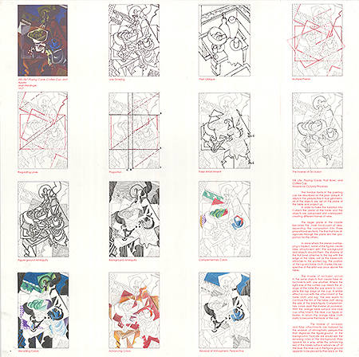
Fig. 1. Plate Two Cubist Analysis Octavia Pinkney
Returning to Dubery’s analysis, the painting of Gris’ Breakfast, is documented in the following principles: use of plan oblique, multiple picture planes, false attachments, inverse of occlusion, reversal of atmospheric perspective and use of text. By using parallel line drawings or non-perspective devices such as plan obliques and axonometric views, the spatial flatness of the orthographic projection compresses the spatial readings of depth. The mind makes sense of the measurable representation of space and form. As a consequence, space and form may invert.

With the use of overlapping planes, the representation of time by multiple planes superimposed over the picture plane establishes several points of views. The articulation of multiple planes lent itself to fragmentation of forms and spaces. Forms and space are broken up and reassembled, altered in their representation or shown from varying point of view.

In the third principle of false attachments, tangencies and adjacencies alter spatial depth. This device creates spatial ambiguity by allowing elements in the foreground to share points or linear conjunctions with elements in the background. Rather than adhering to the perspective rule of overlapping elements, the elements instead touch sides destroying the perception of depth. As a result the fourth principle of inversion of occlusion, tradition placement of objects in the foreground, which obscure elements in the background, is likewise dismantled. Instead of hiding or obstructing elements in the background, elements, which should be seen are missing and elements, which not be seen are revealed.

With the reversal of atmospheric perspective, the fifth principle, the use of advancing colors in the background and recessive colors or the use of the chiaroscuro in the middle ground or foreground are reverted. Advancing colors such as red is used on objects in the background while recessive colors such as blue inhabits the foreground. In Gris’ painting, what should be the focal point in the middle of the composition as a representation of objects becomes instead deep and subtractive in the picture plane.

Finally in the last principle, use of text, Gris incorporates newsprint as means of reading as well as a pattern reiterating field overlaps. Inventively his own name is collaged into the painting as a headline. Dubery and Willats refers to this use of text as “an alternative, non-visual system’. ³

Consequently, this dialogue with the viewer and painting develops a broader understanding of spatial and formal ambiguities. This is a point where the artist-architect Le Corbusier and his colleague, Amédée Ozenfant develop their manifesto, Après le Cubisme (1920), as a response to Cubism.⁴ Reacting against the narratives of Cubist paintings, the selection of industrial objects, particularly glasses, wine bottles, guitars, pipes reinvent the traditional still life. While these forms are continuing the subject matter of Picasso, Braque and Gris, the Purists push the spatial dimension of depth even further by representing both form and void simultaneously. Reacting against the undisciplined and merely decorative character of cubism, the Purist sought a “more rational and universally valid form of expression”. ⁵

Recognizing the Purist painting as an investigational tool, which corresponds to Le Corbusier’s development of the free plan, the articulation of architectural analogies is created between painting and space. In their selection of paintings, the students choose either a painting or collage based on these principles. In addition, they analyzed the paintings in basic design fundamentals: proportion, grid, lines of center, septums, alignment, transparency, hierarchy, figure-ground and figure-ground reversals. As the first project, the assignment staged a reiteration of these principles in addition to testing the student’s understanding and application of learned terminologies. The objective required the students to recognize analogous properties between the gestalt spatial exercises as abstracted spatial compositions and document isomorphic relationships between architecture and painting. Ultimately this ability of transference would be applied to plan analysis of historical building types and subsequently to their design process application in later projects.

The first physical process redrew the Cubist paintings in colored pencils and as a true collage of paper, prints, magazine cutouts, and three-dimensional fragments. These two reproductions situated in the middle of a sheet of 20” x 20” Strathmore paper became the Plate I of their presentation.

The next phase required a free-hand series of sketches, which defined at least sixteen formal design principles. As each were reviewed and developed as a didactic diagram, the students organized the sketches in a comprehensive sequence, which corresponded to a written critique. As a writing component of the project, the students strictly could not rely on historical review. They had to demonstrate their graphic discoveries in supporting text. As an introduction to digital media, the students then produced a mock-up for the second sheet of diagrams, Plate II. They formulated the information on paper beforehand and then further developed the diagrams using software programs: InDesign, Photoshop and AutoCad. Critically this process emphasized the idea of using digital media after one has developed a strategy beforehand in sketches. The third reiteration of a proof sheet introduced the students to the process of redlining a drawing and making corrections. In the final phase, the students presented the painting and the analysis, using only written and graphic representations they had developed and documented.

The model presented a unique challenge in construction. Interestingly, students have an innate ability to construct models without first producing working drawings. While this trait might seem desirable, it conflicts with the development of thinking and drawing in the two-dimensional realm. Orthographic drawings, used in schematic design, design development and constructions drawings, represent the ability to accurately describe through measurable documentation. This educational criteria becomes an important student performance imperative. Models advance the student’s understanding of form and space and equally they are very powerful at conveying design intentions. Yet, as learning objectives require beginning designers to produce models as representational tools, they must also be able to provide workable drawings, which successfully convey to others how to build their designs. Both models and drawings operate in this conveyance of information as well as a means for problem solving in the design process.

The models had two objectives. First, the model had to depict the painting in a singular frontal view. As a three-dimensional object however, each side of the orthographic box also had to be designed. Corresponding the four elevations required the use of orthographic projections to continue datums and explore through drawing new forms and spaces, which characterized the Cubist properties. In opposition to the frontal plane as the literal view or model face, the back elevation had to examine spatial depth through subtraction, additive layering of planes and poche. This particular side addressed the idea of a dominant wall as opposed to the front face as the mise en scène of the painting.

In the second project, a small spatial construct articulated the following spatial objectives: first to investigate the spatial properties inherent with the cubist/purist paintings using the analysis and study model as design tools. Reiterating the understanding of principles and their application, the second objective required the students to investigate plan and section within orthographic projections. These drawings visualized spatial definitions and their development. In the third objective, the exploration of spatial variance used the study model as a precedence to advance multiple space and form possibilities. Finally, the last objective explored form making by looking at the role of “object types” created from the painting and study model as spatial determinants, objects in space and as spatial forms.

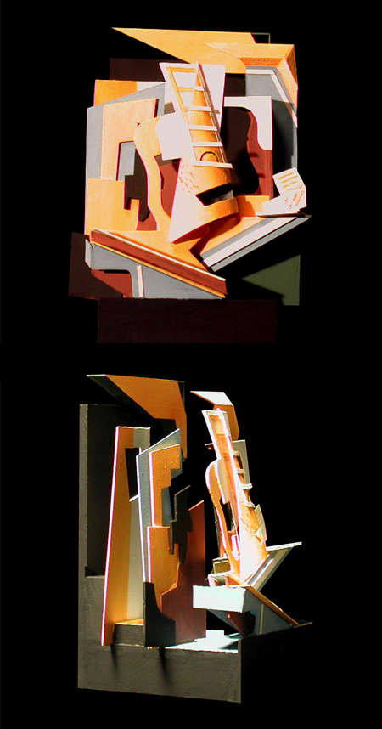

Fig. 2. Cubist Study Model Manuel Flores
Transformational Collages
In the last project, students composed collages demonstrating the rules of the collage set forth in “The Mixed Systems” article. Evaluation of their success depended upon their application of these principles. After the review, students wrote their names on the back as the author of phase one. The collages were collected and then redistributed to a second student. The second student further developed the collage addressing the compositional deficiencies discussed in the review.

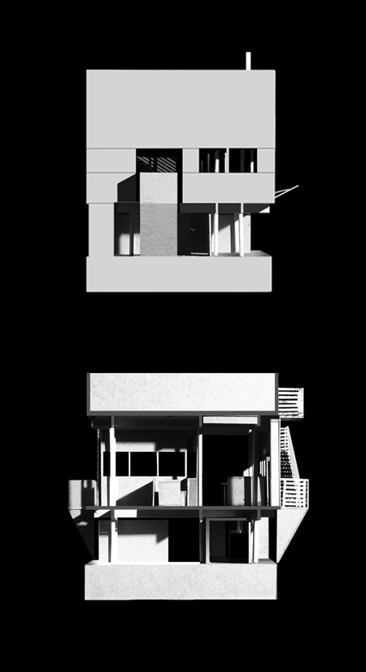

Fig. 3. Cubist Pavilion Models Anthony Boyer

This was a test to their ability to listen to design critique and to challenge their ability to approach design as a logical and objective review. At first, students were hesitant to alter another student’s work and make changes. On the second review, the students reproduced the first phase as a digital print. The requirements were to adopt the theme and ordering of the collage, but also demonstrate their logic as to why they made changes. The second phase had to reinforce and strengthen the principles and compositional organizations.
The next phase allowed the students to rescan the collage in Photoshop and continue to address compositional issues. They were also encouraged to utilize various digital tools to alter the collage. These included artistic filters, grey scaling, transformations of scaling, distortions and constructing new fields and trabeated structures, which alluded to actual building constructions. Each composition had to advance a primary field of hierarchy and a series of second and tertiary fields. Horizontal and vertical datum walls separated the composition into distinct visual realms, using smooth planes, trabeated frames, low-relief grids, texture and scored fields. The collages were constructed as allusion to construction and foundation imagery.
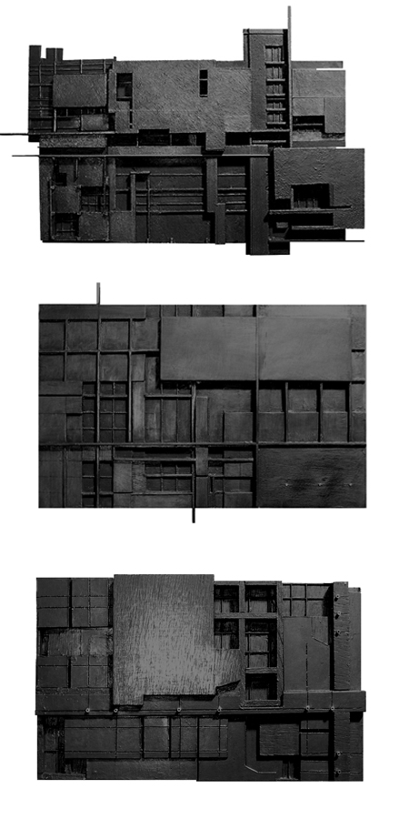
Fig. 4. The Analogous Landscape Models Kwanilisto Khonje,Angel Aquila, Jareb Parker

Analogous Landscapes: Site as Artifact
The black low relief models, carefully constructed as base foundations, used a mix of graphite and acrylic medium over a wood and cardboard construction. This allows the graphite medium to both obscure and reveal jointures and lines of construction. These seminal black paintings create a unified composition of foundational construction with an ominous presence of space and field.
These models, designated as The Analogous Landscapes, became place and site as well as an abstraction of the site plan for the wall project. The site is then seen as an artifact on which to build. Similar to the collage, the site-artifact required design response to existing context, fragments, foundations and spatial definitions.
In the final investigation, the wall façade and site operated to define the primary space and act as a datum wall for a small exhibition space and courtyard. Articulation and development of the façade addressed the principles of façade: proportion, grid, solid versus void, wall versus frame, entry, hierarchy, local centers, regulating lines and free façade. Compositional ideas were transferred from the black models to demonstrate the understanding of plan and elevation simultaneities. Again as an operative device, each project had to develop the wall in series of sketches and final orthographic projections. Invention in form and space take clues from the collage without direct imitation. The collage becomes an artifact in spirit to the architecture, but does not mindlessly direct its outcome.
The collage has a long and valued history in the design education. Its role in the works of early modernist established a foundation, which still resonates in how one sees the world. The collage opens this ability to see the nuances and variety of architectural spaces and dynamic forms. The use of the rules of the collage allows for a level of inventiveness within a structured framework while still challenging the student designers to explore rich compositions. This understanding reveals the design process to be both disciplined in objectives and yet provide a dynamic to creating architecture.
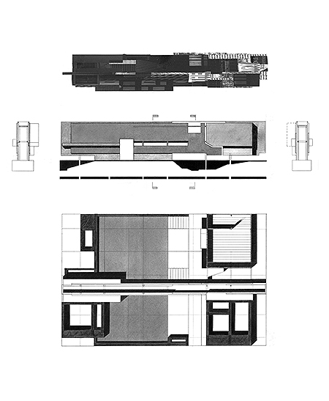Fig. 5. Final Orthographic Projections Jareb Parker
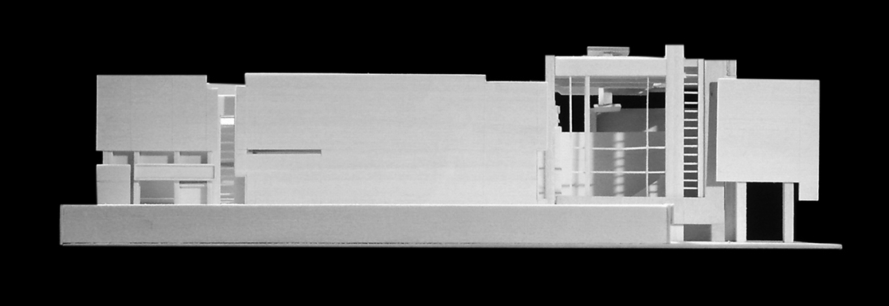

Fig 6. Elevation of Datum Wall Kwanilisto Khonje

Notes
¹Cox, Neil, “Avant-gardism and Modernity” in Cubism, Phaidon Press Limited, London, UK: c2000, p. 145.
2 Dubery, Fred and Willats, John. ”Mixed Systems” in Perspective and Other Drawing Systems, Van Nostrand Reinhold Co., New York: c1983. p. 112-114.
³. Dubery and Willats, p.114.
⁴. Cox, “War and Order” in Cubism, p. 377.
⁵. Ibid.

