Syllabus

This syllabus is current as of February 24, 2017. I reserve the right to adjust this syllabus to meet the educational needs of the student enrolled in this course. Please check Blackboard for the most current course syllabus.
Instructor: Dr. Diane Patrick  Office Phone: 817.272.0988 Office Phone: 817.272.2841 | Office: Trimble Hall 103H  Email: dpatrick@uta.edu
 | Office Hours: By appointment
Course Information: EDAD 5389.541—Administrative Practicum Cohort 54

Time and Place of Class Meetings: Web

Course Description: This course is designed to provide prospective educational administrators job-related experiences under supervision in an appropriate educational setting. An approved professional study is designed in relationship to the intern's interest and past experiences. EDAD 5389 is typically taken by the principal candidate in the first long semester, culminating with EDAD 5399 Capstone Practicum taken in the last long semester, but note that administrative experiences are expected to take place throughout the courses of the entire program.

Candidates work with their site supervisor/mentor, field supervisor, and others to gain administrative type experiences. Some experiences will be through observation, some through participation, and some through being given responsibility. Candidates should expect to experience the annual cycle of administrative events, constant events, planned events, and unplanned events. Candidates are to work on various projects during their practicum.

One project will be used to develop an Action Research PowerPoint to be submitted during the EDAD 5399 Capstone course. Candidates will be given assignments during their content courses that often will require gathering information and data from various sources.

Candidates are expected to give top priority to their current work responsibilities. Each practicum will be unique and should total at least 500 hours for an average of approximately 8-10 hours per week (as reflected in administrative log) over the course of the program.

Read more in the Intern Handbook found in Blackboard! Go to My Organizations and Click on Educational Leadership Policy Forum. Note course materials should be dated January 2017 or later.

For Texas students seeking and eligible for Texas principal certification the university assigns the first field supervisor for the first two observation cycles through videos. When taking the final practicum EDAD 5399, the student has identified a field supervisor who meets Texas Administrative Code requirements for the third observation face to face. The first field supervisor will be assigned by the university and will complete at least two observation cycles via videos and conferencing. The first observation video is due in 5389; the second observation video in Course 5 (approximately halfway through the program); the third observation takes place in 5399. Two months before registering for EDAD 5399, the candidate will submit to the university program for approval of a second field supervisor who will make at least one face-to-face observation/visit during the final practicum in order to evaluate the candidate’s transition toward administration. Communication is required between the candidate, the mentor, the field supervisors, and the program.

Non-Texas students and Texas students without Texas teaching certificates and/or who are not completing a practicum in a TEA-approved school should select their Field Supervisor as well as their Site Supervisor/Mentor for their observation cycles. The non-Texas candidate is responsible for determining and meeting his or her state’s certification requirements, as this program will not result in Texas licensure due to the Texas Education Agency requirement that the practicum experience must take place in a TEA approved site.

Student Learning Outcomes:
During this course, students will
- Become familiar with national educational administration standards.
- Learn their specific state’s requirements for becoming certified as a principal/administrator.
- Understand the structure and instructional philosophy of the UTA ELPS Master’s program.
- Select a site supervisor/mentor who will supervise their practicum.
- Select a certified administrator to serve as their field supervisor.
- Become familiar with the reports that will document their practicum experiences.
- Network with others via technology.
- Identify and begin practicing skills necessary for effective educational administration.
Required Texts:
Cunningham, W.G. (2006). A handbook for educational leadership interns: A rite of passage. Boston, MA: Allyn & Bacon. ISBN: 9780205464234.

Payne, R (2005). A framework for understanding poverty. Highlands, TX: aha! Process, Inc.
Note: Textbooks may be ordered online from your favorite distributor (e.g., Amazon.com or Barnes & Noble) or from the UT Arlington Bookstore.

Tk20: All students are required to purchase Tk20, which need only be purchased once during your degree program. If you have not already done so, you need to purchase it. Refer to Policies in this syllabus for additional information about Tk20.

The course is intended to meet the following standards set by the Educational Leadership Constituent Council 2011 standards for “building-level education leader” internships:

ELCC Standard 7.0: A building-level education leader applies knowledge that promotes the success of every student through a substantial and sustained educational leadership internship experience that has school-based field experiences and clinical internship practice within a school setting and is monitored by a qualified, on-site mentor.

ELCC STANDARD ELEMENTS:

ELCC 7.1: Substantial Field and Clinical Internship Experience: The program provides significant field experiences and clinical internship practice for candidates within a school environment to synthesize and apply the content knowledge and develop professional skills identified in the other Educational Leadership Building-Level Program Standards through authentic, school-based leadership experiences.

ELCC 7.2: Sustained Internship Experience: Candidates are provided a six-month, concentrated (9–12 hours per week) internship that includes field experiences within a school-based environment.

ELCC 7.3: Qualified On-Site Mentor: An on-site school mentor who has demonstrated experience as an educational leader within a school and is selected collaboratively by the intern and program faculty with training by the supervising institution.

Performance Assessments and Grade Calculation:
Title | Points Possible
Module 1: Reading Progress Monitor | 10
Module 1: Assignment on Resources | 10
Module 1: Syllabus Acknowledgement | 10 Requirement for passing course
Module 1: UT Arlington Honor Code Assent | 10 Requirement for passing course
Module 1: Dispositions Acknowledgement | 10 Requirement for passing course
Module 1: FERPA and Code of Ethics | 1 + 1 Requirement for passing course
Module 1: Discussion Post and Replies | 10
Module 1: Purchase Tk20 | Requirement for passing course
Module 1: Application for Practicum/Site Supervisor Contract | 10 Requirement for passing course
Module 1: Field Supervisor Agreement Form | 10 Requirement for passing course
Module 2: Reading Progress Monitor | 10
Module 2: Assignment-Certification and Standards | 10
Module 2: Discussion Post and Replies | 10
Module 3: Reading Progress Monitor | 10
Module 3: Assignment - Traits | 10
Module 3: Discussion Post and Replies | 10
Module 4: Reading Progress Monitor | 10
Module 4: Assignment - Skills | 10
Module 4: Practicum Report | 10 Requirement for passing course
Module 4: Discussion Post and Replies | 10
Module 4: 45 minutes Observation #1 Video | Requirement for passing course
Module 5: Reading Progress Monitor | 10
Module 5: Assignment – Pre-Platform | 10
Module 5: Time Log | 10 Requirement for passing course
Module 5: Discussion Post and Replies | 10
TOTAL | 222

Grading Scale: The course is graded on a pass/fail basis. To pass, all module activities must be completed at an “acceptable” level and at least 133 of the total 222 points must be earned. Late work and work that must be revised in order to meet the “acceptable standard” will receive a maximum of five (5) points per assignment. All assignments required for passing the course must be completed.

This course is designed to facilitate your learning from experiences in your personal and professional environment that will help prepare you for educational administration. Candidates should not enter a course or practicum to earn a grade or just to complete an assignment. You should try to maximize your learning experiences in preparation for advancing their career. Therefore, full participation in course activities, assignments, discussions, and other tasks is expected and required.
order to earn the credits to earn the degree to earn the credentials to be qualified for the position to which you desire, the goal is not to see how quickly you can earn the points so you can stop learning.

Submitting Assignments: You must complete all readings, progress monitors, assignments, and discussion postings/replies by the due dates. All file names must include your last name and the name of the assignment being submitted (e.g., Barron_PracticumReport). All assignments should be a Word document, using 11- or 12-point font in Times New Roman only.

All due dates for the readings, progress monitors, assignments and discussion postings/replies are listed in the course assignment schedule. Late work and work that must be revised to meet the acceptable criteria will receive a maximum of five (5) points per assignment. You are responsible for your technology/internet working to ensure work is completed by deadlines.
Course Assignment Schedule:
Readings, assignments and associated tasks are due on the class day on which they are listed.

Module 1 – Program and Internship Overview Due Date/Time
Read: Supervisor/Mentor and Field Supervisor Report Instructions and Internship Handbook found in Blackboard* |  | 11:59 p.m., Sunday, March 5
Read from text: Preface (vii-viii), Intro (1-2), Ch.1 (3-8), Ch 2 (9-11), Ch. 3 (34-37), Ch 9 (124-129), Ch. 15 (176-186)  Read: Instructor authored reading |  | 11:59 p.m., Sunday, March 5
Assignment: Submit FERPA form with TEA # found in Blackboard* under TEA/TEAL ID# |  | 11:59 p.m., Sunday, March 5
Assignment: Complete the attestations for the course syllabus, UT Arlington Honor Code and Dispositions. |  | 11:59 p.m., Sunday, March 5
Take Ethics/Dispositions quiz. |  | 11:59 p.m., Sunday, March 5
Assessment: Reading Progress Monitor |  | 11:59 p.m., Sunday, March 5
Assignment: Self-assess preparedness to begin internship. |  | 11:59 p.m., Sunday, March 5
Assignment: Purchase Tk20. |  | 11:59 p.m., Sunday, March 5
Assignment: Signed Field Supervisor Agreement will be sent to you by FS. Submit to your Site Supevisor/Mentor who will sign and return to you to be posted in Forum |  | 11:59 p.m., Sunday, March 5
Assignment: Submit Application for Practicum / Site Supervisor/Mentor Contract to Course Coach |  | 11:59 p.m., Sunday, March 5
Assignment: Attach completed Video Consent Form* submitted to Forum |  | 11:59 p.m. Sunday, March 5
Assignment: Familiarize yourself with Practicum Report* Form due Week 4 |  | 11:59 p.m. Sunday, March 5
Discussion: Go to the Discussion Board and prepare responses to discussion prompts. Create a thread to the forum and post your responses. Then read others’ posts and reply appropriately to at least 2 other students’ posts. |  | 11:59 p.m., Sunday, March 5

Module 2 - Standards and State Certification
Read from text: Ch. 4 (42-50), Ch. 5 (58-59), Ch. 14 (159-175)  Read: Instructor-authored reading |  | 11:59 p.m., Sunday, March 12
Assessment: Reading Progress Monitor |  | 11:59 p.m., Sunday, March 12
Assignments: Summarize certification requirements, standards or competencies. Rank six standards. |  | 11:59 p.m., Sunday, March 12
Assignment: Conduct a pre-observation conference with your field supervisor via phone, preferably Skype. |  | 11:59 p.m., Sunday, March 12
Discussion: Go to the Discussion Board and prepare responses to the discussion prompts. Create a thread to the forum and post your responses. Then read others’ posts and reply appropriately to at least two other students’ posts. |  | 11:59 p.m., Sunday, March 12

Module 3 - Halfway Checkpoint
Read from Cunningham text: Ch. 3 (34-41), Ch. 5 (51-61), Ch. 6 (62-70), Ch. 7 (71-89), Ch. 13 (148-156)  Read: Instructor-authored reading |  | 11:59 p.m., Sunday, March 19
Assessment: Reading Progress Monitor |  | 11:59 p.m., Sunday, March 19
Assignment: Analyze similarities and differences between teacher traits and principal traits. |  | 11:59 p.m., Sunday, March 19
Discussion: Go to the Discussion Board and prepare responses to the discussion prompts. Create a thread to the forum and post your responses. Then read others’ posts and reply appropriately to at least two other students’ posts. |  | 11:59 p.m., Sunday, March 19
Module 4 – Practicum Documentation
Read from Cunningham text: Ch. 2 (11-15), Ch. 8 (90-123), Ch. 10 (133-135), Ch. 11 (136-141).  Read: Instructor-authored reading | 11:59 p.m., Sunday, March 26
Assessment: Reading Progress Monitor | 11:59 p.m., Sunday, March 26
Assessment: 45 minutes Observation #1 Video submitted to Forum* | 11:59 p.m., Sunday March 26
Assignment: Describe how input skills are utilized by administrator. | 11:59 p.m., Sunday, March 26
Assignment: Complete and ubmit Candidate Section of Practicum Report to Field Supervisor. After FS returns, send to Site Supervisor/Mentor. After Mentor returns, post in Forum*. | 11:59 p.m., Sunday, March 26
Discussion: Go to the Discussion Board and prepare responses to the discussion prompts. Create a thread to the forum and post your responses. Then read others’ posts and reply appropriately to at least two other students’ posts. | 11:59 p.m., Sunday, March 26
Module 5 – Program Reports
Read from Cunningham text: Ch. 2 (15-33), Ch. 7 (82-89), Ch. 9 (126-129), Ch. 12 (142-147)  Read: Instructor-authored reading | 11:59 p.m., Sunday, April 2
Assessment: Reading Progress Monitor | 11:59 p.m., Sunday, April 2
Assignment: Draft your administrative platform. | 11:59 p.m., Sunday, April 2
Assignment: Submit your Time Log to Forum*. | 11:59 p.m., Sunday, April 2
Discussion: Go to the Discussion Board and prepare responses to the discussion prompts. Create a thread to the forum and post your responses. Then read others’ posts and reply appropriately to at least two other students’ posts. | 11:59 p.m., Sunday, April 2

*Found in Blackboard Forum as follows:
Scroll down to My Organizations.
Click on Educational Leadership and Practicum Forum

Detailed Guidelines for Assignments:
- Attestations: Complete the attestations for the course syllabus, UT Arlington Honor Code, and Dispositions.
- Assignment 1: Self-assess Resources for Program
- Assignment 2: Standards and State Certification Requirements
- Assignment 3: Teacher and Principal Traits
- Assignment 4: Input Skills as Fundamental Skills of Administration
- Assignment 5: Administrative Platform
1. Assignment 1: Self-Assess Resources for Program (Within the module, there will be additional discussion of the assignment)
Use the eight resources and conduct a self-assessment based on both Ruby Payne’s definitions and/or your own common sense understandings of the resources. You may omit any resource with which you are uncomfortable. Remember the context. You are entering into a Master’s degree program with the intent of advancing your career by obtaining an administrative position of some type. To what degree are you without resources?
After the self-assessment, reflect on the value of the assignment. The first five resources are more internal and the last three are more external. As you look toward your internship and the role your mentor plays, what resources can that person provide?
What did you learn from the assignment, or was it busywork with no value? Are there applications from the assignment that you can use now and in the future as an administrator? What do you know about Ruby Payne and her work?
If you wish to be critical of Payne’s theory, you may do so in your reflection without penalty.

Assignment Format:
Resource: | Self-assessment of your current resource/discussion
Financial
Emotional
Physical
Intellectual
Spiritual
Support System
Role Models
Knowledge of Hidden Rules
Reflection on value of assignment:

Rubric
Tasks | 10 Target  Points Earned | 7 Acceptable  Points Earned | 0 Unacceptable  Points Earned
Summarized discussion of resource self-assessment | Responses showed candidate understood purpose of assignment and made a connection with what they learned. They justified their value claim or supported their criticism of the assignment. | Responses showed candidate understood purpose of assignment but did not make a connection and had no explanation to justify their value or busywork position. | Responses were very short with no elaboration.
2. Assignment 2: Standards and State Certification Requirements (Within the module, there will be additional discussion of the assignment)
Your assignment is threefold:
1) Explore your state’s educational department web sites for the requirements for the certification you will be seeking.
2) Ascertain the type of assessment examination you will be required to pass, if any.
3) Rank the six ISLLC standards according to some sense of personal importance or priority.
As with the assignment in Module 1, there are no right or wrong answers. Hopefully though, there will be value in the assignment rather than just busywork.
It may be easiest to rank the six ISLLC standards in terms of 1a, 1b, 1c, 1d, 1e, and 1f. They are all important, but there still is an order of some kind to their importance.

Assignment Format:
State:
Source of information:
Certification to which you are seeking:
Certification Requirements:
Type of Assessment:
Source for study guide/preparation for assessment:
Personal evaluation of your status regarding certification requirements
Rank of six ISLLC standards:
1.
2.
3.
4.
5.
6.
Rationale for the ranking:
Value of the assignment or rationale for thinking the assignment was just busywork:

Rubric
Tasks | 10 Expert  Points Earned | 7 Acceptable  Points Earned | 0 Unacceptable  Points Earned
Summarized discussion of standards and state certification requirements | Responses show candidate understood purpose of assignment, had some justification for his/her value or busywork position, and was able to make a connection with what s/he learned, or supported criticism. | Responses show candidate understood the purpose of assignment, but had no explanation to justify his/her value or busywork position. | Responses were very short with no elaboration or were incomplete.

3. Assignment 3 Teacher and Principal Traits (Within the module, there will be additional discussion of the assignment)
This assignment has four parts:
- Organize the principal themes into intra, inter, and extra-personal categories. There are no right or wrong answers; so, don’t worry about your responses being graded according to which theme fits into which category. As you think about the principal themes, what are the similarities and the differences between the teacher and the principal themes?
Teacher Themes by Category | Principal Themes by Category
Intra-personal: | Intra-personal:
Mission
Investment
Focus
Inter-personal: | Inter-personal:
Empathy
Rapport drive
Listening
Objectivity
Extra-personality: | Extra-personality:
Individualized Perception
Input Drive
Activation
Innovation
Gestalt
2) Conduct a self-assessment of your teacher themes and how you view yourself as an administrator. Can you act the same as a teacher and as an administrator? How will your strengths carry over to administration? Will you have to act differently as an administrator? If so, how will this occur as you transition through an internship? Are the principal themes present in your classroom? Will the same style of classroom administration work in building administration?
3) Conduct an assessment of your mentors. How would you assess the themes of the administrators in your building? Are there similarities between their themes and your themes? Are there differences? How will you handle this as you work with them in your internship?
4) What is your opinion of these themes? Would you like to use the themes in selecting teachers? Would you like your district to use them in selecting principals? How might this system be an advantage and a disadvantage to you as you seek an administration position? What do you want to know more about concerning themes and selecting teachers/principals using themes, etc.?

Assignment Format:
Similarities and differences between teacher and principal themes:
Self-assessment of teacher and principal themes:
Assessment of my mentor’s/mentors’ principal themes:
Discussion of using themes for teacher and principal selection (include value of the assignment):

Rubric
Tasks | 10 Expert  Points Earned | 7 Acceptable  Points Earned | 0 Unacceptable  Points Earned
Summarized discussion of teacher and principal traits | Responses show candidate understood purpose of assignment, had some justification for his/her value or busywork position, and was able to make a connection with what s/he learned, or supported criticism. | Responses show candidate understood the purpose of assignment, but had no explanation to justify his/her value or busywork position. | Responses were very short with no elaboration or were incomplete.

4. Assignment 4: Input Skills as Fundamental Skills (Within the module, there will be additional discussion of the assignment)

Your assignment has four parts based on the following chart:
Input Strategy | Illustration
Use planning behaviors
Focus perception on specific stimulus
Control impulsivity
Explore data systematically
Use appropriate and accurate labels
Organize space with stable systems of reference
Orient data in time
Identify constancies across variations
Gather precise and accurate data
Consider two sources of information at once
Organize data (parts of a whole)
Visually transport data

1) Use a personal example to illustrate several of the input strategies. For example, take cooking. What happens if you don’t have some of these input skills, or if you make some mistakes utilizing these skills? Or take some other personal activity in which you are involved, and see if these input strategies make sense. You can also think back to your childhood. What games did you play as a child? How did playing these games help you in the development of your skills? What about games for adults? Do they utilize these same skills? What about video games / computer games? What games do your students/children play?
Can you distinguish differences between all 12 of the skills? Is there a 13th skill? Could you organize these skills into one, two or three categories? Could you become better at your activity if you improved in your input skills?
2) Consider your current work position and describe how some of these skills can be practiced/developed. It could be how you utilize these skills in teaching, or it could be how to help your students with their input skills, or both. Have you had a student teacher assigned to you? Did s/he ask you questions such as, “How did you know that?” or “How did you know to do that?” How did you? Did you have to really stop and think about how you knew that? It’s easy to assume the input skills are present in everyone or should be present in everyone. To some degree, they are present in everyone and individuals just have to figure it out on their own. But, what if they can’t? To what degree should you help them with their fundamental input skills?
3) Consider your desire to learn how to become an administrator and describe how some of these skills will be utilized. For example, take controlling impulsivity. How is this skill utilized in cooking? How is this skill utilized in teaching or learning math? How is this skill utilized in administration? How can it be practiced? How can it be evaluated?
4) Evaluate the assignment. Did the assignment make sense? Did it have value, or was it just busywork? Can you see implications for your own use? Can you see implications for future use as an administrator? Will you someday (or do you now) have a training camp for the “school season?” What would that look like? What do you think about Payne’s theory of input skills as fundamental skills? About what do you want to know more?

Assignment Response Format:
Summarize your discussion to the four aspects of the assignment below. You do not need to include your decision on what is an illustration of each specific input strategy. Focus on what you learned from each of the activities and on the value of the activities rather than on the specifics. You may certainly give an example or two to support or illustrate your thinking/learning but it is not necessary to include an answer to each and every question asked.
Input skills as they relate to a personal skill and/or learning these skills through playing games:
Input skills as they relate to your present position:
Input skills as they relate to your learning to become an administrator:
Discussion of input skills as a theory to learning (include value of the assignment):

Rubric
Tasks | 10 Target  Points Earned | 7 Acceptable  Points Earned | 0 Unacceptable  Points Earned
Summarized discussion of input skills as fundamental skills of administration | Responses show candidate understood purpose of assignment, had some justification for his/her value or busywork position, and was able to make a connection with what s/he learned, or supported criticism. | Responses show candidate understood the purpose of assignment, but had no explanation to justify his/her value or busywork position. | Responses were very short with no elaboration or were incomplete.
5. Assignment 5: Administrative Platform (Be sure to keep a copy of this, as you will submit it again during your EDAD 5399 Capstone course. Keep a hard copy or a “cloud” version in case your computer crashes sometime during the program.)
Your assignment for Module 5 is to write a pre-internship administrative platform. The platform is divided into four sections.
1. Describe your context. What is your current position? How long have you been employed in this position? What other positions/work/life experiences have you had that you believe contribute to your development and preparation for administrative positions?
2. In the areas of leadership and policy, what has contributed to your success? How do you define success? You can refer back to Cunningham’s textbook page 19 for an explanation of an administrative platform. One activity I sometimes use to help students think about this is to imagine you are getting ready to hold their first formal faculty meeting as principal (or similar setting). Write down the first three sentences you are going to say. What are the first three sentences you say to your classes at the start of each school year or each school day? Is this the platform upon which you operate? Why do you do the things you do? What do you value most?
Have you written down your first three sentences? If so, analyze them according to the degree they contain elements of the following four dimensions: 1) Function – I am going to be your principal and I am going to...…… 2) Programs – We are here to provide opportunities for students to learn, etc.….. 3) Interpersonal - We are going to work together……. and 4) Context – We are going to reach out to parents, we are going to achieve awards, we have to cut back, etc. Do your first three sentences contain one, two, three, or four of these themes? Should your first three sentences contain all of these themes? If your first three sentences are the first impressions your faculty get, what impressions would they get from your first three sentences?
Leadership is about behavior. Policy is about rule making. What is your platform on rules? Do you like rules as absolutes or as guidelines? How have you dealt with policies you do not necessarily like? How do you deal with people who do not necessarily like your policies?
3. Another aspect of your platform is your belief about school and society. What is your belief as to the purpose of education for our nation? What is your view of citizenship? What should schools do regarding politics and political parties? Should schools be neutral? Is citizenship like church where you just don’t talk about it? Has the purpose of school in society changed? If it has changed, has it been for the better or for the worse? Where should students receive their instruction about citizenship? Should students learn about citizenship from school, from parents, from peers, or from the media? What is the “correct” view of citizenship?
What role do you want to play as a future administrator in public school regarding the issue of school and society? What about “social justice.” Is there a difference between “protecting” individual rights and “promoting” individual rights?
4. Reflect on your administrative platform. What questions remain? About what are you certain? Can the content courses and your internship experiences help you continue to develop your administrative platform? About what are you most concerned? About what are you most excited?
Was the assignment of value? Remember, this is your pre-administrative platform. You will revisit this platform in approximately 15 months.

Assignment Format:
Summarize your discussion to the four aspects of the assignment below.
Describe the context:
Leadership and policy:
Citizenship:
Reflection:

Rubric
Task | 10 Target  Points Earned | 7 Acceptable  Points Earned | 0 Unacceptable  Points Earned
Summarized discussion of administrative platform | Responses show candidate understood purpose of assignment, had some justification for his/her value or busywork position, and was able to make a connection with what s/he learned, or supported criticism. | Responses show candidate understood the purpose of assignment, but had no explanation to justify his/her value or busywork position. | Responses were very short with no elaboration or were incomplete.

Action Research: You will submit a PowerPoint Action Research Project as part of your EDAD 5399 course. For the action research, you will address a concern, gather information and make a decision. Never conduct a survey without principal approval. You will receive additional information when you take the research course.

About the Professor:
My Ph.D. degree in Educational Administration was conferred by the University of North Texas, where my dissertation was entitled, “The Response of a Public School District to Charter School Competition: An Examination of Free-Market Effects.” Educational policy issues, including school finance and governance from PK-16, are particular interests of mine.
After receiving a B.A. degree from Baylor University, my initial public school employment began when I taught sixth grade in the Waco ISD, followed by Richardson ISD. During this time, I also earned my M.Ed. degree from the University of North Texas. Later I taught sixth and third grades in Birdville ISD, followed by three years as Director of Education at a PK-12 psychiatric hospital school. I have served 24+ years in various positions of public service: Arlington School Board for four terms, including four years as President. I was then elected to serve on the Texas State Board of Education. I taught graduate and undergraduate classes at UT-Arlington for 13 years prior to my election in 2006 as State Representative for House District 94, where I served on the Appropriations, Public Education, and Higher Education Committees. In January 2015 I retired from the Legislature, a position which I held for eight years, but I am excited to be back in the world of academia, including serving as a Trustee on the Tarrant County College Board. Last fall I was humbled to be honored by AISD when they named their new school Diane Patrick Elementary. My husband Ned and I met at Baylor University, been married 51 years, and live in Arlington, where he has retired from his dental practice. We have two grown children and seven beautiful and brilliant grandchildren!

Policies:

Class Attendance: At The University of Texas at Arlington, taking attendance is not required but attendance is a critical indicator in student success. Each faculty member is free to develop her or his own methods of evaluating students’ academic performance, which includes establishing course-specific policies on attendance. As this course is online, I expect all students to access the learning modules as required and complete assignments, discussions, and reflections as directed in the module by the posted deadline. While UT Arlington does not require instructors to take attendance in their courses, the U.S. Department of Education requires that the University have a mechanism in place to mark when Federal Student Aid recipients “begin attendance in a course.” UT Arlington instructors will report when students begin attendance in a course as part of the final grading process. Specifically, when assigning a student a grade of F, faculty report the last date a student attended their class based on evidence such as a test, participation in a class project or presentation, or an engagement online via Blackboard. This date is reported to the Department of Education for federal financial aid recipients.

Class Expectations. This course is designed to facilitate your learning from experiences in your personal and professional environment to help prepare you for educational administration. Candidates should not enter a course or practicum to earn a grade or just to complete an assignment. You should try to maximize your learning experiences in preparation for advancing your career. Therefore, full participation in course activities, assignments, discussions, and other tasks is expected and required. All students are expected to access the learning materials as required and complete assignments, discussions, and reflections and submit them in Blackboard by the specified deadline. While the course must be passed in order to earn the credits to earn the degree to earn the credentials to be qualified for the position to which you desire, the goal is not to see how quickly you can earn the points so you can stop learning.

Tk20: In states across the nation, efforts are again underway to reform public education. Texas is no exception, and each of us will play a significant role in ensuring quality education for all students PK - 20. Achieving this goal requires that we systematically monitor our progress through the assessment process and use the data we collect to inform program improvement, advising, and accreditation efforts.
To ensure quality of our educator preparation academic programs, the College of Education uses TK20 HigherEd, a comprehensive data management system that provides powerful tools to
- manage growth and streamline processes to meet your needs more efficiently and effectively;
- enable analyses at multiple levels;
- help ensure continuous quality of programs and preparation while maintaining national accreditation; and
- enhance the value of the degrees and certifications you receive through our College.
This set of tools is required as a course text; and as with other course materials, you will need to purchase an individual Tk20 account. However, you only need to purchase it once during your program:
- Tk20 will be where you submit certain key performance artifacts and build your academic performance portfolio.
- For designated key assignments, you must submit your work in both Tk20 and in Blackboard to receive credit.
- It also serves as the centralized location for submitting forms and is the hub for internships and practicums.
- It is best to purchase Tk20 during the initial weeks of your first course so you have access to it for submitting work on time.
- You will not be penalized for any Tk20 technical problems that cannot be avoided, but you must have access to TK20 so that you can submit work once any technical delays are addressed.
- On-line tutorials and training materials have been organized to orient you to the Tk20 system and its use. Check the College of Education Website for more information, updates and answers to frequently asked questions.

Grading and Levels of Proficiency: The course is graded on a pass/fail basis. To pass, all module activities must be completed at an “acceptable” level and 127 points must be earned. Late work and work that must be revised in order to meet the “acceptable standard” will receive a maximum of five (5) points per assignment. All assignments required for passing the course must be completed.

Policy on Granting an Incomplete: Incomplete grades are highly discouraged. Incomplete grades will only be granted because of extenuating circumstances or major emergencies.

Drop Policy: Students may drop or swap (adding and dropping a class concurrently) classes through self-service in MyMav from the beginning of the registration period through the late registration period. After the late registration period, students must see their academic advisor to drop a class or withdraw. Undeclared students must see an advisor in the University Advising Center. Drops can continue through a point two-thirds of the way through the term or session. It is the student's responsibility to officially withdraw if they do not plan to attend after registering. Students will not be automatically dropped for non-attendance. Repayment of certain types of financial aid administered through the University may be required as the result of dropping classes or withdrawing. For more information, contact the Office of Financial Aid and Scholarships (http://wweb.uta.edu/aao/fao/).

Disability Accommodations: UT Arlington is on record as being committed to both the spirit and letter of all federal equal opportunity legislation, including The Americans with Disabilities Act (ADA), The Americans with Disabilities Amendments Act (ADAAA), and Section 504 of the Rehabilitation Act. All instructors at UT Arlington are required by law to provide “reasonable accommodations” to students with disabilities, so as not to discriminate on the basis of disability. Students are responsible for providing the instructor with official notification in the form of a letter certified by the Office for Students with Disabilities (OSD). Only those students who have officially documented a need for an accommodation will have their request honored. Students experiencing a range of conditions (Physical, Learning, Chronic Health, Mental Health, and Sensory) that may cause diminished academic performance or other barriers to learning may seek services and/or accommodations by contacting:

The Office for Students with Disabilities, (OSD) www.uta.edu/disability or calling 817-272-3364. Information regarding diagnostic criteria and policies for obtaining disability-based academic accommodations can be found at www.uta.edu/disability.

Counseling and Psychological Services, (CAPS) www.uta.edu/caps/ or calling 817-272-3671 is also available to all students to help increase their understanding of personal issues, address mental and behavioral health problems and make positive changes in their lives.

Non-Discrimination Policy: The University of Texas at Arlington does not discriminate on the basis of race, color, national origin, religion, age, gender, sexual orientation, disabilities, genetic information, and/or veteran status in its educational programs or activities it operates. For more information, visit uta.edu/eos.

Title IX Policy: The University of Texas at Arlington (“University”) is committed to maintaining a learning and working environment that is free from discrimination based on sex in accordance with Title IX of the Higher Education Amendments of 1972 (Title IX), which prohibits discrimination on the basis of sex in educational programs or activities; Title VII of the Civil Rights Act of 1964 (Title VII), which prohibits sex discrimination in employment; and the Campus Sexual Violence Elimination Act (SaVE Act). Sexual misconduct is a form of sex discrimination and will not be tolerated. For information regarding Title IX, visit www.uta.edu/titleIX or contact Ms. Jean Hood, Vice President and Title IX Coordinator at (817) 272-7091 or jmhood@uta.edu.

Academic Integrity: Students enrolled all UT Arlington courses are expected to adhere to the UT Arlington Honor Code:

I pledge, on my honor, to uphold UT Arlington’s tradition of academic integrity, a tradition that values hard work and honest effort in the pursuit of academic excellence.
I promise that I will submit only work that I personally create or contribute to group collaborations, and I will appropriately reference any work from other sources. I will follow the highest standards of integrity and uphold the spirit of the Honor Code.

UT Arlington faculty members may employ the Honor Code in their courses by having students acknowledge the honor code as part of an examination or requiring students to incorporate the honor code into any work submitted. Per UT System Regents’ Rule 50101, §2.2, suspected violations of university’s standards for academic integrity (including the Honor Code) will be referred to the Office of Student Conduct. Violators will be disciplined in accordance with University policy, which may result in the student’s suspension or expulsion from the University. Additional information is available at https://www.uta.edu/conduct/.

Electronic Communication: UT Arlington has adopted MavMail as its official means to communicate with students about important deadlines and events, as well as to transact university-related business regarding financial aid, tuition, grades, graduation, etc. All students are assigned a MavMail account and are responsible for checking the inbox regularly. There is no additional charge to students for using this account, which remains active even after graduation. Information about activating and using MavMail is available at http://www.uta.edu/oit/cs/email/mavmail.php.

Campus Carry: Effective August 1, 2016, the Campus Carry law (Senate Bill 11) allows those licensed individuals to carry a concealed handgun in buildings on public university campuses, except in locations the University establishes as prohibited. Under the new law, openly carrying handguns is not allowed on college campuses. For more information, visit http://www.uta.edu/news/info/campus-carry/

Student Feedback Survey: At the end of each term, students enrolled in face-to-face and online classes categorized as “lecture,” “seminar,” or “laboratory” are directed to complete an online Student Feedback Survey (SFS). Instructions on how to access the SFS for this course will be sent directly to each student through MavMail approximately 10 days before the end of the term. Each student’s feedback via the SFS database is aggregated with that of other students enrolled in the course. Students’ anonymity will be protected to the extent that the law allows. UT Arlington’s effort to solicit, gather, tabulate, and publish student feedback is required by state law and aggregate results are posted online. Data from SFS is also used for faculty and program evaluations. For more information, visit http://www.uta.edu/sfs.

Final Review Week: for semester-long courses, a period of five class days prior to the first day of final examinations in the long sessions shall be designated as Final Review Week. The purpose of this week is to allow students sufficient time to prepare for final examinations. During this week, there shall be no scheduled activities such as required field trips or performances; and no instructor shall assign any themes, research problems or exercises of similar scope that have a completion date during or following this week unless specified in the class syllabus. During Final Review Week, an instructor shall not give any examinations constituting 10% or more of the final grade, except makeup tests and laboratory examinations. Additionally, no instructor shall give any portion of the final examination during Final Review Week. During this week, classes are held as scheduled. Also, instructors are not required to limit content to topics that have been previously covered; they may introduce new concepts as appropriate.

Writing Standards: Class participants who enroll in this course are considered graduate university students, whether part-time or full-time. Effective communication skills are demanded in today’s competitive world, and individuals are often judged based upon their proficiency in the use of the language. Therefore, high written standards (including adherence to specifications and use of acceptable grammar, punctuation and spelling) are expected on formal assignments and will be applied in grading assignments. However, with non-formal communication; e.g., email, consideration will be given to the message rather than to the format.

Student Support Services: The University of Texas at Arlington provides a variety of resources and programs designed to help students develop academic skills, deal with personal situations, and better understand concepts and information related to their courses. Resources include tutoring, major-based learning centers, developmental education, advising and mentoring, personal counseling, and federally funded programs. For individualized referrals, students may contact the Maverick Resource Hotline at 817-272-6107, send a message to resources@uta.edu, or view the information at www.uta.edu/resources.

Student Support Services: UT Arlington provides a variety of resources and programs designed to help students develop academic skills, deal with personal situations, and better understand concepts and information related to their courses. Resources include tutoring, major-based learning centers, developmental education, advising and mentoring, personal counseling, and federally funded programs. For individualized referrals, students may visit the reception desk at University College (Ransom Hall), call the Maverick Resource Hotline at 817-272-6107, send a message to resources@uta.edu, or view the information at http://www.uta.edu/universitycollege/resources/index.php.

The IDEAS Center (2nd Floor of Central Library) offers free tutoring to all students with a focus on transfer students, sophomores, veterans and others undergoing a transition to UT Arlington. To schedule an appointment with a peer tutor or mentor email IDEAS@uta.edu or call (817) 272-6593.
The English Writing Center (411LIBR): The Writing Center Offers free tutoring in 20-, 40-, or 60-minute face-to-face and online sessions to all UTA students on any phase of their UTA coursework. Our hours are 9 am to 8 pm Mon.-Thurs., 9 am-3 pm Fri. and Noon-6 pm Sat. and Sun. Register and make appointments online at http://uta.mywconline.com. Classroom Visits, workshops, and specialized services for graduate students are also available. Please see www.uta.edu/owl for detailed information on all our programs and services.
Librarian to Contact: Michelle Reed, michelle.reed@uta.edu, 817.272.5127

Professional Dispositions: Each candidate in the College of Education at UT Arlington will be evaluated on Professional Dispositions by faculty and staff. These dispositions have been identified as essential for a highly-qualified professional. Instructors and program directors will work with candidates rated as “unacceptable” in one or more stated criteria. The candidate will have an opportunity to develop a plan to remediate any digressions.

College of Education Conceptual Framework: The conceptual framework of the UT Arlington College of Education was developed collaboratively and has evolved over time. Following the identification of a set of core values held by all involved in the preparation of candidates enrolled in the College, members of the University, PK-12 districts, higher education institutions, and area business and foundation communities worked together to develop a shared vision for education.

All activities in the College are guided by the premise that we are Partners for the Future, committed to fostering critical, creative thinkers prepared to engage meaningfully in a dynamic society. This premise is characterized and distinguished by three core values: Professionalism, Knowledge, and Leadership. Research, Diversity, and Technology are themes woven throughout each core value. The College mission, core values, and themes serve as the coherent thread running through all professional programs, guiding the systematic design and delivery of clinical/field experiences, course curricula, assessments, and evaluation. The Conceptual Framework consists of six interrelated and interacting components, which are viewed as essential contexts for the shaping of informed, skilled, and responsible partners:

- The first core value, Professionalism, represents the contention that candidates develop an expertise and specialized knowledge of their field. A high quality of work, standard of professional ethics and behaviors, as well as work morale and motivation are all necessary factors of a developed interest and desire to excel in job performance.

- The second core value, Knowledge, represents candidate theoretical or practical understanding of a subject. In today's world, candidate knowledge includes not only academic content mastery, but also skills such as critical thinking, communication, technology literacy, and collaboration, each required for success in college, life, and career.

- The third core value, Leadership, represents candidate ability to organize, assist, and support others in the achievement of a common task. Candidates develop and refine their leadership skills within the context of their interactions with PK-20 students, curricula, faculty, and other professionals. The additional three components of the model, Research, Diversity, and Technology, represent themes woven into the core values:
  - Research encompasses the investigation of ideas and theories with the purpose of discovering, interpreting, and developing new systems, methods, and support for knowledge, behaviors, and attitudes.

  - Diversity is an indispensable component of academic excellence. A commitment to diversity means a dedication to the inclusion, welcome, and support of individuals from all groups, encompassing the various characteristics of persons in our community such as race, ethnicity, national origin, gender, age, socioeconomic background, religion, sexual orientation, and disability.

  - Technology is emphasized throughout all programs and is used to support and improve content delivery and student learning.

All components lead to the achievement of one goal–the development of informed and responsible Partners for the Future–who are committed to fostering analytical, innovative thinkers prepared to engage meaningfully in a dynamic society.

Uploading your Video

Record a video with any video camera
(For example: personal video camera, smartphone, tablet, webcam, etc.)
- Record your video.
- Transfer the video from the camera to your computer.
Every camera has a different way to transfer videos. Check your camera documentation or use an internet search to find instructions on how to transfer your video.
- In Blackboard, navigate to Discussions link and then click the Introduction Videos forum.
- Click the Create Thread button.
- Enter a Title in the Subject field and any text you want to include in the Message field.
- In the text area for Message, there should be three rows of icons. If not, click the double down arrow on the far right.
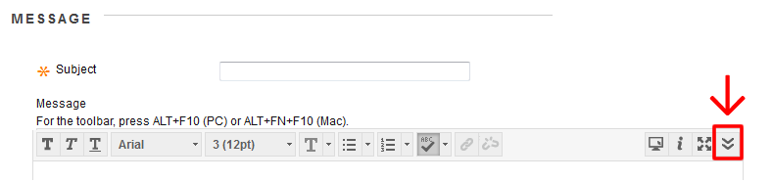

- Click the “Mashups” button (located on the third row of icons).
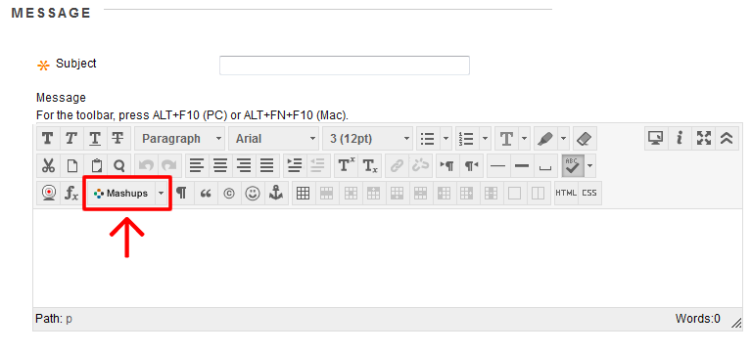
- Select “Kaltura Media” from the menu that appears.
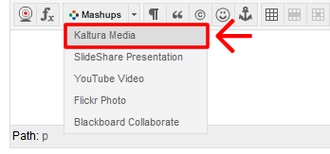
- A new window appears. Click the “Add New” button in the top right.

- Select “Media Upload” from the menu that appears.

- Click the “Choose a File to Upload” button.
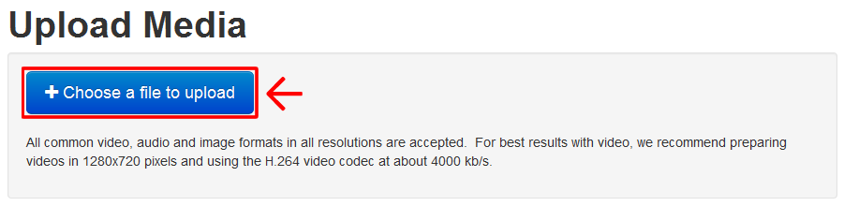
- Navigate your computer’s files to locate the video file.
- Select the video file and click Open.

- Your video will begin to upload and you will receive a message that the upload has completed.
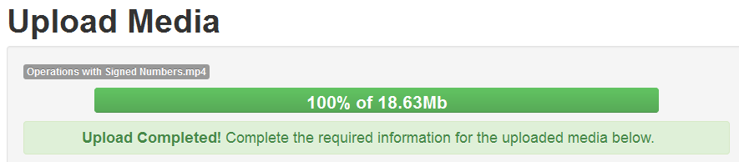
- Enter a name and description for the video and click the Save button when done.
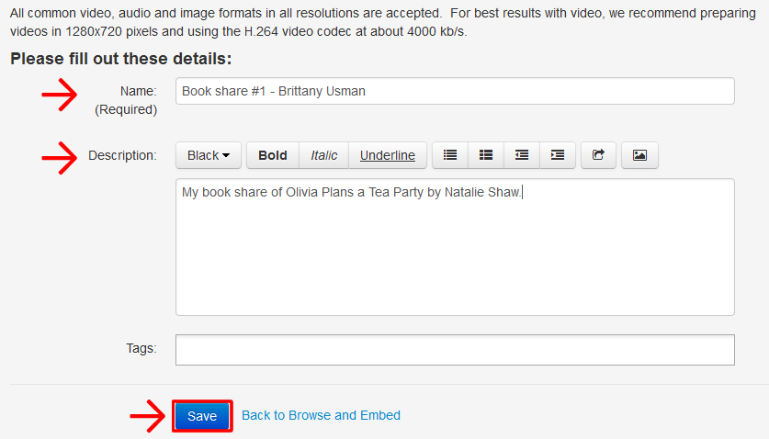

- You will receive a message that says your changes have been saved.
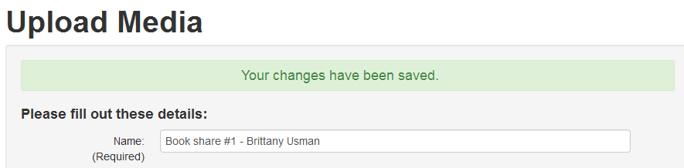
- Click the “Back to Browse and Embed” link.
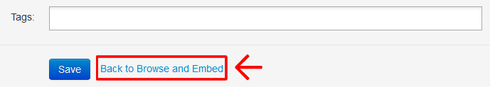
- Click the “Select” button next to the video you uploaded.
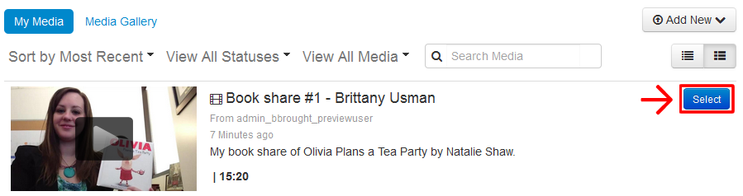

- Your video and details added will appear in the Message box.
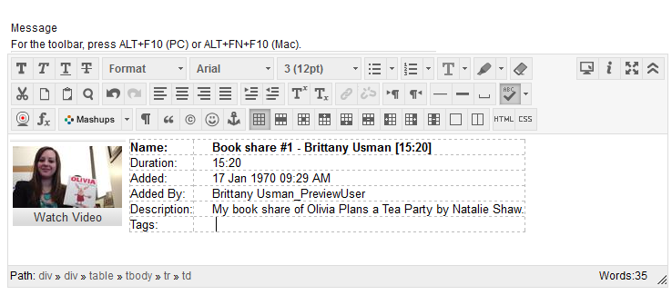
- Click the “Submit” button when done.
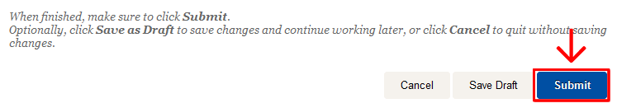

Emergency Phone Numbers: In case of an on-campus emergency, call the UT Arlington Police Department at 817-272-3003 (non-campus phone), 2-3003 (campus phone). You may also dial 911.

