**UTA. The University of Texas at Arlington.**

College of Business

Department of Marketing

**INSTRUCTOR**: Linda Wilson

Office Location: COB Room 323

Office Phone Number: 817-272-1014

Email: lkwilson@uta.edu

Office Hours: M/W 3:15 – 3:45 p.m.

**BCOM 3360-007 Effective Business Communications; 3 hours**

**Spring 2017; COB Room 149**

**Class Schedule: 7 – 8:20 p.m. Mon. and Wed.**

**COURSE DESCRIPTION**

This course will develop the student’s written and verbal skills which will be necessary for effective communication in a business environment. The course includes resume preparation and interpretation. Oral communication is practiced by individual oral presentations. There will be a special emphasis on the business writing process including business letters, organization memos, business reports, and Internet communication such as emails. The relationship of communication and interpersonal skill development within teams will be explained. The course will utilize a variety of methods including lecture, class discussion, and exercises to achieve this purpose.

**STUDENT LEARNING OUTCOMES**

Upon completion of the classroom instruction, including appropriate media, case discussion, & problem-solving simulations, the following student learning outcomes will be achieved:

1. The students will be able to implement the appropriate business communication strategy based upon the business problem presented.

1. The students will be able to understand and implement the general guidelines for effective communication in letters, emails, presentations and other forms of business communication.
2. The students will be able to create effective resumes, cover letters, and other business related communication documents.
3. The students will be able to develop their interpersonal skills through a better understanding of the communication process.
4. The students will be able to create a higher level of confidence when communicating routine business messages.
5. The students will be able to understand the process of developing and planning business communications (written and oral) through practical application.

**TEXTBOOK (Required Materials for the Course )**

**Business Communication: Developing Leaders for a Networked World**; Peter W. Cardon; McGraw-Hill Irwin, New York, New York; Third Edition, 2018. The buying options for the students: see below.

**Where and How to Get It:  *Student Options for Purchasing:***

|  |  |
| --- | --- |
| 1. **UTA Bookstore (discounted price)**:  **Business Communication: Developing Leaders for a Networked World with Connect Plus**)   Product Requested for Discount - CARDON GEN CMB LL BUSN COMM; CNCT 3 2018 NEW ISBN: 9781260200324 (LL + Connect)    Product Requested for Discount - CARDON CNCT AC BUS COMM 3 2018 NEW ISBN: 9781260200591 (Connect)  What you will need: You will be required to have materials from McGraw-Hill Education that include the textbook content and CONNECT. CONNECT houses Learnsmart, your adaptive online study tool. The UTA bookstore has this package which includes the print book and the Connect Code.  You need the CONNECT code to access the online study modules. |  |

***OR:***

1. **Online**:  All DIGITAL. You can purchase Connect **(no print book, EBook and access to all the Connect/Learnsmart content)** directly from the publisher.

**CONNECT/Learnsmart Registration:**

**Please wait until the first day of class to register for Connect*.* A representative from the publisher is going to be at the first class to explain how to register and use Connect.**

If you chose to go pure digital, and then decide that you need a hardcopy of the book, you will be able to order one from McGraw-Hill directly from your Connect class site.  A loose leaf color copy can then be sent to your home or campus address.

**SUPPORT: If you need any Technical Support (forgotten password, wrong code, etc.; please contact McGraw-Hill Education Customer Experience Group at**

**(800) 331-5094**

(Please be sure to get your case number for future reference if you call the CXG line.)

**FAQs:** [**http://www.connectstudentsuccess.com/**](http://www.connectstudentsuccess.com/)

**BCOM 3360 – Business Communication - Developing Leader for a Networked World**

**Course Outline – Fall Term 2017**

The following schedule is tentative and subject to change at the instructor’s or university’s discretion.

**ALL ASSIGNMENTS ARE DUE AT NOON (12 p.m.) ON THE DESIGNATED DATE.**

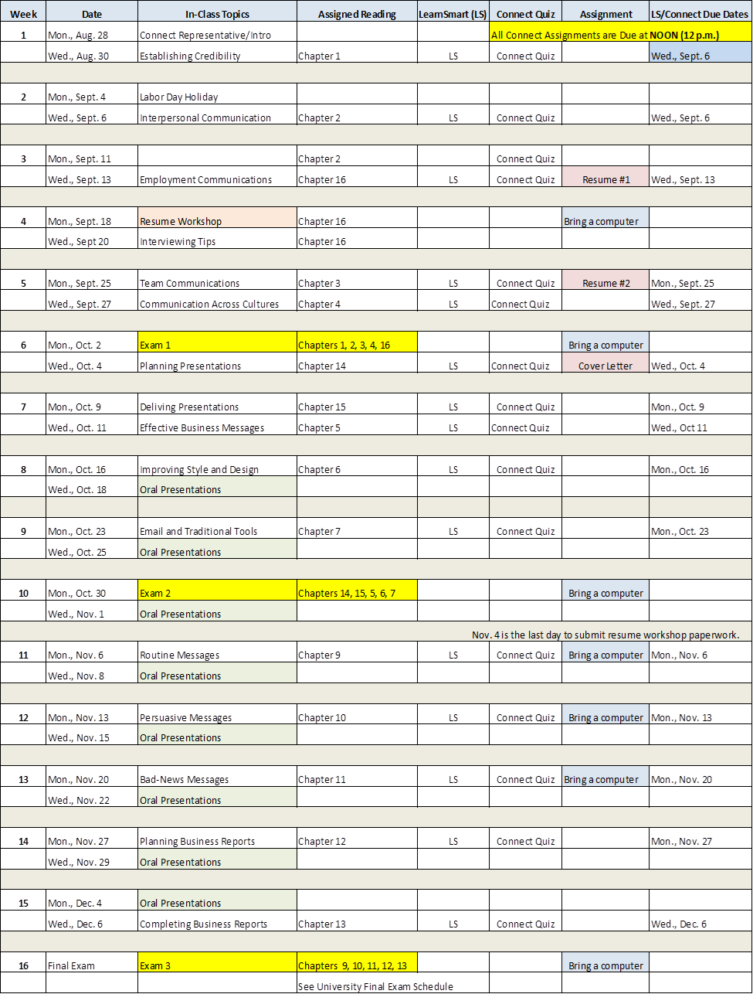

Requirements for Credit

**WHAT STUDENTS ARE EXPECTED TO DO:** Active participation is critical for an optimum learning experience. Prior to coming to class, students will be expected to know the subject and content of scheduled material in order to participate in class discussions/activities. Preparation for class includes a thorough reading of the scheduled material and completed assignments on Connect. Class lectures will also cover information that is supplemental to that found in the text. Any material covered in assigned readings, lectures, or videos shown in class may be included on exams. Please note that videos shown in class may not be available for later viewing. **Make sure you bring your textbook or e-book to each class since it will be used in class activities.**

**STUDENT CLASSROOM BEHAVIOR:** Each class session is a formal meeting. Students are not to engage in any behavior that interferes with the right of other students to learn. No cell phone use will be allowed. Cell phones need to be turned off and out of sight. Laptops will be allowed for in-class activities. Most classes will have an electronic-free discussion time. That means that all electronics will need to be turned off.

**ATTENDANCE/PARTICIPATION (60 points):** At the University of Texas at Arlington, taking attendance is not required. Rather, each faculty member is free to develop his or her own methods of evaluating students’ academic performance, which includes establishing course-specific policies on attendance. As the instructor of this section, I have established the following attendance policy: Each student is expected to attend each class session, be punctual, remain for the entire class session, and be prepared to actively participate in class discussion. Class starts at 7 p.m. Your attendance is crucial to your getting the most out of this class, including your grade, as material covered in class may not necessarily be found in your textbook, and some assignments and participation activities for points will take place during class. These assignment/participation points can only be earned in class. If you are not present, you will not receive any points for that assignment/participation activity. Students are responsible for all the material presented during their absence.

**CONNECT (300 points):** Each chapter has a **Learnsmart** assignment (10 points each) and a quiz (10 points each). Both of these are on *Connect.* You can access all of *Connect* assignments through Blackboard. All *Connect* assignments have a due date and time. See the above table for each chapter’s due date. You will not be able to submit your work if the due date and time has expired. No LearnSmart assignment or Connect quiz will be dropped; you need to complete each chapter by the due date and time for credit. I will only reopen a Connect assignment if Blackboard is not working properly on the due date at NOON (12 p.m.)

**SUPPORT: *If you need any Technical Support (forgotten password, wrong code, etc.; please contact McGraw-Hill Education Customer Experience Group at* (800) 331-5094.**

(Please be sure to get your case number for future reference if you call the CXG line.)

**EXAMS (300 Points):** There will be three exams during the semester. Exams will be taken electronically, so you must bring your laptop, tablet, or smart phone with you to class on the exam dates. Once the exam opens, no other document can be on your computer screen and all exams must be taken with a full screen. If any other document is brought up on your screen, you will receive a zero for the exam. Exams might be multiple choice, a writing assignment, short answer, and/or essay question format and may include some case study or video scenario questions in addition to any material covered in the chapters and/or class discussions. All backpacks and book bags must be closed and not opened during the exam.

The exams have a time limit. If you are late for the start of an exam, you will not have the entire number of minutes to take the exam.  **No make-up exams** will be administered without complete documentation of a university approved excuse **and** prior permission from instructor. Missing a scheduled exam for an **unexcused** reason will result in a zero recorded for that exam. If permission is given for a make-up exam, it will be a short-answer exam. A student taking a make-up exam will not receive any “curve” on the exam.

**ASSIGNMENTS (50 POINTS):** There are various assignments throughout the semester. All assignments will be explained in class. Assignments need to be submitted via Blackboard by the due date and the start of class (7 p.m.). Use the *Browse My Computer* (attach a document) feature on the Blackboard assignment page; do not type directly on the assignment page of Blackboard. In addition to submitting the assignment on Blackboard, bring a paper copy of your assignment to class. This copy will be collected and used for BCOM assessment purposes.

Assignments are individual work, not group work, be careful not to paraphrase too closely the examples in the text. All assignments are due at the beginning of class (7 p.m.) Once the assignment is closed on Blackboard, it will not be reopened unless you have a university approved excuse.

**Resume/Cover Letter Writing Session** (**required**) – All students taking BCOM 3360 are required to attend a resume/cover letter workshop that is conducted by the Career Development Center. For your convenience, a representative from the Career Development Center will conduct a session during the Monday, Sept. 18 class. If you are absent that class, you need to schedule a resume/cover letter writing session at the Career Development Center. These sessions are given every Thursday at 2 p.m. and every Friday at 10 a.m. Students need to register in advance for one session of their choice. Another alternative is to schedule a one-on-one counselling session with a Career Development staff member. Documentation of your attendance at a writing session is needed before Nov. 4 in order to fulfill this requirement. Failure to participate in a writing session before Nov. 4 will result in a one letter grade reduction in this course.

**ORAL PRESENTATION** **(50 points)** – All students taking BCOM 3360 are required to give a five-to-seven minute oral presentation. This assignment is not an option; it is a mandatory portion of the class. Failure to complete this assignment will result in getting an Incomplete in the class. The details of the presentation will be explained in class.

**UTA HONOR CODE** and **Ethics:** Academic honesty and integrity is a requirement for passing this course – the same standard that is necessary to achieve professional success. Failure to demonstrate these characteristics will result in a grade of “F” for the course. Cheating on a test or homework assignment is a violation of this requirement.

**EMAIL** - As per the UTA policy, I cannot accept ANY email from students unless it is from a UTA e-mail address (@mavs.uta.edu). This policy includes all email correspondence.

**Expectations for Out-of-Class Study**: Beyond the time required to attend each class meeting, students enrolled in this course should expect to spend at least an additional nine hours per week of their own time in course-related activities, including reading required materials, completing assignments, preparing for exams, etc.

**There is no extra credit.**

**FINAL GRADES**: BCOM 3360’s grade is dependent on your successful completion of this course AND the associated BCOM lab class that you enrolled in. If you do not successfully complete the lab class, you will receive an Incomplete (I) in BCOM 3360. When you successfully complete the lab portion of the class, you will receive the letter grade that you earned in BCOM 3360.

Grade information cannot be given via telephone, mail, or email. Final grade information will be provided by the Registrar’s Office. The following grading scale will be utilized for determining each student’s **total points** earned.

**GRADING**

**Connect Assignments……… 300 Points**

**Exam #1……………………….. 100 Points**

**Exam #2……………………….. 100 Points**

**Exam #3……………………….. 100 Points**

**Assignments……………….…. 50 Points**

**Oral Presentation……………. 50 Points**

**Participation Points…………. 60 Points**

**Total Points…………………… 760 Points**

**EVALUATION**

**A = 684 – 760 points (90 – 100%)**

**B = 608 -- 683 points (80 – 89%)**

**C = 532 -- 607 points (70 – 79%)**

**D = 456 -- 531 points (60 – 69%)**

**F = Below 456 points (0 – 59%)**

The syllabus and other documents needed for class can be found on Blackboard.

**The instructor reserves the right to change this syllabus. It is each student’s responsibility to be aware of any and all changes that may occur.**

***College of Business Administration / University General Policies***

**Drop Policy:** Students may drop or swap (adding and dropping a class concurrently) classes through self-service in MyMav from the beginning of the registration period through the late registration period. After the late registration period, students must see their academic advisor to drop a class or withdraw. Undeclared students must see an advisor in the University Advising Center. Drops can continue through a point two-thirds of the way through the term or session. It is the student's responsibility to officially withdraw if they do not plan to attend after registering. **Students will not be automatically dropped for non-attendance**. Repayment of certain types of financial aid administered through the University may be required as the result of dropping classes or withdrawing. For more information, contact the Office of Financial Aid and Scholarships (<http://wweb.uta.edu/aao/fao/>).

**Disability Accommodations:** UTArlington is on record as being committed to both the spirit and letter of all federal equal opportunity legislation, including *The Americans with Disabilities Act (ADA), The Americans with Disabilities Amendments Act (ADAAA),* and *Section 504 of the Rehabilitation Act.* All instructors at UT Arlington are required by law to provide “reasonable accommodations” to students with disabilities, so as not to discriminate on the basis of disability. Students are responsible for providing the instructor with official notification in the form of **a letter certified** by the Office for Students with Disabilities (OSD).Only those students who have officially documented a need for an accommodation will have their request honored. Students experiencing a range of conditions (Physical, Learning, Chronic Health, Mental Health, and Sensory) that may cause diminished academic performance or other barriers to learning may seek services and/or accommodations by contacting:

**The Office for Students with Disabilities, (OSD)** [www.uta.edu/disability](http://www.uta.edu/disability) or calling 817-272-3364. Information regarding diagnostic criteria and policies for obtaining disability-based academic accommodations can be found at [www.uta.edu/disability](http://www.uta.edu/disability).

Counseling and Psychological Services, (CAPS) [www.uta.edu/caps/](http://www.uta.edu/caps/) or calling 817-272-3671 is also available to all students to help increase their understanding of personal issues, address mental and behavioral health problems and make positive changes in their lives.

**Non-Discrimination Policy:** The University of Texas at Arlington does not discriminate on the basis of race, color, national origin, religion, age, gender, sexual orientation, disabilities, genetic information, and/or veteran status in its educational programs or activities it operates. For more information, visit [uta.edu/eos](http://www.uta.edu/hr/eos/index.php).

**Title IX Policy:** The University of Texas at Arlington (“University”) is committed to maintaining a learning and working environment that is free from discrimination based on sex in accordance with Title IX of the Higher Education Amendments of 1972 (Title IX), which prohibits discrimination on the basis of sex in educational programs or activities; Title VII of the Civil Rights Act of 1964 (Title VII), which prohibits sex discrimination in employment; and the Campus Sexual Violence Elimination Act (SaVE Act). Sexual misconduct is a form of sex discrimination and will not be tolerated.*For information regarding Title IX, visit* [www.uta.edu/titleIX](http://www.uta.edu/titleIX) or contact Ms. Jean Hood, Vice President and Title IX Coordinator at (817) 272-7091 or jmhood@uta.edu.

**Academic Integrity:** Students enrolled all UT Arlington courses are expected to adhere to the UT Arlington Honor Code:

*I pledge, on my honor, to uphold UT Arlington’s tradition of academic integrity, a tradition that values hard work and honest effort in the pursuit of academic excellence.*

*I promise that I will submit only work that I personally create or contribute to group collaborations, and I will appropriately reference any work from other sources. I will follow the highest standards of integrity and uphold the spirit of the Honor Code.*

UT Arlington faculty members may employ the Honor Code in their courses by having students acknowledge the honor code as part of an examination or requiring students to incorporate the honor code into any work submitted. Per UT System *Regents’ Rule* 50101, §2.2, suspected violations of university’s standards for academic integrity (including the Honor Code) will be referred to the Office of Student Conduct. Violators will be disciplined in accordance with University policy, which may result in the student’s suspension or expulsion from the University. Additional information is available at <https://www.uta.edu/conduct/>.

**Electronic Communication:** UT Arlington has adopted MavMail as its official means to communicate with students about important deadlines and events, as well as to transact university-related business regarding financial aid, tuition, grades, graduation, etc. All students are assigned a MavMail account and are responsible for checking the inbox regularly. There is no additional charge to students for using this account, which remains active even after graduation. Information about activating and using MavMail is available at <http://www.uta.edu/oit/cs/email/mavmail.php>.

**Campus Carry:** Effective August 1, 2016, the Campus Carry law (Senate Bill 11) allows those licensed individuals to carry a concealed handgun in buildings on public university campuses, except in locations the University establishes as prohibited. Under the new law, openly carrying handguns is not allowed on college campuses. For more information, visit <http://www.uta.edu/news/info/campus-carry/>

**Student Feedback Survey:** At the end of each term, students enrolled in face-to-face and online classes categorized as “lecture,” “seminar,” or “laboratory” are directed to complete an online Student Feedback Survey (SFS). Instructions on how to access the SFS for this course will be sent directly to each student through MavMail approximately 10 days before the end of the term. Each student’s feedback via the SFS database is aggregated with that of other students enrolled in the course. Students’ anonymity will be protected to the extent that the law allows. UT Arlington’s effort to solicit, gather, tabulate, and publish student feedback is required by state law and aggregate results are posted online. Data from SFS is also used for faculty and program evaluations. For more information, visit <http://www.uta.edu/sfs>.

**Final Review Week:** for semester-long courses**,** a period of five class days prior to the first day of final examinations in the long sessions shall be designated as Final Review Week. The purpose of this week is to allow students sufficient time to prepare for final examinations. During this week, there shall be no scheduled activities such as required field trips or performances; and no instructor shall assign any themes, research problems or exercises of similar scope that have a completion date during or following this week *unless specified in the class syllabus*. During Final Review Week, an instructor shall not give any examinations constituting 10% or more of the final grade, except makeup tests and laboratory examinations. In addition, no instructor shall give any portion of the final examination during Final Review Week. During this week, classes are held as scheduled. In addition, instructors are not required to limit content to topics that have been previously covered; they may introduce new concepts as appropriate.

**Emergency Exit Procedures:**  Should we experience an emergency event that requires us to vacate the building, students should exit the room and move toward the nearest exit, which is located on the first floor of the Business Building. When exiting the building during an emergency, one should never take an elevator but should use the stairwells. Faculty members and instructional staff will assist students in selecting the safest route for evacuation and will make arrangements to assist individuals with disabilities.

Students are encouraged to subscribe to the MavAlert system that will send information in case of an emergency to their cell phones or email accounts. Anyone can subscribe at <https://mavalert.uta.edu/> or <https://mavalert.uta.edu/register.php>

**Student Support Services**:UT Arlington provides a variety of resources and programs designed to help students develop academic skills, deal with personal situations, and better understand concepts and information related to their courses. Resources include [tutoring](http://www.uta.edu/universitycollege/current/academic-support/learning-center/tutoring/index.php), [major-based learning centers](http://www.uta.edu/universitycollege/resources/college-based-clinics-labs.php), developmental education, [advising and mentoring](http://www.uta.edu/universitycollege/resources/advising.php), personal counseling, and [federally funded programs](http://www.uta.edu/universitycollege/current/academic-support/mcnair/index.php). For individualized referrals, students may visit the reception desk at University College (Ransom Hall), call the Maverick Resource Hotline at 817-272-6107, send a message to [resources@uta.edu](mailto:resources@uta.edu), or view the information at <http://www.uta.edu/universitycollege/resources/index.php>.

**The IDEAS Center (**2nd Floor of Central Library) offers **free** tutoring to all students with a focus on transfer students, sophomores, veterans and others undergoing a transition to UT Arlington. To schedule an appointment with a peer tutor or mentor email [IDEAS@uta.edu](mailto:IDEAS@uta.edu) or call (817) 272-6593.

**The English Writing Center (411LIBR)**: The Writing Center Offers free tutoring in 20-, 40-, or 60-minute face-to-face and online sessions to all UTA students on any phase of their UTA coursework. Our hours are 9 am to 8 pm Mon.-Thurs., 9 am-3 pm Fri. and Noon-6 pm Sat. and Sun. Register and make appointments online at http://uta.mywconline.com. Classroom Visits, workshops, and specialized services for graduate students are also available. Please see [www.uta.edu/owl](http://www.uta.edu/owl) for detailed information on all our programs and services.

**Emergency Phone Numbers**: In case of an on-campus emergency, call the UT Arlington Police Department at **817-272-3003** (non-campus phone), **2-3003** (campus phone). You may also dial 911. Non-emergency number 817-272-3381